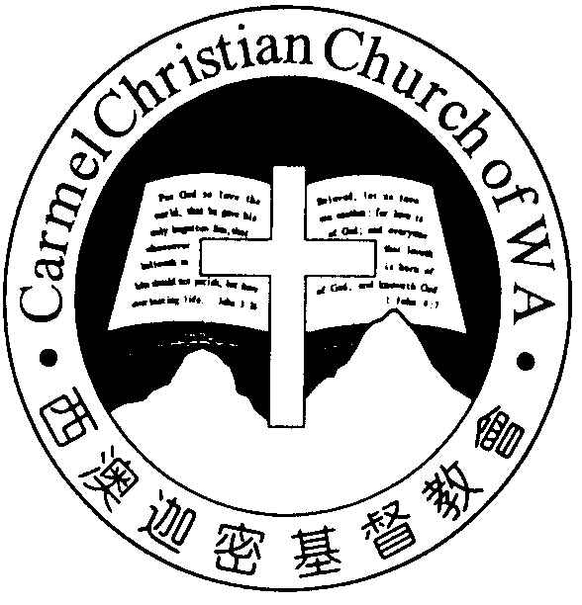
Carmel Christian Church of W.A.
Christ’s Love Brings Us Together

Theme for 2012/2013: Committed to Be Christlike

Vol. 15 No. 7 | Order of Worship  10.30am |  |  |  |  | 17/2/2013
Prelude |  | Pianist: Jason Liu
Congregation |  | “The Lord is in His Holy Temple”
Call To Worship |  | James Chen  Interpreter: Tony Hung
Welcome & Greetings
Praise Choruses |  |  |  | Dn Timothy Cheong
Invocation &  Doxology* |  |  |  | *Congregation standing
Responsive Reading |  |  |  | Psalm 95 (p.407)
Hymn of Response* |  |  |  | HOP 1  O Worship the King
Announcement |  | James Chen  Interpreter: Tony Hung
Pastoral Prayer |  | Rev Yeo S.H.  Interpreter: Dn Thong Kok Fai
Message |  | Starting 2013 Afresh...  “Reflect on the Past to Look Ahead ”  Deuteronomy 8:1-10 (p.129)
Hymn of  Reflection* |  |  | HOP 219  ‘Tis so sweet to Trust in Jesus
Benediction Sing Threefold Amen after Benediction
You’re invited to join us in our lunch fellowship

Sermon Outline:

Reflect on the Past to Look Ahead Deuteronomy 8:1-10

- Do not forget God’s commandments vv.1, 6
- Do not forget God’s grace, vv.2-5
- Do not forget God's promises vv.7-10

We warmly welcome you to join us in worshiping the Lord. May God’s peace and joy be your portion.

Worshipping at: Oberthur Pri. Sch., Nicholls Cres., Bull Creek, WA 6149
Church Office: 8, Agincourt Drive, Willetton, WA 6155
Telephone: 08- 6161-9239
Email: carmelwa@optusnet.com.au
Pastors: Rev Peter Chng Mobile: 0411-230-240
Rev Henry Tay Phone: 9414-6212
Preacher Lawrence Chan Mobile: 0431-699-316
Pastoral Chat

Dearly Beloved,

Man is indeed a funny creature. For some reasons, hard times are easily remembered than the good times. Perhaps bad experiences stir up stronger emotions than the good experiences. They tend to etch deeper into our memories. Nobody forgets the September 11, 2001 when the Twin Tow-er in New York was attacked by terrorists or December 26, 2004 when a massive earthquake in Aceh, Indonesia that triggered a monstrous tsunami.

In the book of Deuteronomy, we read of the many times how the children of God, the Israelites remembered only the difficulties they experienced in the wilderness. They had com-pletely forgotten God’s goodness and promise. Since the day they left Egypt till they reached the land of Canaan, the Lord has displayed His mighty acts, His protection and providence in their midst.

Instead of being indebted to Him, they have been whining and complaining for every trial that they faced. They looked back and recalled only the bad times but ignored the faithful-ness of God. They did not remember His awesome presence. The Israelites were a grumbling and ungrateful nation.

The Russian novelist and essayist Aleksander Solzhenitsyn said that giving thanks in everything is all about remem-bering, “I heard a number of older people offer this explan-ation for the great disasters that had befallen Russia: Men have forgotten God; that's why all this has happened”.

Moses says to the people, “Every commandment which I command you today you must be careful to observe, that you may live and multiply, and go in and possess the land of which the Lord swore to your fathers. And you shall remem-ber that the Lord your God led you all the way these forty years in the wilderness, to humble you and test you, to know what was in your heart, whether you would keep His com-mandments or not” (Deuteronomy 8:1-2). He is asking them that their entire life should be one of remembrance and thanksgiving. He is not telling them to dwell in the past but to benefit from it.

We remember our past so as to appreciate our present. Looking back to reflect on God’s past blessings encourages us to go forward boldly as we remember His goodness. Let us always be thankful to our Lord for His bountiful blessing.

With a grateful heart,
Pr Lawrence

Count your blessings and name them one by one – Charlotte A. Barnard
Ministries for this Week (17 Feb – 24 Feb )
We welcome you to join us in our weekly ministries:
- Friday: 7:30pm: English Care-Group, Dn Timothy’s
home, (68, Rhoda Ave, Willetton).
- Saturday: YF/LF: Summer break; resuming in
March 2013.
YAF: 4:30pm Dn Daniel’s home,
(U7/92 Gilbertson Rd, Kardinya)
- Sunday: 9:30am: SBC/ Prayer Meeting: Library.
10:30am: Combined Service: Library.
Children Ministry: Classrooms.

Sharing With You:
- We welcome Rev Yeo to our pulpit as he shares God’s Word to us.
- Lunar New Year Gathering will be held at Dn Kok Lay’s Home (15 Lefroy Rd, Bull Creek), 23/2 (Sat), 6:30pm. You are encouraged to bring your loved ones, friends and a dish to share in the fellowship dinner.
- Worship Services in summer: The English and Manda-rin services will combine to worship till end of Feb 2013.
- Library: Please see Sandy if you need library service.

Prayer Items: Our Missions Outreach
- God’s wisdom and guidance for the brethren’s evan-gelistic ministry and spiritual growth in China.
- God’s safety and protection be on Henry & Veroni-ca’s as they travel to schools and villages in Accra, Ghana for their outreach ministry.

Today’s (17/02/13) Roster:
Welcomers: Yinglong, Jonah
Audio/ Visual: Jill Flowers: Mrs Gao
CM Teacher: Joyce Asst: Esther Music: Joyce

Next Lord’s Day (24/02/13) Roster:
Worship Leader: Dn Kok Fai Interpreter: Ricky
Preacher: Rev Yeo S.H. Interpreter: Nathan
Praise Chorus: Alexander, Trina Pianist: Esther
Audio/Visual: Jason
Welcomers: Lin Feng, Lu Meng Flowers: Mrs Gao
CM Teacher: Joyce Asst: Yang Ping Music: Joyce

Last Week’s Offerings (10/02/13):
General Fund: $1,435.55;
Two love-gift envelopes for Pr Lawrence
Camp Fund: $20.00 To-date: $6,914.80
Building Fund: $233.00; $800.00 (# 33)
To-date: $127,621.08

