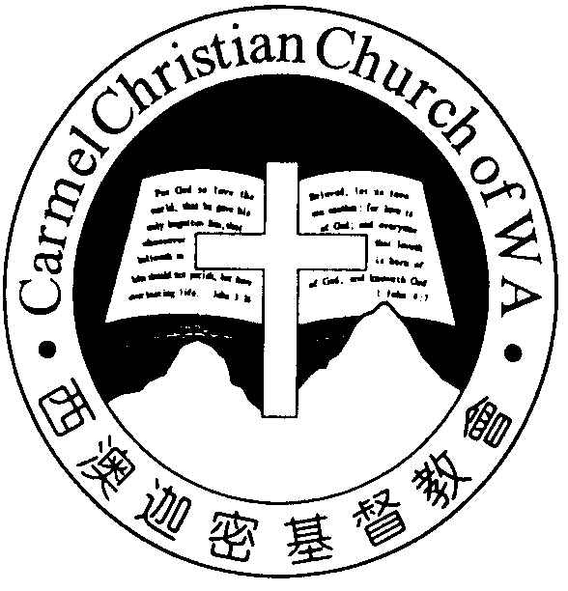
Carmel Christian Church of W.A.
Christ’s Love Brings Us Together

Theme for 2012/2013: Committed to Be Christlike

Vol. 15 No. 10 | Order of Worship  10.30am |  |  |  |  |  | 10/3/2013
Prelude |  | Pianist: Angela Wang
Congregation |  | “The Lord Is in His Holy Temple”
Call To Worship |  | Dn Timothy Cheong
Welcome & Greetings
Praise Choruses |  |  |  |  | Fiona Wang
Invocation &  Doxology* |  |  |  |  | *Congregation standing
Responsive Reading |  |  |  |  | Psalm 63 (p.392)
Hymn of Response* |  |  |  | HOP 391  The Love of God
Offering  Offertory Prayer  Announcement |  | Dn Timothy Cheong
Pastoral Prayer |  | Pastor Peter
Message |  | God’s Amazing Love Demonstrated...  “Christ Reconciling Us to God”  Romans 5:9-11 (p.760)
Hymn of  Reflection* |  |  | HOP 244  More like The Master
Benediction Sing Threefold Amen after Benediction
You’re invited to join us in our lunch fellowship

Sermon Outline:

Christ Reconciling Us to God Rom 5:9-11

Christ reconciling us to God impacts our lives in two ways.

1 Saved from the wrath of God (vv. 9-10)
1.1 What’s the wrath of God?
1.2 The impact of being saved

2 Rejoicing in God (v.11)
2.1 How do we rejoice in God?
2.2 The impact of rejoicing in God in life

We warmly welcome you to join us in worshiping the Lord. May God’s peace and joy be your portion.

Worshipping at: Oberthur Pri. Sch., Nicholls Cres., Bull Creek, WA 6149
Church Office: 8, Agincourt Drive, Willetton, WA 6155
Telephone: 08- 6161-9239
Email: carmelwa@optusnet.com.au
Pastors: Rev Peter Chng Mobile: 0411-230-240
Rev Henry Tay Phone: 9414-6212
Preacher Lawrence Chan Mobile: 0431-699-316
Pastoral Chat

Dearly beloved,

When God, through the prophet Isaiah, foretold the coming of the Messiah, He had this to say of His ministry: “And He was numbered with the transgressors, and He bore the sin of ma-ny, and made intercession for the transgressors” (Isa. 53:12).

The Gospels record the seven words of Jesus when He was crucified on the cross. One of the words is recorded in Luke 23:34: “Then Jesus said, ‘Father, forgive them, for they do not know what they do.” For the soldiers who crucified Jesus, it would have meant an immediate judgment from God. But Jesus mediated by His prayer to God the Father, and pre-vented the execution of God’s judgment. God sent Jesus to reconcile the world to Himself, and Jesus fulfilled that ministry!

What impact does this have on our daily living? What must we learn from the Lord?

The words of Jesus in Luke 23:34 are inscribed on a wall of a church in Jakarta, Indonesia. Bill Crowder went there to teach a 2-night Bible conference, and was shown around the host church building by the pastor. It was impressive and beautiful. Then the pastor took him to the lower assembly hall. Behind the pulpit was a plain concrete wall on which hung a wooden cross. Below it were some words inscribed in Indonesian lan-guage. So Bill asked the pastor what was written, and the pastor replied by quoting Christ’s words in Luke 23:34.

Surprised, Bill asked the pastor if it was there for a particular reason. The pastor explained that several years earlier there had been a serious rioting in the city, and 21 churches were burned to the ground in one day. That wall was all that re-mained of their former facility—the first of the churches to be torched. The pastor then went on to say that the wall and the verse was there to serve as a reminder of the compassion of Christ which He showed on the cross. That became the church’s message to their city. Instead of revenge and bitter-ness, which would never be healing responses to the hatred and rage of a lost world, the message of Christ’s compassion is what’s needed to reconcile the lost world to God.

After being touched by the compassion of Christ on his way to Damascus to arrest Christ’s followers, the apostle Paul spent the rest of his life telling and showing Christ’s recon-ciling ministry. “Now all things are of God, who has reconciled us to Himself through Jesus Christ, and has given us the ministry of reconciliation” (2 Cor. 5:18). As much as it was for Paul and the church in Jakarta, it’s for all of us as well.

In God’s grace,
Pastor Peter

God was in Christ reconciling the world to Himself, not imputing their trespasses to them.—2 Cor. 5:19
Ministries for this Week (10Mar – 17 Mar)
We welcome you to join us in our weekly ministries:
- Friday: 7:30pm: English Care-Group, Dn Timothy’s
home, (68, Rhoda Ave, Willetton).
- Saturday: YAF,LF,YF: No fellowship meeting this
Saturday
9am-9pm: Session & Ministry Leaders’
Retreat at Dn Timothy’s house.
- Sunday: 9:30am: SBC/ Prayer Meeting: Library
10:30am: Mandarin Service: Main Hall.
English Service: Library.
Children Ministry: Classrooms

Sharing With You:
- Good Friday and Easter Combined Services, 10.30am
- Easter Baptism, Reaffirmation of Faith and Transfer of Membership Class has started this morning at 9.30am, Music Room. Those who are prepared, please see Pastor or Session Members and attend the class.
- Library is open for you to borrow books and CDs. Please register with Sandy.

Prayer Items: Our Ministries Needs
- God’s grace and guidance for the Church Session/ Ministry Leaders’ Retreat, 16/3, as they meet to plan the church future direction.
- God’s grace and blessing for our members to have a meaningful worship during GF and Easter Services.

Today’s (10/03/13) Roster:
Welcomers: Dn Lin Feng, Huiqing
Audio/ Visual: Alexander Flowers: Victor
CM Teacher: Jieqi Asst: Esther Music: Trina

Next Lord’s Day (17/03/13) Roster:
Worship Leader: Dn Kok Fai
Preacher: Pr Lawrence
Praise Chorus: Alexander Pianist: Trina
Audio/Visual: Dn Timothy
Welcomers: Gavin Zou, Jonah Flower: Rose
CM Teacher: Jieqi Asst: Shuie Music: Angela

Last Week’s Offerings (03/03/13):
General Fund: $1,650,85; Thanksgiving: 100.00
One love-gift envelope for Pr Lawrence
Mission Fund: $100.00
Camp Fund: $20.00 To-date: $6,974.80
Building Fund: $50.00; $200.00 (#1045) To-date: $127,871.08

