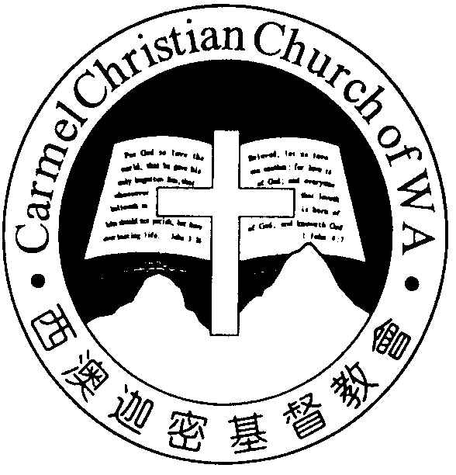
Carmel Christian Church of W.A.
Christ’s Love Brings Us Together

Theme for 2012/2013: Committed to Be Christlike

Vol. 15 No. 12 | Order of Worship  10.30am |  |  |  |  |  | 24/3/2013
Prelude |  | Pianist: Trina Quek
Congregation |  | “The Lord Is in His Holy Temple”
Call To Worship |  | Dn Thong Kok Fai
Welcome & Greetings
Praise Choruses |  |  |  |  | Alexander Quek
Invocation &  Doxology* |  |  |  |  | *Congregation standing
Responsive Reading |  |  |  |  | Psalm 47 (p.386)
Hymn of Response* |  |  |  | HOP 2  To God Be the Glory
Offering |  | Gavin Zou
Offertory Prayer |  | Dn Thong Kok Fai
Announcement
Pastoral Prayer |  | Pr Lawrence
Message |  | God’s Amazing Love Demonstrated...  “Freedom to Choose”  Romans 5:9-12-21 (p.760)
Hymn of  Reflection* |  |  | HOP 146  I Know whom I Have Believed
Benediction Sing Threefold Amen after Benediction
You’re invited to join us in our lunch fellowship

Sermon Outline:

Freedom to Choose Rom 5:12-21

God’s loves gives us the freedom to choose either the way to condemnation or the way to salvation.

- The way to condemnation (vv.12-14)
  - Because of Adam’s disobedience
  - Consequence of eternal damnation

- The way to salvation (v.15-21)
  - Because of Christ’s righteousness
  - God’s gift of grace – life in Christ

We warmly welcome you to join us in worshiping the Lord. May God’s peace and joy be your portion.

Worshipping at: Oberthur Pri. Sch., Nicholls Cres., Bull Creek, WA 6149
Church Office: 8, Agincourt Drive, Willetton, WA 6155
Telephone: 08- 6161-9239
Email: carmelwa@optusnet.com.au
Pastors: Rev Peter Chng Mobile: 0411-230-240
Rev Henry Tay Phone: 9414-6212
Preacher Lawrence Chan Mobile: 0431-699-316
Pastoral Chat

Dearly beloved,

Patrick Henry was an attorney and politician, also a known orator in 1770s. He was regarded as one of the most influen-tial champions for independence and was remembered for "Give me liberty or give me death!" speech. Evidently, he placed a high value on freedom.

I guess every one of us consider freedom as a very important aspect of our lives. We love the freedom to do things our ways without any interferences. We despise being imposed by others or our freedom being encroached. It is quite unima-ginable what life will be if freedom is taken away from us.

Before my illness, I should say I prided myself to be rather independent. I enjoy the freedom of my movement and being accountable only to myself and, of course, to our Lord Jesus. But what a humbling experience it was during this period of time I realise that I needed God and others more than any-thing else to walk me through this journey. No one could live a life apart from God and others.

Freedom is our personal right and we demand that we would not want anyone to tell us what to do. Man, since that fall of Adam and Eve, would not want to be controlled by others. In other word, we detest authority and being boxed in by rules and regulations. We sincerely believe that we are capable of running our own lives. Literally, we are telling others off, “Stop infringing into my rights”.

But do we envisage that freedom come with responsibilities and consequences? Wherever we go, do we realise that we are being bound by the laws of that particular place?

God, in His indefinite wisdom, has demonstrated His amazing love by giving us the freedom to choose. Since the beginning of time, He has never burdened us or insisted that we follow after His way. But He did lay down His laws and precepts clearly to us, through the books of the Bible, from Genesis to Revelation. His Word is made plain, in black and white, that all of us stand condemned before Him and can only be justified by Him. We have only two choices. It is either the way of the world or the way of Jesus. We can either take the path to destruction or we can take the path to salvation.

Freedom is a privilege that comes with responsibilities, inclu-ding the consequences. In our freedom to determine the way to go, let’s us be remember and be grateful that our God is ever loving and gracious, and not tyrannical.

With a grateful heart,
Pr Lawrence

True freedom is in the Lord Jesus
Ministries for this Week (24 Mar – 31 Mar)
We welcome you to join us in our weekly ministries:
- Wednesday: 10.30am: Tandara Aged Care
- Friday: 7:30pm: English Care-Group, Dn Timothy’s
home, (68, Rhonda Ave, Willetton).
- Saturday: 4.30pm: YAF: Q&A Workshop “Difficult
Biblical Questions & Passages”, Jim &
Jill’s home, (17A, Napier Rd., Morley).
- Sunday: 9:30am: SBC/ Prayer Meeting: Library
10:30am: Mandarin Service: Main Hall.
English Service: Library.
Children Ministry: Classrooms

Sharing With You
- Good Friday and Easter Combined Services, 10.30am
- Easter Baptism, Reaffirmation of Faith and Transfer of Membership Class has started this morning at 1.30pm, Library Room. Those who are prepared, please see Pastor or Session Members and attend the class.
- Monthly Mandarin Gospel Night, including three Combined Meeting with the English CG: If you would like to open your home for gospel meeting this year, please contact Dn Matthew.
- Library is open for you to borrow books and CDs. Please register with Sandy.

Prayer Items: Our Missions Needs:
- God’s grace and wisdom for the brethren’s evangelistic work and spiritual growth and in China.
- God’s grace and strength for Tetteh’s outreach ministry among the villages and students in Accra, Ghana.

Today’s (24/03/13) Roster:
Welcomers: Gavin Zou, Jonah
Audio/ Visual: Timothy Flowers: Rose
CM Teacher: Jieqi Asst: Shuie Music: Angela

Next Lord’s Day (31/03/13) Roster:
Worship Leader: Dn Timothy
Preacher: Pr Lawrence
Praise Chorus: Angela Pianist: Fiona
Audio/Visual: Alexander
Welcomers: Dn Kok Fai, Changying Flower: Shawn
CM Teacher: Jieqi Asst: Yang Ping Music: Syee Chee/Jessica

Last Week’s Offerings (17/03/13):
General Fund: $1,481.50; Thanksgiving: $20.00
One love-gift envelope for Pastor Tay
One love-gift envelope for Pr Lawrence
Camp Fund: $20.00 To-date: $6,994.80
Building Fund: -- To-date: $127,871.08

