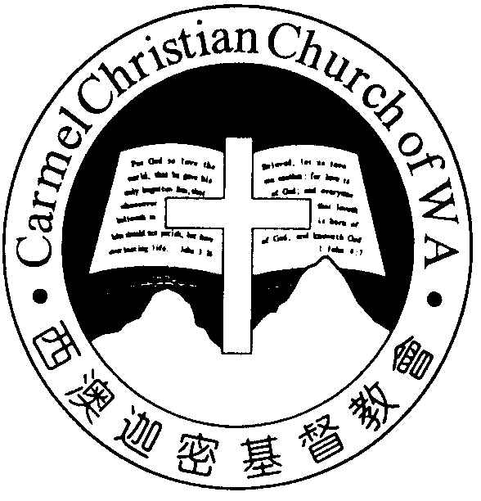
Carmel Christian Church of W.A.
Christ’s Love Brings Us Together

Theme for 2012/2013: Committed to Be Christlike

Vol. 15 No. 34 |  | Order of Worship  10.30am |  |  |  |  | 25/8/2013
Prelude |  |  | Pianist: Fiona Wang
Congregation |  |  | “The Lord Is in His Holy Temple”
Call To Worship |  |  | Dn Timothy Cheong;  Interpreter: Nathan Teo
Welcome & Greetings
Praise Choruses |  |  |  |  | Tony Hung; Angela Wang
Invocation &  Doxology* |  |  |  |  | *Congregation standing
Children Item | ‘Our Journey Through Sunday School’
Choir | ‘Our Everlasting God’
Adult Baptism |  |  | Joy Han
Child/ Infant Baptism |  |  | Matthew Han, son of Mr & Mrs Han Zhaohui
 |  |  | John Ong Henken, son of Dn & Mrs Daniel Ong
Responsive Reading |  |  | Psalm 111 (p.414)
Hymn of Response* |  |  | HOP 364  Praise Him! Praise Him!
Announcement |  |  | Dn Timothy Cheong;  Interpreter: Nathan Teo
Pastoral Prayer |  |  | Pastor Peter; Interpreter: Dn Daniel Ong
Message |  |  | O Rejoice in the Lord...  “O Rejoice in the Lord”  Psalm 100 (p.408)
Hymn of  Reflection* |  |  |  | HOP 379  Sweeter as the Years Go By
Benediction Sing Threefold Amen after Benediction

Sermon Outline: O Rejoice in the Lord Psalm 100

Amid whatever circumstances we’re in, there are two reasons that can cause us to continue to rejoice in the Lord.

- Our Lord is the Creator-God (vv.1-3)
1.1 It infuses a sense of belonging
1.2 His meticulous care

- Our Lord is good (vv.4-5)
2.1 Enduring steadfast love
2.2 Faithfulness to all generations
We warmly welcome you to join us in worshiping the Lord on our 14th Anniversary Thanksgiving Service. May God’s peace and joy be your portion.

Worshipping at: Oberthur Pri. Sch., Nicholls Cres., Bull Creek, WA 6149
Church Office: 8, Agincourt Drive, Willetton, WA 6155
Telephone: 08- 6161-9239
Email: carmelwa@optusnet.com.au
Pastors: Rev Peter Chng Mobile: 0411-230-240
Rev Henry Tay Phone: 9414-6212
Preacher Lawrence Chan Mobile: 0431-699-316

Pastoral Chat

Dear friends and Carmelites,

Let me represent the church to warmly welcome friends to our 14th Anniversary Thanksgiving Service.

Although we encountered challenges and difficulties in the past 14 years, we all can echo with one voice that our Lord has led us through all these years as a spiritual family. Our hearts just burst out with thanks to the Lord that He added to the church those who were being saved (Acts 2:47).

The church has stepped into yet another new milestone by in-stalling her first Session in place of the Committee, and ac-quired a property at Forrestdale for the enhancement of the ministries. While we’re certainly exuberant with the progress, we realise that we’re in a transition of the church life—leaping from one year to the next. Transition in life, or the church life, is like an experience of white-water rafting, seen recently in the Avon Descent.

Writing an article in Our Daily Bread (1/7/2007), Joseph Stowell, the former President of Moody Bible Institute, related his first experience of riding through the white-water. While he was enjoying the start, his emotions were flooded with feelings of uncertainty, fear, and insecurity when he heard the roar of the rapids up ahead. He called that a first-rate, white-knuckle experience!

But then, Stowell wrote, it was over. The guide in the back of the raft had navigated them through. He was safe, at least, until the next set of rapids.

Joshua navigated through dramatic transition of his life and the history of Israel. Though the Lord had earlier anointed him to lead the Israelites into the Promised Land (Num. 27:18-23; Deut. 3:28), the death of Moses thrust him into the unknowns of leadership. The Lord had to urge him on with His words, “Moses My servant is dead. Now therefore, arise, go over this Jordan,…to the land which I am giving to them…as I was with Moses, so I will be with you. I will not leave you nor forsake you….Only be strong and very coura-geous, that you may observe to do according to all the law which Moses My servant commanded you” (Jos. 1:2-7).

In the days ahead, even when it seems to fill with uncertain-ties, let’s grasp the reality that the Lord is our Guide. It’s with this in mind that the pastoral team has set this year’s Anniversary theme: “O, Rejoice in the Lord.”

If the Lord is our Guide, shouldn’t we rejoice in Him?

Rejoice in the Lord,
Pastor Peter

Enter into [God’s] gates with thanksgiving,
And into His courts with praise.—Psalm 100:4
Ministries for this Week (25Aug – 1 Sept)
We welcome you to join us in our weekly ministries:
- Wednesday: 10.30am: Tandara Aged Care
- Friday: 7:30pm: English Care-Group Meeting:
Steven’s home, (32 Godwin Ave., Manning).
- Saturday: 4.30pm: YAF: “Fellowship: Singing and
Prayer”, Jim & Jill’s home, (17A
Napier Rd., Morley).
- Sunday: 9:30am: SBC/ Prayer Meeting: Library
10.30am: Mandarin Service: Main Hall.
English Service: Library
Children Ministry: Classrooms
Sharing With You
For those who have registered for the Thanksgiving Lunch, please proceed to Serai Dining, 406 North Lake Rd., Bibra Lake after the service.
- A warmest welcome to Joy Han (adult baptism), Matthew Han, son of Mr & Mrs Han Zhaohui and John Ong Henken (child/ infant baptism), , son of Dn & Mrs Daniel Ong, in joining this spiritual family.
- Next Lord’s Day is our Lord’s Supper Sunday. Let us prepare our hearts to partake the Lord’s Supper.
- 2014 Flower Roster: The chart is displayed at the welcomer’s desk. If you wish to offer flowers, there are still a few slots left, please fill in your name as soon as possible. For more information, please see Sandy.
- Young Adult Church Camp 2013 will be held on 26-29 Sept at Forrestdale. Topic is “Why Are We in the Church?” The speaker is Rev Calvin Loh, our borrowed-Elder from Life BP Church in Singapore. Student $110 and Adult $130 per person. Closing date for registration is 1 September. Contact Daniel for further information. Please register with Jason.
- Library is open for you to borrow books and CDs. Please register with Sandy.
Prayer Items: World and Our Nation
- God’s mercy and grace that the escalation of civil war in Syria will be abated.
- God’s wisdom and guidance for our nation in the coming Federal election on 7th September.
Today’s (25/08/13) Roster:
Welcomers: Dn Kok Fai, Jonah Flowers: Lyanne
Audio/ Visual: Vera Kitchen Roster: No Duty
CM Teacher: Joyce Asst: Yanping
Music: Syee Chee/ Jessica
Next Lord’s Day (01/09/13) Roster:
Worship Leader: Dn Kok Fai Flower: Rose
Preacher: Pastor Peter
Praise Chorus: Angela Pianist: Syee Chee
Audio/Visual: Gavin, Jonah Welcomers: David, Sandy
Kitchen Roster: Faithfulness Team Flower: Rose
CM Teacher: Shan Shan Asst: Bonnie Music: Dn Timothy
Last Week’s Offerings (18/08/13):
General Fund: $827.00; Thanksgiving: $170.00
Camp Fund: $20.00 To-date: $7,474.80
Choir Fund: $50.00
Building Fund: $800.00; $5,000.00; (#1001); $100 (1059) To-date: $184,527.08
BF Interest-free Loan: $10,000.00 (#1061) To-date: $320,000

