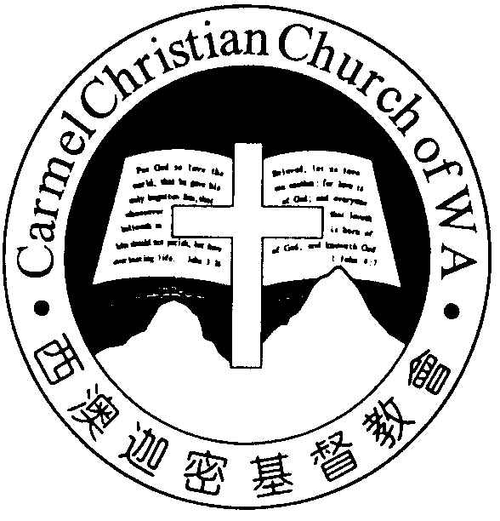
Carmel Christian Church of W.A.
Christ’s Love Brings Us Together

Theme for 2012/2013: Committed to Be Christlike

Vol. 15 No. 35 | Order of Worship  10.30am |  |  |  |  | 1/9/2013
Prelude |  | Pianist: Yang Syee Chee
Congregation |  | “The Lord Is in His Holy Temple”
Call To Worship |  | Dn Thong Kok Fai
Welcome & Greetings
Praise Choruses |  |  |  | Angela Wang
Invocation &  Doxology* |  |  |  | *Congregation standing
Responsive Reading |  | Psalm 150 (p.428)
Hymn of Response* |  | HOP 8  Now Thank We All Our God
Announcement |  | Dn Thong Kok Fai
Pastoral Prayer |  | Pastor Peter
Message |  | O Rejoice in the Lord...  “Rejoicing in God’s Blessings”  1 Kings 8:31-53 (p.238)
Hymn of  Preparation* |  |  | HOP 434  Count Your Blessings
Lord’s Supper |  |  | Assisted by Dn Thong Kok Fai
Benediction Sing Threefold Amen after Benediction

Sermon Outline:

Rejoicing in God’s blessing 1 Kings 8:31-53

Gleaning from the praise-prayer of King Solomon, we discover two dimensions of God’s blessing that we can rejoice in.

- Physical dimension of God’s blessing
1.1 Our daily provisions
1.2 God’s protection against calamities

- Spiritual dimension of God’s blessing
2.1 Forgiveness for the penitent
2.2 Mercies amid discipline

We warmly welcome you to join us in worshiping the Lord. May God’s peace and joy be your portion. We invite all baptized believers to partake the Lord’s Supper with us in remembrance of our Lord.
On this Father’s Day we wish every father God’s wisdom and blessings.

Worshipping at: Oberthur Pri. Sch., Nicholls Cres., Bull Creek, WA 6149
Church Office: 8, Agincourt Drive, Willetton, WA 6155
Telephone: 08- 6161-9239
Email: carmelwa@optusnet.com.au
Pastors: Rev Peter Chng Mobile: 0411-230-240
Rev Henry Tay Phone: 9414-6212
Preacher Lawrence Chan Mobile: 0431-699-316

Pastoral Chat

Dearly beloved,

We know that our salvation is unconditional. It’s solely the grace of, the unmerited favour from, God, and not upon even a single merit we’ve earned along the way. That’s perfectly correct. However, we may have erroneously carried the con-cept a little too far when we think that it’s the same with God’s blessing. While God’s salvation is unconditional, His blessing is conditional.

It’s indeed tough to speak of God’s blessing when your life seems to be “walk[ing] through the valley of the shadow of death” (Ps. 23:4), and yet I’m confronted with a stark remind-er that the focus should be on God rather than His blessing.

Dave Branon in Our Daily Bread (2/12/06) made this obser-vation: “I observe Christian couples who struggle to have ba-bies while others are blessed with children and then abuse them. I look at families whose children are all alive and well, while I go through life without one of mine. I see friends who long to serve God but can’t because of health issues. It’s then that I must go back to a basic truth. We are not the arbiters of fairness. God is, and He knows far more than we do about His plans and purposes. The question isn’t about fairness. In the end, it’s about trust in a faithful God who knows what He is doing.” He then concluded his observation, saying, “Life will never look fair. But when we trust God, we always know that He is faithful. If you feel that blessings pass you by, and for you, life seems a bit unfair, just remember, Christ was born to die, and in His great salvation you can share.” That’s blessing!

While we look beyond circumstances and focus on the faith-fulness of God, that doesn’t preclude us from our responsibili-ty for God to be pleased to bless us. President Abraham Lin-coln made this passionate speech to America in 1863: "We have been the recipients of the choicest bounties of heaven; we have been preserved these many years in peace and prosperity; we have grown in numbers, wealth, and power as no other nation has ever grown. But we have forgotten God. We have forgotten the gracious hand which preserved us in peace and multiplied and enriched and strengthened us, and we have vainly imagined, in the deceitfulness of our hearts, that all these blessings were produced by some superior wisdom and virtue of our own. Intoxicated with unbroken suc-cess, we have become too self-sufficient to feel the necessity of redeeming and preserving grace, too proud to pray to the God that made us." That’s our responsibility!

May we never forget, but always praise God for His blessings.

In God’s mercy,
Pastor Peter

God’s salvation is unconditional, we can never earn it;
God’s blessing is conditional, we must preserve it.
Ministries for this Week (1 Sept – 8 Sept)
We welcome you to join us in our weekly ministries:
- Friday: 7:30pm: English Care-Group Meeting: Steven’s
home, (32 Godwin Ave., Manning).
- Saturday: 2pm: YAF: Prepare for camp site at 6,
Commercial Rd., Forrestdale.
7.30pm: Elim Fellowship: Tang Qiong’s home
54 Hetherington Dr., Bull Creek).
YF: Pastor Peter’s home, (34 Nicholls
Cres., Bull Creek).
- Sunday: 9:30am: SBC/ Prayer Meeting: Library
10.30am: Mandarin Service: Main Hall.
English Service: Library
Children Ministry: Classrooms
Sharing With You
- Today is the Lord’s Supper Sunday. Let’s prepare our hearts to come before the Lord’s Table as we partake the Lord’s Supper in remembrance of Christ.
- Church & Choir: Sale of finger-food for church fundraising 15 Sept after service. For further detail, please see Dn Lin Feng or Doris.
- Notice is hereby given that the 14th Church Annual Congrega-tional Meeting (ACM) is called on 29th September, 2pm at Oberthur Primary School (main Hall).
- 2014 Flower Roster: The chart is displayed at the welcomer’s desk. If you wish to offer flowers, there are still a few slots left, please fill in your name as soon as possible. For more detail, please see Sandy.
- Young Adult Church Camp 2013 will be held on 26-29 Sept at Forrestdale. Topic is “Why Are We in the Church?” The speaker is Rev Calvin Loh, our borrowed-Elder from Life BP Church in Singapore. Student $110 and Adult $130 per person. Closing date for registration is 1 September. Contact Daniel for further information. Please register with Jason.
- Library is open for you to borrow books and CDs. Please register with Sandy.
Prayer Items: Our Congregational Needs
- God’s mercy and grace for Soh Yong’s husband, Joo Lim (stroke), Chi Kou (blood disorder) and Dn Matthew’s son Terry (post-operation recovery).
- God’s wisdom and understanding for Lo Chi Keong, Lucy Yang, Christopher Lee, Joanna Lin, & Lily Ye as they prepare for their mock examination.
Today’s (01/09/13) Roster:
Welcomers: David, Sandy Flowers: Rose
Audio/ Visual: Gavin, Jonah Kitchen Roster: Faithfulness Team
CM Teacher: Shan Shan Asst: Bonnie Music: Dn Timothy
Next Lord’s Day (08/09/13) Roster:
Worship Leader: Dn Timothy Preacher: Pastor Peter
Praise Chorus: Steven Pianist: Angela
Audio/Visual: Jonah & Andrew Welcomers: Dn Lin Feng, Huiqing
Kitchen Roster: Gentleness Team Flower: Shuie
CM Teacher: Shan Shan Asst: Esther Music: Shan Shan
Last Week’s Offerings (25/08/13):
General Fund: $2,262.00; $170.00 (choir uniform); $80.00 (Elim) Thanksgiving: $300.00 Missions: $50.00
Camp Fund: $20.00 To-date: $7,474.80
Building Fund: $100.00; $5,000.00; (#1007); $200 (#1045); $300.00 (#1103) To-date: $190,127.08
BF Interest-free Loan: -- To-date: $320,000

