Ministries for this Week (24 Nov – Dec 1)
We welcome you to join us in our weekly ministries:
- Friday: 7.30pm: English Care-Group Meeting: Steven’s home, (32
Godwin Ave., Manning).
- Saturday: 1pm: YAF: Outing, meet at 6 Commercial Rd.,
Forrestdale.
- Sunday: 9:30am: SBC/ Prayer Meeting: Library
10.30am: Combined Service: Main Hall.
Children Ministry: Classrooms.

Sharing With You
- Note: This year’s Combined Service has been brought forward from November 2013 to February 2014.

- Today is the last day for the Sale of finger-food. The church and the choir express their appreciation for the support given by the members.

- Preacher Lawrence will be away in Singapore from 25 Nov 2013 to 11 Feb 2014.

- Next Lord’s Day is the Lord’s Supper Sunday. Let’s prepare our hearts to partake the Lord’s Supper at His Table.

- New Church Office address: 6 Commercial Rd.; Telephone no: 9393-3515; Email: carmelbpc@iinet.net.au wef 11 Nov 13.

- Library is closed for the summer till February 2014.
.

Worshipping at: Oberthur Pri. Sch., Nicholls Crescent., Bull Creek, WA 6149
Church Office: 6, Commercial Road, Forrestdale, WA 6112
Telephone: 08-9393-3515
Email: carmelbpc@iinet.net.au
Church Website: www.carmelwa.org.au
Pastors: | Rev Peter Chng | Mobile: 0411-230-240
 | Rev Henry Tay | Telephone: 9414-6212
 | Preacher Lawrence Chan | Mobile: 0431-699-316
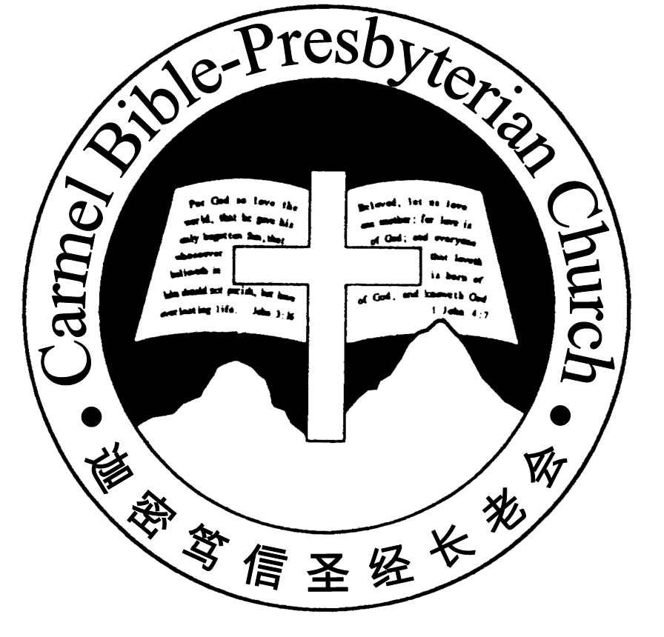
Carmel Bible-Presbyterian Church
Christ’s Love Brings Us together

Theme for 2012/2013: Committed to Be Christlike

Vol. 15 No 47 | 24/11/2013

Pastoral Chat
The idols of Christian
“Son of man, these men have set up their idols in their heart, and put the stumbling block of their iniquity before their face: Should I be enquired of at all by them?” (Ezekiel 14:3).

Since I became a father, I start to realize that sometimes kids can be as stubborn as adults. For instance, when they find a toy that they love very much, they will force their parents to buy it for them by using different ways, such as crying or throwing tantrums...etc. And when they finally have it in their hands, it is usually quite impossible for you to take it away from their hands.

This reminds me of how we tend to behave in front of our God at times. When He takes away something from us that we treasure very much, we may feel depressed, or even harbor bitter thoughts against God in our hearts.

A pastor once pointed out that Christians often responded to God in this manner because they did not recognize that Jesus is far more precious than the idols that they treasure in their hearts. I cannot agree with this pastor more.

Indeed, it is a fact that some Christians do not understand how valuable Christ is to them because only those who are walking closely with the Lord can appreciate how precious He is to them.

We see this, for example, with the Psalmist who praises the Lord in Psalm 36, saying “How excellent is thy lovingkindness, O God! Therefore the children of men put their trust under the shadow of thy wings. They shall be abundantly satisfied with the fatness of thy house, and thou shalt make them drink of the river of thy pleasures” (vv.7-8). Because he walked with God, and had experienced the goodness of God, he could see very clearly that the joy that was based on worldly relationships and material gains could never be compared with the joy that one could experience through a close relationship with the Lord.

It was this awareness that caused the attractiveness of the world to fade before him, and compelled him to cry out unto God, saying, “Whom have I in heaven but thee? And there is none upon earth that I desire beside thee. My flesh and my heart faileth: but God is the strength of my heart, and my portion for ever” (Psalm 73:23-26).

To a great extent, this transformation of behaviour is only natural. Like a child who discovers a better toy and releases the original toy from his hands willingly, so when a man finally realizes how precious God is to him, he will naturally let go of all the idols that he has been holding on in his heart, in order to obtain Christ.

Since this the case, I will like you to ponder over two important questions concerning the state of your heart this morning.

First of all, is there any idol still remaining within your heart? If you sought after God in prayer over something that you felt was very important to you e.g. marriage partner, ideal job...etc and He turned down your prayer request, will you keep thinking about it and feeling bitter over it? Will you lose the joy in your life just because you could not get what you want in your prayer? If this is indeed so with you, then it shows that some idols still remain within your hearts. You need to ask for God's forgiveness and cast them out of your hearts.

Furthermore, do you actually know that what you possess today through Christ is far more precious than what the world can ever offer you? Do you really believe that to have God walking with you in your life is far better than all the friends that you can have in the world?

This morning, it is my earnest prayer that our God will open your spiritual eyes so that you can see how wonderful it is to know God and to have Him beside you in your life.

By Rev Calvin Loh

Prayer Items: The World and our Nation
- God’s mercy and encouragement to the people of Philippines affected recently by natural disaster typhoon Haiyan.
- God’s wisdom and grace for our Federal government to lead the nation in the year 2014.

Duty Roster | Today 24/11/13 | Next Lord’s Day 1/12/13
Preacher | Rev Calvin Loh | Rev Tay
Interpreter | Nathan Teo | Dn Daniel Ong
Worship Leader | Dn Timothy Cheong | Dn Thong Kok Fai
Interpreter | Tony Hung | Tony Hung
Lord’s Supper Assistants |  | Dn Teo Kok Lay  Dn Shao Quanxi
Pianist | Jason Liu | Joy Han
Praise Chorus | Doris Lo | Nathan Teo
AV | Lo Chi Gou | Gavin Zou
Toddlers | Teacher: Ng Shan Shan | Teacher: Ng Shan Shan
Lower Junior | Teacher: Joyce Cheong  Assistant: Yanping  Musician: : Syee Chee/ Jessica | Teacher: Joyce Cheong  Assistant: Bonnie  Musician: Timothy Cheong
Upper Junior | Teacher: Steven Lee | Teacher: Steven Lee
Welcomers | Tian Changying,  Gavin Zou | David Hong  Sandy Hong
Flower | Tian Changying | Candas Thong

Offerings |  |  | 17/11/13
General Fund |  |  | $2,066.10
Thanksgiving |  |  | $70.00
Mission Fund |  |  | $0.00
Camp Fund |  |  | $20.00 | To-date: $7,794.80
Finger-food Sale |  |  | $421.00 | To-date: $10,912.50
Building Fund |  |  | $50.00; $200.00 (1045);  $150.00 (1061);  $300.00 (1103) | To-date:$213,743.78
BF Interest-free Loan |  |  | $0.00 | To-date:$320,000
Order of Worship
10.30am
Prelude | Pianist: Jason Liu
Congregation | “The Lord is in His Holy Temple”
Call to Worship | Dn Timothy Cheong; Interpreter: Tony Hung
Welcome & Greetings
握手问安
Praise Chorus | Doris Lo
Invocation & Doxology* |  | *Congregation Standing
Responsive Reading |  | Psalm 47 (p.386)
Hymn of Response* |  | HOP 355 Jesus Is All the World to Me
Announcement | Dn Timothy Cheong; Interpreter: Tony Hung
Choir | “In Christ There Is Peace”
Pastoral Prayer | Rev Calvin Loh; Interpreter: Nathan Teo
Message | What does Christ Look For in His Church? …  “What is God’s Will for Us?”  Philippians 1:27-28 (p.790)
Hymn of Reflection | HOP 182 Blest Be the Tie That Binds
Benediction* | Sing Threefold Amen after Benediction
You’re invited to join us in our lunch fellowship欢迎您会后留下与我们共享午餐

Sermon Outline:

What is God’s Will for us? Philippians 1:27-28

We warmly welcome you to join us in worshipping the Lord. May God’s peace and joy be your portion.

