Ministries for this Week (1 Dec – 8 Dec)
We welcome you to join us in our weekly ministries:
- Friday: 7.30pm: English Care-Group Meeting:
Summer break resuming in March 2014
- Saturday: 4.30pm: YAF Summer break;
resuming in March 2014
- Sunday: 9:30am: SBC/ Prayer Meeting: Library
10.30am: Combined Service: Main Hall.
Children Ministry: Classrooms.

Sharing With You

- Note: This year’s Combined Service has been brought forward from November 2013 to February 2014.
- Today is the Lord's Supper Sunday. Let's prepare our heart and mind as we come before the Lord's Table to partake of the Lord's Supper in remembrance of our Lord Jesus.
- Note to all Sunday Worship Leaders: you are lead the Sunday morning prayer meeting at 9.30am.
- Church Choir: there will be no choir practice until mid-January 2014.
- Christmas Carolling: if you like to open your home to carollers on Christmas Eve (24/12), please let Dn Timothy know as soon as possible. Carol practice begins today after the fellowship lunch. You are encouraged to join in the carolling and attend the practice.
- Easter Combined Church Camp with Covenant BPC from 21-24 April 2014. The theme is “Forgetting what lies behind and straining forward to what lies ahead” (Philippians 3:13). For more detail, please see Dn Lin Feng.
- New Church Office address: 6 Commercial Rd.; Telephone no: 9393-3515; Email: carmelbpc@iinet.net.au wef 11 Nov 13.
- Library is closed for the summer till February 2014.

Worshipping at: Oberthur Pri. Sch., Nicholls Crescent., Bull Creek, WA 6149
Church Office: 6, Commercial Road, Forrestdale, WA 6112
Telephone: 08-9393-3515
Email: carmelbpc@iinet.net.au
Church Website: www.carmelwa.org.au
Pastors: | Rev Peter Chng | Mobile: 0411-230-240
 | Rev Henry Tay | Telephone: 9414-6212
 | Preacher Lawrence Chan | Mobile: 0431-699-316

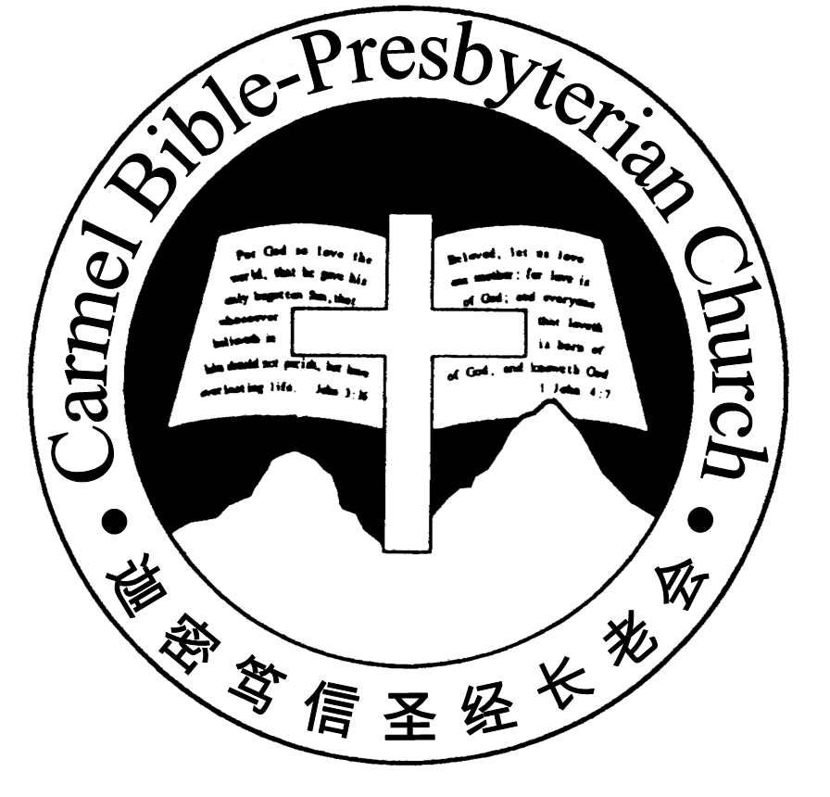
Carmel Bible-Presbyterian Church
Christ’s Love Brings Us together

Theme for 2013/2014: Committed to Be Christlike

Vol. 15 No 48 | 01/12/13

Pastoral Chat
What is True Repentance？(Pt 1)

'Saul said to Samuel, “I have sinned, for I have transgressed the commandment of the Lord and your words...' - 1Sa 15:24

Many years back when I was still a fairly young believer, some brethren encouraged me to cultvate the habit of memorising the Scripture, which I eventually did. Of the many verses that I memorised at that time, the promise given by the apostle John in 1 John chapter 1 verse 9 was especially precious to me - 'If we confess our sins, He is faithful and just to forgive us our sins, and to cleanse us from all unrighteousness.'
It was precious to me because it allows me to see the mercy of God, and also reminds me of the compassion that was displayed by the father of the prodigal son. (cf. Luke 15:20) From this verse, I began to realise how important it was to confess our sins to the Father.
After many years later, I still believe with all my heart that this is an especially precious promise. I believe that a man will never be able to experience the joy of being forgiven by the Lord unless he first humble himself and confess his sins before Him.
But having said that, I have also realise thoughout the years of ministry and learning that not every kind of confession and repentance is accepted by the Lord.
Sometimes, a man may confess his sins, and even shed rivers of tears before the Lord, but he receives nothing from the Lord because his repentance is not in accordance to the will of God. The repentance of king Saul is a good example.
Based on the Scripture in 1 Samuel chapter 15, we know that he had received strict orders from the Lord to destroy, not just the Amalekites, but everything that pertained unto them as a sign of His hot displeasure and righteous judgment against them. However, instead of carrying out the instruction completely, he spared the life of the Amalekites' king. He also spared the best of the Amalekites' flock. When his disobedience was eventually found out and confronted by the prophet Samuel, we notice that he did confess his sins. But it was obvious from prophet Samuel's response later on that he has never received any forgiveness from the Lord.
At this juncture, some people may be very perplexed by the situation because they feel that God was to hash with king Saul. After all, wasn't this only the second time that he had disbeyed the Lord? And did he not confessed his sins in the end? Since this is the case, why then was he not forgiven? Has God indeed forgotten to be merciful according to His promises?
Of course not! The scripture makes it very clear - 'God is not man, that he should lie, or a son of man, that he should change his mind. Has he said, and will he not do it? Or has he spoken, and will he not fulfill it?' (Num 23:19)
But king Saul was not forgiven because his motivation for confession was wrong. He confessed, not because he truly believed that what he did was truly sinful and offensive towards God, but because he was afraid of the consequences of his sin. To put it in another way, his confession stems from self-pity rather than the realisation of his own sinfulness.
In contrast, years later king David also confessed his sin after he was confronted by the prophet Nathan, but he did so before the issue of punishment was even brought up by the prophet. He confessed, not because he hoped to lessen the sentence of God against him, but because he truly realised that he had offended God with his sins.
If I may use an illustration, king Saul is like a crimnal who weeps and apologizes only after he has been caught by the police and brought before the judge to be sentenced. But king David's confession is like a child who suddenly realises that he has done something terribly wrong against the father whom he loves. The former's confession is self-centered while the latter's confession is God-centered.
Due to this reason, we should not be surprised that king Saul was not forgiven, regardless of how many tears he has shed. (to be continued)

By Pastor Calvin Loh
__________________________________________________________________________________________________________________________________

Prayer Items: Congregational Needs
- God's blessing and protection for brethren who are travelling on work assignments or holidays.
- God's mercy and healing for full recovery to good health of those who are sick.

Duty Roster | Today 1/12/13 | Next Lord’s Day 8/12/13
Preacher | Rev Tay | Rev Tay
Interpreter | Dn Daniel Ong | Nathan Teo
Worship Leader | Dn Thong Kok Fai | Dn Teo Kok Lay
Interpreter | Tony Hung | Dn Timothy Cheong
Lord’s Supper Assistants | Dn Teo Kok Lay  Dn Shao Quanxi
Pianist | Joy Han | Grace Shao
Praise Chorus | Nathan Teo | Tony Hung
AV | Gavin Zou | Jonah Thong
Toddlers | Teacher: Ng Shan Shan | Teacher: Ng Shan Shan
Lower Junior | Teacher: Joyce Cheong  Assistant: Bonnie  Musician: : Timothy Cheong | Teacher: Joyce Cheong  Assistant: -------------  Musician: Ng Shan Shan
Upper Junior | Teacher: Steven Lee | Teacher: Steven Lee
Welcomers | David Hong  Sandy Hong | Ye Huiqing  Dn Thong Kok Fai
Flower | Candas Thong | Rose Cheong

Offerings |  | 24/11/13
General Fund |  | $1,578.75
Thanksgiving |  | $40.00
Mission Fund |  | $0.00
Camp Fund |  | $20.00 | To-date: $7,814.80
Finger-food Sale |  | $478.1.00 | To-date: $11,390.60
Building Fund |  | $50.00;$200.00 (1020) | To-date:$213,993.78
Property Maintenance |  | $1,400.00 | To-date: $1,400.00
BF Interest-free Loan |  | $0.00 | To-date:$320,000
Order of Worship
10.30am
Prelude | Pianist: Joy Han
Congregation | “The Lord is in His Holy Temple”
Call to Worship | Dn Thong Kok Fai; Interpreter: Tony Hung
Welcome & Greetings
握手问安
Praise Chorus | Nathan Teo
Invocation & Doxology* |  | *Congregation Standing
Responsive Reading |  | Psalm 48 (p.386)
Hymn of Response* |  | HOP 78 O Come, All Ye Faithful
Announcement | Dn Thong Kok Fai; Interpreter: Tony Hung
Pastoral Prayer | Rev Tay; Interpreter: Dn Daniel Ong
Message | Jesus Is Our Joy For Christmas …  “Salvation has come”  Hebrews 2:14-18 (p.804)
Hymn of Preparation* | HOP 156 Have You Been to Jesus?
Lord's Supper | Assisted by Dn Teo Kok Lay; Dn Shao Quanxi
Benediction* | Sing Threefold Amen after Benediction
You’re invited to join us in our lunch fellowship欢迎您会后留下与我们共享午餐

Sermon Outline:
Salvation has come Hebrews 2:14-18

- Introduction
- Who can inherit this salvation?
- What is the principle to be regarded as one of Abraham's descendants?

We warmly welcome you to join us in worshipping the Lord. May God’s peace and joy be your portion. We invite all beptized believers to partake the Lord's Supper with us in remembrance of our Lord.

