Ministries for this Week (15 Dec – 22 Dec)
We welcome you to join us in our weekly ministries:
- Friday: 7.30pm: English Care-Group Meeting:
Summer break resuming in March 2014
- Saturday: 4.30pm: YAF Summer break;
resuming in March 2014
7.30pm: Elim's fellowship Summer break till further notice
YF Summer break till further notice
- Sunday: 10am: Prayer Meeting: Library
10.30am: Combined Service: Main Hall
Children Ministry: Classrooms

Sharing With You

- Note: This year’s Combined Service has been brought forward from November 2013 to February 2014.
- Note: There is no Sunday Bible Class at 9.30am till further notice. But there is still Prayer Meeting at 10am.
- Note to all Sunday Worship Leaders: You are required to lead the Sunday morning prayer meeting at 10am.
- Pastor Yeo ministered to us today. We express our thanks to him.
- Next Lord's Day is Christmas Lord's Day You are encouraged to bring your loved ones and friends.
- Pastor Mark Chen from Covenant BPC will minister to us for next Sunday. We express our thanks to him.
- Church Choir: there will be no choir practice until mid-January 2014.
- Christmas Carolling: Christmas Eve (24/12) will be held at Dn Timothy’s house (68 Rhonda Ave., Willetton) at 6pm. Brothers and sisters are encouraged to bring a dish, we have fellowship dinner. Carol practice begins today after the fellowship lunch. You are encouraged to join in the carolling and attend the practice.
- Easter Combined Church Camp with Covenant BPC from 21-24 April 2014. The theme is “Forgetting what lies behind and straining forward to what lies ahead” (Philippians 3:13). Adult (13+yrs) $230; 6-12yrs $190. For more detail, please see Dn Lin Feng.
- New Church Office address: 6 Commercial Rd.; Telephone no: 9393-3515; Email: carmelbpc@iinet.net.au effective from 11 Nov 13.
- Library is closed for the summer till February 2014.

Worshipping at: Oberthur Pri. Sch., Nicholls Crescent., Bull Creek, WA 6149
Church Office: 6, Commercial Road, Forrestdale, WA 6112
Telephone: 08-9393-3515
Email: carmelbpc@iinet.net.au
Church Website: www.carmelwa.org.au
Pastors: | Rev Peter Chng | Mobile: 0411-230-240
 | Rev Henry Tay | Telephone: 9414-6212
 | Preacher Lawrence Chan | Mobile: 0431-699-316

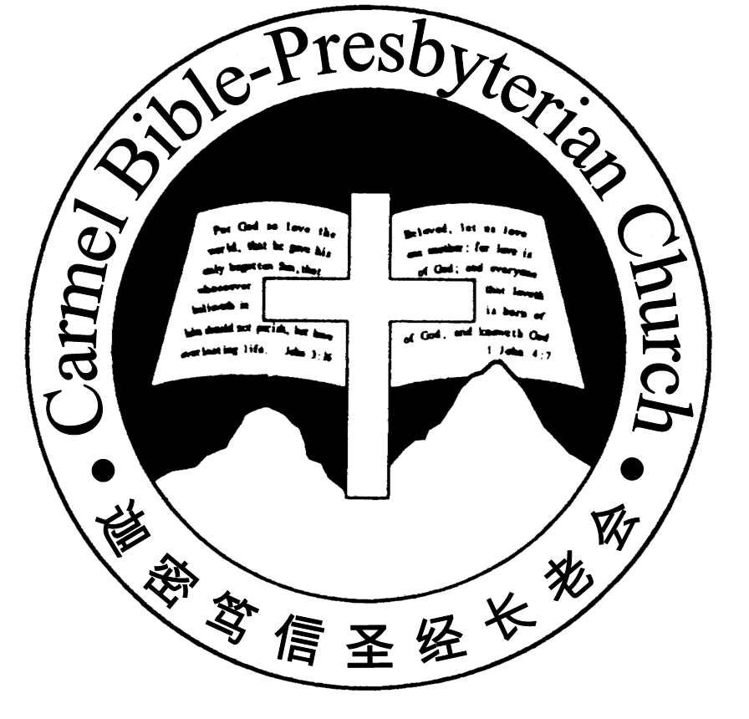
Carmel Bible-Presbyterian Church
Christ’s Love Brings Us together

Theme for 2013/2014: Committed to Be Christlike

Vol. 15 No 50 | 15/12/13

Pastoral Chat
WE ARE SOLDIERS

“Share in suffering as a good soldier of Christ Jesus. No soldier gets entangled in civilian pursuits, since his aim is to please the one who enlisted him.”（2 Timothy 2:3-4）

Until three years ago, I had been going back for my army reservist training on an annual basis. Every time when I was called up, I would be away from the church office for about 2 weeks. Once I had to return to the church office to collect some stuff, and accidentally bumped into a member from the English congregation. She told me jokingly that I looked weird to her because I was wearing my army combat uniform with boots. I suppose this was a natural response because she had never seen me in such attire. As a result, she has forgotten that I was not only a pastor of the church, but a soldier as well.
To some extent, this experience reminded me of a common problem that I see among many Christians today. Because they have not put on an army uniform, and had ever hold a rifle in their hands before, they do not see themselves as soldiers, and are not prepared to enter into the battlefield at all.
But in reality, every genuinly born again believer is a soldier before God, regardless of whether he is aware of this fact or not. In his epistle to Timothy, the apostle Paul described the Christian as the soldiers of Christ, the elite troops who fight under the banner of the Lord in the front lines. He has granted unto us the whole armor of God, that we may wage war against sin, and against '...the rulers, against the authorities, against the cosmic powers over this present darkness, against the spiritual forces of evil in the heavenly places.' (Eph 6:12) And he also pointed out that the weapons of our warfare '...are not of the flesh but have divine power to destroy strongholds. We destroy arguments and every lofty opinion raised against the knowledge of God, and take every thought captive to obey Christ...' (2 Cor 10:4-5) Since this is the case, I would like you to consider a few solemn questions this morning.
Firstly, are we prepared to exert a positive influence over the sin darkened world as the light of the world and the salt of the earth? Are we prepared to live out a godly testimony before men despite of their hostility and cruel mockings? If we have indeed put on the uniform of Christ's army, then do not imagine that you can still remain neutral in the world. A man cannot be friend of God and a friend of the world at the same time because Jesus Himself has not given us such an option. He makes this very clear to us through James, 'You adulterous people! Do you not know that friendship with the world is enmity with God? Therefore whoever wishes to be a friend of the world makes himself an enemy of God.' (Jam 4:4)
Secondly, are we familiar with the complete set of spiritual armor that God has granted unto us? (cf. Eph 6:10-18) As an ex-soldier myself, I believe that nothing is more important to a soldier than to be thoroughly familiar with his own weapons and equipment in the battlefield. This applies to the spiritual battlefield as well. Since this is the case, may I ask if you are well trained in th use of the shield of faith and the sword of the Spirit?
Thirdly, are you aware that you are not fighting alone in this spiritual battlefield? Unlike many human commanders who stay in the back and send their soldiers to fight in the frontlines, Christ walks before us, and lead us personally into the battlefield. He is the Lord of Host who leads us and fight together with us. He says, 'Have I not commanded you? Be strong and courageous. Do not be frightened, and do not be dismayed, for the Lord your God is with you wherever you go.' (Josh 1:9)
Finally, are you aware that in this awesome battle against 'the rulers, against the authorities, against the cosmic powers over this present darkness, against the spiritual forces of evil in the heavenly places', the overall victory has already been secured by the Lord Himself? Listen to what He says in John 16:33, 'I have said these things to you, that in me you may have peace. In the world you will have tribulation. But take heart; I have overcome the world.' In other words, no matter how ferocious the devil and his demonic host may struggle in this spiritual battle, the final outcome has already been detemined. As the apostle Paul pointed out, there will definitely come a day when every knee will bow at the name of Jesus, '...in heaven and on earth and under the earth, and every tongue confess that Jesus Christ is Lord, to the glory of God the Father.' (Phi 2:10-11) And when that day arrives, we shall sit together with Him victoriously to judge as well as to rule the whole world. (cf. Rev 5:10) What a glorious day it will be when this precious promise finally come to pass!
Since this is the case, let us fight valiantly for the Lord while we are still here on earth. The day will soon come when we will not need to fight anymore.

By Pastor Calvin Loh
__________________________________________________________________________________________________________________________________

Prayer Items: Our Missions Needs

- God's grace and protection for the brethren's evangelistic ministry and spiritual growth in China.
- God's mercy and strength for Tetteh's outreach work among the villagers and students in Accra, Ghana.

Duty Roster | Today 15/12/13 | Next Lord’s Day 22/12/13
Preacher | Rev Yeo | Rev Mark Chen
Interpreter | Dn Daniel Ong | Nathan Teo
Worship Leader | Dn Timothy Cheong | Dn Daniel Ong
Interpreter | Tony Hung | Tony Hung
Pianist | Jason Liu | Joy Han
Praise Chorus | Nathan Teo | Tony Hung
AV | Vincent Tian | Vera Wang
Toddlers | Teacher: Ng Shan Shan | Teacher: Ng Shan Shan
Lower Junior | Teacher: Joyce Cheong  Assistant: Chen Shuie  Musician: : Clifford Lee | Teacher: Joyce Cheong  Assistant: Yanping  Musician: Jessica Hung
Upper Junior | Teacher: Steven Lee | Teacher: Steven Lee
Welcomers | Chen Yinglong;Peng Shuzhi | Gore Chen ; Chang Ying
Flower | Chen Shie | Shao Quanxi
Kitchen | Patience Team(Tony,Jason,Vera) | Kindness Team  (Jessica,Syee Chee,Phung)

Offerings |  | 08/12/13
General Fund |  | $1,520.05
Thanksgiving |  | $0.00
Mission Fund |  | $0.00
Camp Fund |  | $20.00 | To-date: $7,854.80
Finger-food Sale |  | $0.00 | To-date: $11,390.60
Building Fund |  | $150.00(1061);$100.00(1072) | To-date:$214,893.78
Property Maintenance |  | $0.00 | To-date: $1,400.00
BF Interest-free Loan |  | $0.00 | To-date:$320,000
Order of Worship
10.30am
Prelude | Pianist: Jason Liu
Congregation | “The Lord is in His Holy Temple”
Call to Worship | Dn Timothy Cheong; Interpreter: Tony Hung
Welcome & Greetings
握手问安
Praise Chorus | Nathan Teo
Invocation & Doxology* |  | *Congregation Standing
Responsive Reading |  | Psalm 98 (p.408)
Hymn of Response* |  | HOP 77 Hark! The Herald Angels Sing
Announcement | Dn Timothy Cheong; Interpreter: Tony Hung
Pastoral Prayer | Rev Yeo; Interpreter: Dn Daniel Ong
Message | Jesus Is Our Joy For Christmas …  “A message of great joy”  Luke 2:8-12 (p.690)
Hymn of Reflection* | HOP 84 Tell Me the Story of Jesus
Benediction* | Sing Threefold Amen after Benediction
You’re invited to join us in our lunch fellowship欢迎您会后留下与我们共享午餐

Sermon Outline:

A message of great joy Luke 2:8-12

- Introduction

- The silent generation

- The witnesses with good news

- The sign that brings hope to mankind

- Conclusion

We warmly welcome you to join us in worshipping the Lord. May God’s peace and joy be your portion.

