Ministries for this Week (22 Dec – 29 Dec)
We welcome you to join us in our weekly ministries:
- Friday: 7.30pm: English Care-Group Meeting:
Summer break resuming in March 2014
- Saturday: 4.30pm: YAF Summer break;
resuming in March 2014
7.30pm: Elim's fellowship Summer break till further notice
YF Summer break till further notice
- Sunday: 10am: Prayer Meeting: Library
10.30am: Combined Service: Library
Children Ministry: Classrooms
Sharing With You

- Note: This year’s Combined Service has been brought forward from November 2013 to February 2014.
- Note: There is no Sunday Bible Class at 9.30am till further notice. But there is still Prayer Meeting at 10am.
- Note to all Sunday Worship Leaders: You are required to lead the Sunday morning prayer meeting at 10am.
- This Lord's Day is Christmas Lord's Day You are encouraged to bring your loved ones and friends.
- Pastor Mark Chen from Covenant BPC minister to us today. We express our thanks to him.
- Next Lord’s Day is our Gospel Sunday You’re encouraged to bring your loved ones and friends to the service.
- Church Choir: there will be no choir practice until mid-January 2014.
- Christmas Carolling: Christmas Eve (24/12) will be held at Dn Timothy’s house (68 Rhonda Ave., Willetton) at 6pm. Brothers and sisters are encouraged to bring a dish, we have fellowship dinner. Carol practice begins today after the fellowship lunch. You are encouraged to join in the carolling and attend the practice.
- Easter Combined Church Camp with Covenant BPC from 21-24 April 2014. The theme is “Forgetting what lies behind and straining forward to what lies ahead” (Philippians 3:13). Adult (13+yrs) $230; 6-12yrs $190. For more detail, please see Dn Lin Feng.
- New Church Office address: 6 Commercial Rd.; Telephone no: 9393-3515; Email: carmelbpc@iinet.net.au effective from 11 Nov 13.
- Library is closed for the summer till February 2014.

Worshipping at: Oberthur Pri. Sch., Nicholls Crescent., Bull Creek, WA 6149
Church Office: 6, Commercial Road, Forrestdale, WA 6112
Telephone: 08-9393-3515
Email: carmelbpc@iinet.net.au
Church Website: www.carmelwa.org.au
Pastors: | Rev Peter Chng | Mobile: 0411-230-240
 | Rev Henry Tay | Telephone: 9414-6212
 | Preacher Lawrence Chan | Mobile: 0431-699-316

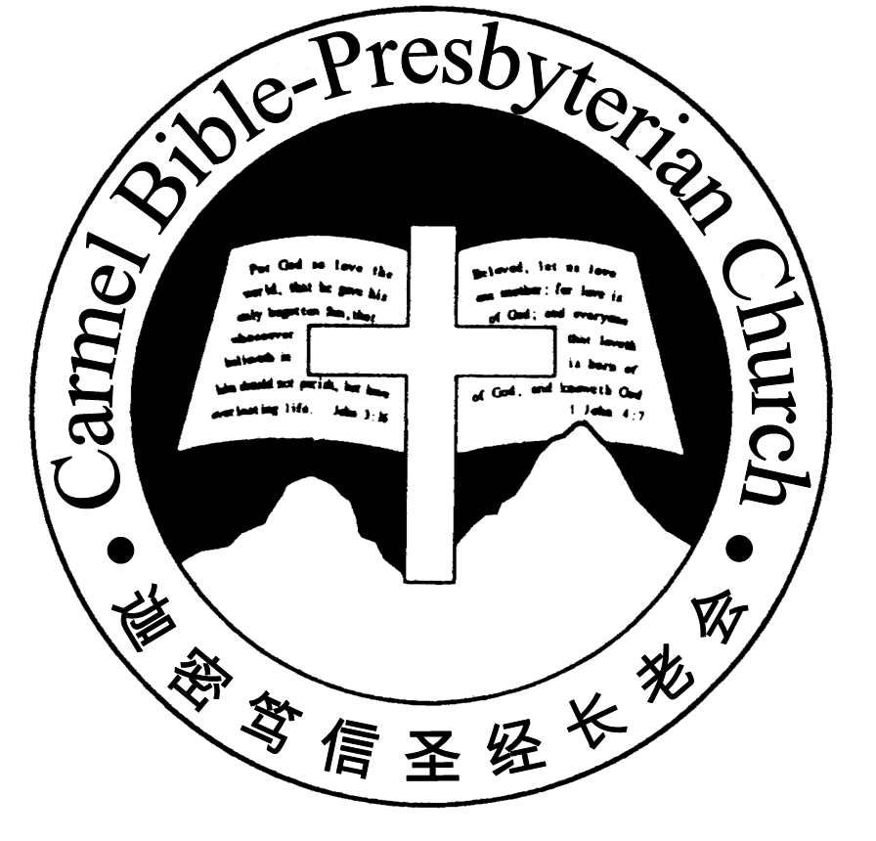
Carmel Bible-Presbyterian Church
Christ’s Love Brings Us together

Theme for 2013/2014: Committed to Be Christlike

Vol. 15 No 51 | 22/12/13

Pastoral Chat
SOME THOUGHTS ON CHRISTMAS

“In this is love, not that we have loved God but that he loved us and sent his Son to be the propitiation for our sins.”(1 John 4:10)

Dear brothers and sisters in Christ, do you not think that time really flies! In a few weeks' time, Christmas will have arrived.
To many children, Christmas is the time where they can expect their parents to buy new toys for them; To many young people, Christmas is the time where they can party to their hearts' delight; To many working adults who are often crushed by the daily demands and pressure of work, Christmas is the time where they can rest and catch their breath; To those in the retail business, Christmas is the time to attract more consumers and to increase their sales with numerous promotions and discount; And to many professing Christians, Christmas is a very important festival of the Christian calender. Hence, many of them who never bother to come for worship on the usual Lord's Day, will suddenly appear in the church during Christmas eve services to perform their religious duty. But what about you? What is Christmas to you? Is it important to you? If it is, why is it so?
For me personally, Christmas is certainly an important day, but it is so because it reminds me about the boundless love of God for sinners like myself.
Now, we know from experiences that every one who intend to buy a present for a loved one or friends usually set certain limits concerning the price that he is willing too pay for the present.
For example, if we are buying Christmas presents for gift exchange with our colleages in the work place, we may not want to go beyond ten dollars. If it is for our relatives' children, we may not want to go beyond thirty dollars. And if it is for our loved ones e.g. our spouses, our children or parents, we may tend to be more generous. Even so, there will still be a limit as to how much we are willing to spend.
But in contrast, God gave unto us way beyond what we can ever imagine or hope for. The Lord Jesus Himself says in John 3:16 that '...God so loved the world, that he gave his only Son, that whoever believes in him should not perish but have eternal life.' The apostle Paul also says that 'He who did not spare his own Son but gave him up for us all...' (Rom 8:32) Surey there is no love greater than what God has shown unto us!
Secondly, Christmas is important to me as well because it also reminds me about the wonder of His grace towards me. Think about it - Have we ever come across anyone who would willingly give up his life for those who hurt him? Or have we ever meet anyone who will sacrifice his only beloved son for the sake of those who hate him?
Frankly, I have never come across anyone like that in my life, and yet the Word of God tells us that this was exactly what God did for us. We are told in Romans 5 verses 7 and 8 that '...one will scarcely die for a righteous person, though perhaps for a good person one would dare even to die, but God shows his love for us in that while we were still sinners, Christ died for us.'
Finally, Christmas is important to me because it reminds me why I should love my Lord, obey and serve Him with all my heart, soul and might. The apostle John says, 'We love him, because he first loved us.' (1 Jn 4:19)
Because of all these reasons, I love Christmas. It allows me to see the light in the midst of darkness; to possess hope in place of hopelessness; to receive life in place of death; and to experience the matchless love of God in the midst of a world that is filled with hatred and misery.
It is my sincere desire that you will feel the same towards Christmas as well.
__________________________________________________________________________________________________________________________________

Prayer Items: Our World and Nation

- Pray for hindrance to Australian same sex marriage bill, who is actively pushed forward from ACT.
- Pray for citizen’s sensitivity towards the increased weather warming across the globe.

Duty Roster | Today 22/12/13 | Next Lord’s Day 29/12/13
Preacher | Rev Mark Chen | Dn Shao Quanxi
Interpreter | Nathan Teo | Dn Daniel Ong
Worship Leader | Dn Daniel Ong | Dn Teo Kok Lay
Interpreter | Tony Hung | Dn Timothy Cheong
Pianist | Joy Han | Andrew Chen
Praise Chorus | Dn Daniel Ong, Tony Hung | Steven Lee
AV | Vera Wang | Vera Wang
Toddlers | Teacher: Ng Shan Shan | Teacher: Ng Shan Shan
Lower Junior | Teacher: Joyce Cheong  Assistant: Yanpng  Musician: : Jessica Hung | Teacher: Joyce Cheong  Assistant: ---------------  Musician: Ng Shan Shan
Upper Junior | Teacher: Steven Lee | Teacher: Steven Lee
Welcomers | Gore Chen ; Chang Ying | Huiqing ; Shuzhi
Flower | Shao Quanxi | Shang Weili
Kitchen | Kindness Team  (Jessica, Syee Chee, Phung) | Goodness Team (Alex,Huiqing,Yanhong)

Offerings |  | 15/12/13
General Fund |  | $777.00
Thanksgiving |  | $0.00
Mission Fund |  | $0.00
Camp Fund |  | $20.00 | To-date: $7,874.80
Finger-food Sale |  | $0.00 | To-date: $11,390.60
Building Fund |  | $0.00 | To-date:$214,893.78
Property Maintenance |  | $0.00 | To-date: $1,400.00
BF Interest-free Loan |  | $0.00 | To-date:$320,000
One love-gift envelope for Rev Tay
Order of Worship
10.30am
Prelude | Pianist: Joy Han
Congregation | “The Lord is in His Holy Temple”
Call to Worship | Dn Daniel Ong; Interpreter: Tony Hung
Welcome & Greetings
握手问安
Praise Chorus | Dn Daniel Ong; Tony Hung
Invocation & Doxology* |  | *Congregation Standing
Responsive Reading |  | Psalm 62:1-12 (p.391)
Hymn of Response* |  | HOP 80 As with Gladness Men of Old
Announcement | Dn Daniel Ong; Interpreter: Tony Hung
Children Praise Item
Pastoral Prayer | Rev Mark Chen; Interpreter: Nathan Teo
Message | Jesus Is Our Joy For Christmas …  “Christ Came to Save Sinners”  1 Timothy 1:15 (p.797)
Hymn of Reflection* | HOP 219 Tis so Sweet to Trust in Jesus
Benediction* | Sing Threefold Amen after Benediction
You’re invited to join us in our lunch fellowship欢迎您会后留下与我们共享午餐

Sermon Outline:

Christ Came to Save Sinners 1 Timothy 1:15

- There is a savior

- He came to give salvation

- He came to save sinners

- This is a faithful saying

We warmly welcome you to join us in Christmas worshipping the Lord. May God’s peace and joy be your portion.

