Ministries for this Week (9 Feb – 16 Feb 2014)
We welcome you to join us in our weekly ministries:
- Friday: 7.30pm: English Care-Group Meeting:
Summer break resuming in March 2014
- Saturday: 4.30pm: AF Summer break;
resuming in March 2014
7.30pm: Elim's fellowship Summer break till further notice
YF Summer break till further notice
- Sunday: 10am: Prayer Meeting: Library
10.30am: Combined Service: Main hall
Children Ministry: Classrooms

Sharing With You

- Easter Baptism, Reaffirmation of Faith, Child Baptism and Transfer of membership class will continue on 23 Feb after service in Library. Those who are prepared, please let Pastor Peter know immediately and attend the class.
- Easter Combined Church Camp with Covenant BPC from 21-24 April 2014. The theme is “Forgetting what lies behind and straining forward to what lies ahead” (Philippians 3:13). Adult (13+yrs) $230; 6-12yrs $190. For more details, please see Dn Lin Feng.
- Library is closed for the summer till February 2014.

Worshipping at: Oberthur Pri. Sch., Nicholls Crescent., Bull Creek, WA 6149
Church Office: 6, Commercial Road, Forrestdale, WA 6112
Telephone: 08-9393-3515
Email: carmelbpc@iinet.net.au
Church Website: www.carmelwa.org.au
Pastors: | Rev Peter Chng | Mobile: 0411-230-240
 | Rev Henry Tay | Telephone: 9414-6212
 | Preacher Lawrence Chan | Mobile: 0431-699-316

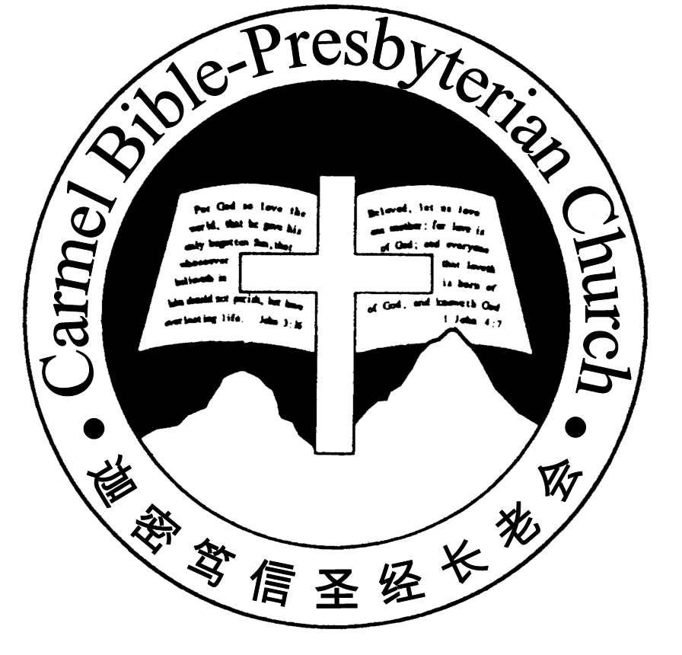
Carmel Bible-Presbyterian Church
Christ’s Love Brings Us together

Theme for 2013/2014: Committed to Be Christlike

Vol. 16 No 6 | 9/2/14

Pastoral Chat OUR UNIQUE PRIVILEGE

Preacher Lawrence and I had a telephone conversation on the eve of Lunar New Year. He told me that it was by God’s mercy that he was able to fly out of Chicago, USA, just before the New Year. Many flights were either cancelled or delayed due to the unprecedented snowstorms hitting many parts of the US. He pleaded with the Airline, and they were kind to switch him to another flight.

While cold snaps hit the northern hemisphere, the southern hemisphere is going through an equally unprecedented hot spells, and Australia is in its path. Bushfires in many states had authorities worried. The usually warm Singapore, however, is affected by the dry cold stream coming from China. While the weather is cooler, it’s unusually dry, with no rain in January. It’s worrying for authorities.

The topics of global warming and drastic climate changes brought the conversation with my siblings to the Second Coming of our Lord. Indeed, it’s something to awa-ken us to the imminent return of our Lord. While this jolts us from our seeming slumber, it shouldn’t be our focus. The Lord Jesus foretold His coming in one of His discourses in Matthew chapters 24 and 25. He said, “And you will hear of wars and rumours of wars. See that you are not troubled, for all these things must come to pass, but the end is not yet….And there will be famines, pestilences, and earth-quakes in various places. All these are the beginning of sorrows” (24:6-8; em-phases mine). The Lord doesn’t want us to be troubled by these phenomena!

If the Lord doesn’t want us to be troubled by spending too much attention on the is-sues of global warming and wars, what then does He want us to focus on with re-ference to His Return?

Instead of focusing undue attention on natural disasters and wars, the Lord urges us to persevere. “And because lawlessness will abound, the love of many will grow cold. But he who endures to the end shall be saved” (vv.12-13). Witnessing these events shouldn’t cause our love for Jesus and one another to grow cold, but conti-nue to draw strength from the Lord to persevere till He comes.

When we mention the concept of endurance (or perseverance), we tend to think it to be passive. But the Lord doesn’t want our endurance to be passive, as if doing nothing. He went on to urge us, “And this gospel of the kingdom will be preached in all the world as a witness to all the nations, and then the end will come” (v.14).
When a lecturer in the Bible College expounded on this verse and told us that God had given us, His children, a unique privilege to co-work with Him in the Second Coming of our Lord, I was overawed and excited. Natural phenomena and wars are but indications to alert us, but the preaching of the gospel of Christ’s Return is one sure sign to signal the dawn of that great event. And you and I are given that uni-que privilege! How this works is a mystery to God, but He wants all of us to “[look] for and [hasten] the coming of the day of God” (2 Pet. 3:12).

Are we excited with this unique privilege? If we are, then live our daily lives with this great event constantly in our minds.—Pastor Peter
__________________________________________________________________________________________________________________________________

Prayer Items: Ministries Needs

- God’s guidance and wisdom for the Session to lead and build the church in the days head.
- God’s grace and understanding for the leaders in charge of the various ministries to implement their vision plan in the years ahead.

Duty Roster | Today 9/2/14 | Next Lord’s Day 16/2/14
Preacher | Rev Henry Tay | Rev Mark Chen
Interpreter | Dn Daniel Ong | Dn Daniel Ong
Worship Leader | Dn Teo Kok Lay | Dn Thong Kok Fai
Interpreter | Tony Hung | Dn Timothy Cheong
Pianist | Grace Shao | Andrew Chen
Praise Chorus | Dn Timothy Cheong | Tony Hung
AV | Jonah Thong | Vera Wang
Toddlers | Teacher: Mandy; Crystal | Teacher: Mandy; Crystal
Lower Junior | Teacher: Joyce Cheong  Assistant: ----------------  Musician: : Joyce Cheong | Teacher: Joyce Cheong  Assistant: Shuie Chen  Musician: Joyce Cheong
Upper Junior | Teacher: Steven Lee | Teacher: Steven Lee
Welcomers | Huiqing, Lin Feng | Yinglong , Shuzhi
Flower | Alex Wang | Yueying
Kitchen | Peace Team  (Xiaohong, Yueying, Zhengxin) | Patience Team  (Vera, Jason, Tony)

Offerings |  |  | 2/02/14
General Fund |  |  | $693.50
Thanksgiving |  |  | $0.00
Mission Fund |  |  | $0.00
Camp Fund |  |  | $20.00 | To-date: $8,014.80
Building Fund |  |  | $40.00 | To-date:$277,333.78
Property Maintenance |  |  | $0.00 | To-date: $1,400.00
BF Interest-free Loan |  |  | $0.00 | To-date:$260,000
Order of Worship
10.30am
Prelude | Pianist: Grace Shao
Congregation | “The Lord is in His Holy Temple”
Call to Worship | Dn Teo Kok Lay; Interpreter: Tony Hung
Welcome & Greetings
握手问安
Praise Chorus | Dn Timothy Cheong
Invocation & Doxology* |  |  | *Congregation Standing
Responsive Reading |  |  | Psalm 98 (p.408)
Hymn of Response* |  |  | HOP 255 I Need Thee Every Hour
Announcement |  | Dn Teo Kok Lay; Interpreter: Tony Hung
Pastoral Prayer |  | Rev Henry Tay ; Interpreter: Dn Daniel Ong
Message |  | Living Consciously of Christ’s Return  “Christ has spoken the last things (2)”  Mark 1:1-15(p.673)
Hymn of Reflection* |  | HOP 141 Wonderful Grace of Jesus
Benediction* |  | Sing Threefold Amen after Benediction
You’re invited to join us in our lunch fellowship欢迎您会后留下与我们共享午餐

Sermon Outline:

Christ has spoken the last things (2) Mark 1:1-15

- Introduction
- Repent and believe the good news!
- The implication of gospel
- Gospel is saver of life
- Church is the massager
- The key of rebirth

We warmly welcome you to join us in worshipping the Lord. May God’s peace and joy be your portion.

