Ministries for this Week (23 Feb – 2 Mar 2014)
We welcome you to join us in our weekly ministries:
- Sunday: 2:30pm: Church Session Meeting: Art & Craft Room
- Friday: 7.30pm: English Care-Group Meeting:
Summer break resuming in March 2014
- Saturday: 11:30am: AF Meeting: Devotional Study, “The Gospel of
John, chapter 8.” 6 Commercial Rd, Forrestdale.
7.30pm: Elim's Fellowship Summer break till further notice
YF Summer break till further notice
- Sunday: 10am: Prayer Meeting: Art & Craft Room
10.30am: Combined Service: Main hall
Children Ministry: Classrooms

Sharing With You

- Next Lord’s Day is our Lord’s Supper Sunday. Let us prepare our hearts as we come before His presence to partake the Lord’s Supper.
- A warmest welcome to Xu Meng (adult baptism) in joining Carmel spiritual family.
- Easter Baptism, Reaffirmation of Faith, Child Baptism and Transfer of membership class will resume today after service in Art & Music Room. Those who are prepared, please let Pastor Peter know immediately and attend the class.
- Easter Combined Church Camp with Covenant BPC from 21-24 April 2014. The theme is “Forgetting what lies behind and straining forward to what lies ahead” (Philippians 3:13-14). The camp speakers are Rev David Yan for the English session and Rev Yeo Say Hock for the Mandarin session. The camp fee for the adult, 13 yrs and above: $230; 12yrs and below: $190. The last day of registration is 30/3. You are encouraged to come for the camp and please see Dn Lin Feng or Tony for the registration form.
- Library is closed for the summer till further notice.

Worshipping at: Oberthur Pri. Sch., Nicholls Crescent., Bull Creek, WA 6149
Church Office: 6, Commercial Road, Forrestdale, WA 6112
Telephone: 08-9393-3515
Email: carmelbpc@iinet.net.au
Church Website: www.carmelwa.org.au
Pastors: | Rev Peter Chng | Mobile: 0411-230-240
 | Rev Henry Tay | Telephone: 9414-6212
 | Preacher Lawrence Chan | Mobile: 0431-699-316

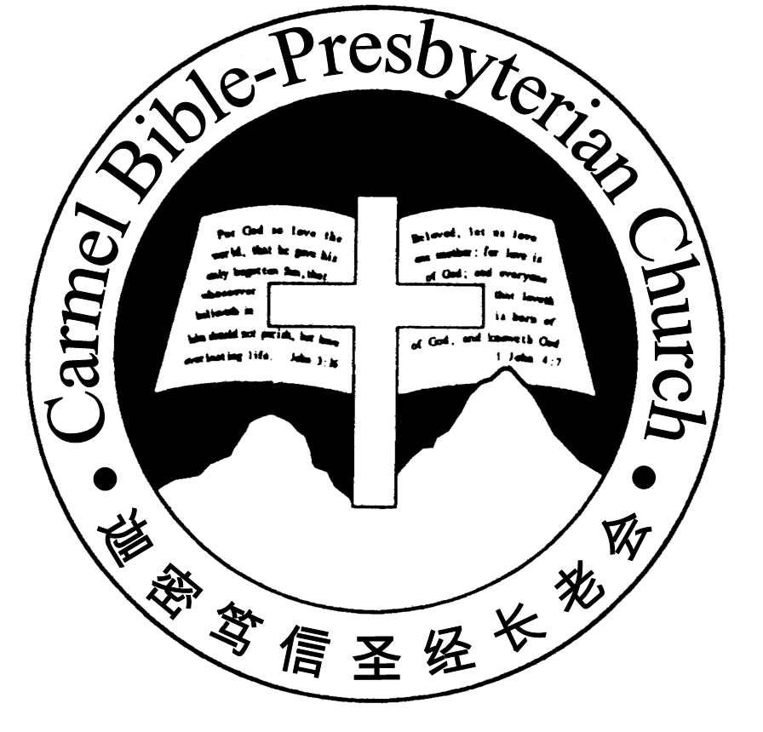
Carmel Bible-Presbyterian Church
Christ’s Love Brings Us Together

Theme for 2013/2014: Committed to Be Christlike

Vol. 16 No 8 | 23/2/14

Pastoral Chat TRUE BLESSING

“Blessed is he whose transgression is forgiven, whose sin is covered. Blessed is the man to whom the LORD does not impute iniquity, and in whose spirit there is no deceit” (Psalm 32:1-2).

While in Singapore during the Lunar New Year season, the most prominent well wishes I heard or read was the word “Blessing (福).” Standing at the threshold of the New Year, people hope for and look forward to blessing to carry them through.

Closely connected to the wish of blessing are prosperity (发财), success (大顺) and peace of mind (平安). Embedded in the mind of many is the concept that prospe-rity, success in all pursuits and peace of mind bring blessings to a person, without which a person can scarcely be regarded as being blessed.

Looking at this prevalent concept, how many people on earth, honestly speaking, can be considered as having found blessing? Hardly! It’s little wonder that many are still hoping for blessing year after year, without much achievement.

In the eyes of the world, King David, although anointed as King of Israel, could hardly be regarded as being blessed. God instructed the prophet Samuel to anoint David as King to succeed King Saul, whom God had rejected because of his per-sistent disobedience to God’s instruction. David refused to dethrone Saul, choosing rather to rely on God’s timing and removal. But that didn’t appease King Saul, who went all out to hunt and kill David. Anointed as a king, David became a fugitive!

Finally, in God’s own timing, David ascended the throne after King Saul was killed in a battle. But, in a moment of weakness, King David committed adultery with Bathsheba. In order to cover his iniquity, he plotted to have Bathsheba’s husband, Uriah, killed in the battlefield. God sent the prophet Nathan to uncover, rebuke and then judge David’s sin of adultery and murder. Since then, tragedies and sibling’s rivalries and killings befell the family. His son Absalom rebelled against him and usurped his throne. And King David became a fugitive again!

It’s with all this in mind that King David clearly understood what true blessing is when he penned Psalm 32. True blessing finds its source to God, to the forgive-ness God grants to us.
Sin shouldn’t be treated flippantly. Many have chosen to lessen its impact by call-ing it “moral lapses” “wrongs.” But David experienced its destructive power. “When I kept silent (about my sin), my bones grew old through my groaning all the day long….My vitality was turned into the drought of summer” (vv.3-4). David faced it squarely, “I acknowledge my sin to You,….I said, ‘I will confess my transgression to the LORD.’” (v.5). God forgave his sin (v.6), and he found true blessing.

Not only will God forgive our sin if we truly confess, but also promise to continually give us wisdom to navigate through life’s winding journey. God promises, “I will in-struct you and teach you in the way you should go; I will guide you with My eye” (v.8). May you seek the wisdom God so willing to grant to us and find true blessing.—Pastor Peter
__________________________________________________________________________________________________________________________________

Prayer Items: World and Our Nation
- God’s grace and mercy for people affected by the unrest in Ukraine and those affected by the volcano eruption in Indonesia.
- God’s wisdom and understanding for the G20 leaders’ meeting in Sydney to find workable solutions for world issues.

Duty Roster | Today 23/2/14 | Next Lord’s Day 2/3/14
Preacher | Pastor Peter Chng | Pastor Peter Chng
Interpreter | Dn Daniel Ong | Dn Daniel Ong
Worship Leader | Dn Lin Feng | Dn Shao Quanxi
Interpreter | Tony Hung | Dn Thong Kok Fai
Pianist | Jason Liu | Joy Han
Praise Chorus | Dn Timothy Cheong | Steven Lee, Steven Tan
Lord’s Supper Assistants |  | Dn Teo Kok lay, Dn Lin Feng
AV | Jonah Thong | Vera Wang, Gavin Zou
Toddlers | Teacher: Mandy; Crystal | Teacher: Wendy
Lower Junior | Teacher: Joyce Cheong  Assistant: Yanping  Musician: Jessica Hong | Teacher: Joyce Cheong  Assistant: -----------  Musician: Timothy Cheong
Upper Junior | Teacher: Steven Lee | Teacher: Steven Lee
Welcomers | Gore, Changying | David & Sandy Hong
Flower | Han Zhaohui | Bonnie
Kitchen | Kindness Team  (Jessica, Syee Chee, Phung) | Goodness Team  (Alex, Huiqing, Yanhong)

Offerings |  |  | 16/02/14
General Fund |  |  | $1,240.70
Thanksgiving |  |  | $0.00
Mission Fund |  |  | $0.00
Camp Fund |  |  | $20.00 |  | To-date: $8,054.80
Building Fund |  |  | $100.00 |  | To-date:$277,483.78
Property Maintenance |  |  | $0.00 |  | To-date: $1,400.00
BF Interest-free Loan |  |  | $0.00 |  | To-date:$260,000
One love-gift envelope for Rev Tay
Order of Worship
10.30am
Prelude | Pianist: Jason Liu
Congregation | “The Lord is in His Holy Temple”
Call to Worship | Dn Lin Feng; Interpreter: Tony Hung
Welcome & Greetings
握手问安
Praise Chorus | Dn Timothy Cheong
Invocation & Doxology* | *Congregation Standing
Responsive Reading |  |  | Psalm 32 (p.379)
Hymn of Response* |  |  | HOP 37 Come, Thou Fount of Every Blessing
Announcement |  |  | Dn Lin Feng; Interpreter: Tony Hung
Pastoral Prayer |  | Pastor Peter Chng; Interpreter: Dn Daniel Ong
Adult Baptism |  |  |  | Xu Meng
Message |  | Living Consciously of Christ’s Return  “Where Can We Find True Blessing?”  Ephesians 1:1-14 (p.786)
Hymn of Reflection* |  | HOP 140 Amazing Grace
Benediction* |  | Sing Threefold Amen after Benediction
You’re invited to join us in our lunch fellowship欢迎您会后留下与我们共享午餐

Sermon Outline: Where Can We Find True Blessing? Ephesians 1:1-14

True blessing comes from God who bestows to us His grace of salva-tion and the inheritance preserved for those who put their trust on Him.

1 God’s grace of salvation (vv.1-10)
1.1 The grace of sonship
1.2 The blessing of salvation

2 God’s preservation of our inheritance (vv.11-14)
2.1 The promise of obtaining inheritance
2.2 The guarantee of our inheritance

We warmly welcome you to join us in worshipping the Lord on this Gospel Sunday. May God’s peace and joy be your portion.

