Ministries for this Week (2 Mar – 9 Mar 2014)
We welcome you to join us in our weekly ministries:
- Friday: 7.30pm: English Care-Group Meeting: Steven’s home, (32.
Godwin Ave., Manning).
- Saturday: 11:30am: AF Meeting: Westminster Confession of Faith
(WCF), Chapter 2, “Of God, and of the Holy Trinity,”
6 Commercial Rd, Forrestdale.
7.30pm: Elim Fellowship Summer break till further notice
- Sunday: 9.30am: BS & Prayer Meeting: Library
10.30am: Mandarin Service: Main hall
English Service: Library
Children Ministry: Classrooms

Sharing With You

- Today is our Lord’s Supper Sunday. Let us prepare our hearts as we come before His Table to partake the Lord’s Supper.
- The Church thanks the people for cleaning the place at Forrestdale yesterday.
- From next Lord’s Day onwards, the Mandarin and English congregations will have separate services.
- Easter Baptism, Reaffirmation of Faith, Child Baptism and Transfer of membership class will continue today after service in library. Those who are prepared, please let Pastor Peter know immediately and attend the class.
- Easter Combined Church Camp with Covenant BPC from 21-24 April 2014. The theme is “Forgetting what lies behind and straining forward to what lies ahead” (Philippians 3:13-14). The camp speakers are Rev David Yan for the English session and Rev Yeo Say Hock for the Mandarin session. The camp fee for the adult, 13 yrs and above: $230; 12yrs and below: $190. The last day of registration is 30/3. You are encouraged to come for the camp and please see Dn Lin Feng or Tony for the registration form.
- Library is closed for the summer till further notice.

Worshipping at: Oberthur Pri. Sch., Nicholls Crescent., Bull Creek, WA 6149
Church Office: 6, Commercial Road, Forrestdale, WA 6112
Telephone: 08-9393-3515
Email: carmelbpc@iinet.net.au
Church Website: www.carmelwa.org.au
Pastors | Rev Peter Chng | Mobile: 0411-230-240
 | Rev Henry Tay | Telephone: 9414-6212
 | Preacher Lawrence Chan | Mobile: 0431-699-316

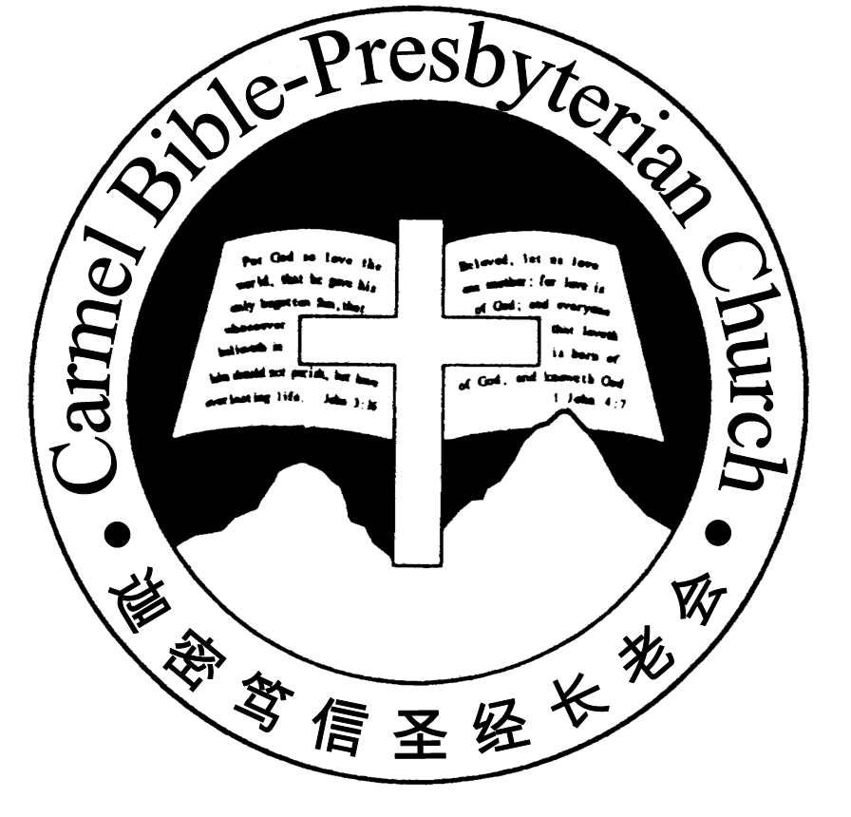
Carmel Bible-Presbyterian Church
Christ’s Love Brings Us Together

Theme for 2013/2014: Committed to Be Christlike

Vol. 16 No 9 | 2/3/14

Pastoral Chat IN REMEMBRANCE OF THE LORD

And [Jesus] took bread, gave thanks and broke it, and gave it to [the disciples], saying, “This is My body which is given for you; do this in remembrance of Me” (Luke 22:19)

The Lord Jesus spoke these words when he instituted the Lord’s Supper. He knows our tendency to forget; hence he adds: “do this in remembrance of Me.”

Everyone forgets at one time or another, according to Karen Bolla, a researcher at John Hopkins University. I came across this humorous story of a preacher’s lapses in memory told by Tony Nester. While on vacation in the Pocono mountains of Pennsylvania, a preacher visited a church. It was a hot summer day and folks were uncomfortable and perspiring in a non-air-conditioned sanctuary. The church’s preacher noticed his audience wasn’t paying too much attention to his sermon. To get their attention, he worked into his sermon these words: “The best years of my life have been spent in the arms of another man’s wife.”

Sure he captured their attention! The congregation let out a gasp and came to im-mediate attention. Then the preacher added, “It was my mother.” The congregation tittered al little and paid a bit more attention throughout the entire sermon.

The preacher who heard this while on vacation filed it away for later use. The next summer on when he noticed his own congregation seemed to be inattentive to his preaching, he decided to use what he had learned from the preacher last summer. So he said in a booming voice: “The best years of my life have been spent in the arms of another man’s wife.” Sure enough, he had their attention, every one of them! But the problem was his memory failed him at that moment. He couldn’t remember what came next. All he could think to say was, “…and…for the life of me, I can’t remember her name!”

Momentary lapses in memory can be funny, but the loss of memory is devastating. We witness this with sadness when our elderly folks suffer Dementia. Jesus is cer-tainly concerned about our memory of Him. The loss of memory for our Lord can lead to dire consequences of our spiritual walk. The history of the Israelites serves as a warning to us (Read Isaiah 51:12f). Hence the Lord, in caring for us, issued this command: “Do this in remembrance of Me.”

Remembering God isn’t restricted only to the observance of the Lord’s Supper. It goes much further. Not only do we keep in memory what the Lord has done for us by dying on the cross, but also of who He is. In the months leading to the Good Friday and Easter, we want you to have cherished memories of God in many ways—His providential care, His goodness, His deliverance, His guidance, His mercy and so forth.

Let’s echo with the psalmist King David who reminded himself: “Bless the LORD, O my soul; and all that is within me, bless His holy name! Bless the LORD, O my soul, and forget not all His benefits” (Ps. 103:1-2).—Pastor Peter
__________________________________________________________________________________________________________________________________

Prayer Items: Our Congregational Needs

- God’s strength and His all-sufficient grace for those who are recuperating from their illnesses.
- God’s grace and wisdom for the college and uni students as they begin another year of learning.

Duty Roster | Today 2/3/14 | Next Lord’s Day 9/3/14
Preacher | Pastor Peter Chng | Pastor Peter Chng
Interpreter | Dn Daniel Ong | --------
Worship Leader | Dn Thong Kok Fai | Pr Lawrence
Interpreter | Tony Hung | --------
Pianist | Joy Han | Andrew Chen
Praise Chorus | Steven Lee, Steven Tan | Dn Timothy Cheong
Lord’s Supper Assistants | Dn Teo Kok lay, Dn Lin Feng | ---------
AV | Vera Wang, Gavin Zou | Jonah Thong
Toddlers | Teacher: Wendy | Teacher: Wendy
Lower Junior | Teacher: Joyce Cheong  Assistant: -----------  Musician: Timothy Cheong | Teacher: Joyce Cheong  Assistant: Wendy  Musician: Joyce Cheong
Upper Junior | Teacher: Steven Lee | Teacher: Steven Lee
Welcomers | David & Sandy Hong | Gore Chen, Changying
Flower | Bonnie | Rose
Kitchen | Goodness Team  (Alex, Huiqing, Yanhong) | Faithfulness Team  (Dn Quanxi, Shuzhi, Gore)

Offerings |  | 23/02/14
General Fund |  | $1,793.70
Thanksgiving |  | $100.00
Mission Fund |  | $0.00
Camp Fund |  | $20.00 | To-date: $7,954.80
Building Fund |  | $550.00; $300.00 (#1061) | To-date:$278,333.78
Property Maintenance |  | $100.00 | To-date: $1,500.00
BF Interest-free Loan |  | $0.00 | To-date:$260,000
A love-gift envelope for Pastor Peter
Order of Worship
10.30am
Prelude | Pianist: Joy Han
Congregation | “The Lord is in His Holy Temple”
Call to Worship | Dn Thong Kok Fai; Interpreter: Tony Hung
Welcome & Greetings
握手问安
Praise Chorus | Steven Lee, Steven Tan
Invocation & Doxology* |  | *Congregation Standing
Responsive Reading |  | Psalm 65 (p.392)
Hymn of Response* |  | HOP 360 We Praise Thee, O God
Announcement | Dn Thong Kok Fai; Interpreter: Tony Hung
Pastoral Prayer | Pastor Peter Chng; Interpreter: Daniel Ong
Message | In Remembrance of Me…  “Remembering God’s Providence”  Genesis 22:1-14 (p.13)
Hymn of Preparation* |  | HOP 340 Leaning on the Everlasting Arms
Lord’s Supper |  | Assisted by Dns Teo Kok Lay & Lin Feng
Benediction* | Sing Threefold Amen after Benediction
You’re invited to join us in our lunch fellowship欢迎您会后留下与我们共享午餐

Sermon Outline: Remembering God’s Providence Gen 22:1-14

Remembering God’s providence provides help in two ways for our Christian walk.

- A deeper understanding of God
  - God demands our all in all
  - God is always in full control

- A constant exercise of our trust in God
2.1 Obeying rather than rationalizing
2.2 Nothing is impossible to God

We warmly welcome you to join us in worshipping the Lord. May God’s peace and joy be your portion. We invite all baptized believers to partake the Lord’s Supper with us in remembrance of our Lord.

