Ministries for this Week (23 Mar – 30Mar 2014)
We welcome you to join us in our weekly ministries:
- Sunday: 1 pm: Worship Workshop, Main Hall
2.45pm: Church Session Meeting, Library
- Wednesday: 10.30am: Tandara Aged Care
- Friday: 7.30pm: English Care-Group Meeting: Steven’s home, (32.
Godwin Ave., Manning).
- Saturday: 3:30pm: AF Meeting: Visitation, detail TBC.
- Sunday: 9.30am: BS & Prayer Meeting: The Epistle of 1 John, Library
10.30am: Mandarin Service: Main hall
English Service: Library
Children Ministry: Classrooms

Sharing With You

- Updating of membership record: Membership Form will be given out to you to update your personal particulars. Please see Mimi or Pr Lawrence for the form.
- BMC will continue to display our church development plan of the Forrestdale property after service during the month of March.
- Next Lord’s Day is our gospel Sunday. Please invite your loved ones and friends to our Sunday Service
- Easter Baptism, Reaffirmation of Faith, Child Baptism and Transfer of membership class will continue today after service in library. Those who are prepared, please let Pastor Peter know immediately and attend the class.
- Easter Combined Church Camp with Covenant BPC from 21-24 April 2014, Bayview Geographe, Resort, Busselton. The theme is “Forgetting what lies behind and straining forward to what lies ahead” (Philippians 3:13-14). The camp speakers are Rev David Yan for the English session, Rev Yeo Say Hock for the Mandarin session and Daniel and Tabitha for the Children Ministry. The camp fee for the adult, 13 yrs and above: $230; 12yrs and below: $190. The last day of registration is 30/3. You are encouraged to come for the camp and please see Dn Lin Feng or Tony for the registration form.
- Library is closed for the summer till further notice.

Worshipping at: Oberthur Pri. Sch., Nicholls Crescent., Bull Creek, WA 6149
Church Office: 6, Commercial Road, Forrestdale, WA 6112
Telephone: 08-9393-3515
Email: carmelbpc@iinet.net.au
Church Website: www.carmelwa.org.au
Pastors | Rev Peter Chng | Mobile: 0411-230-240
 | Rev Henry Tay | Telephone: 9414-6212
 | Preacher Lawrence Chan | Mobile: 0431-699-316

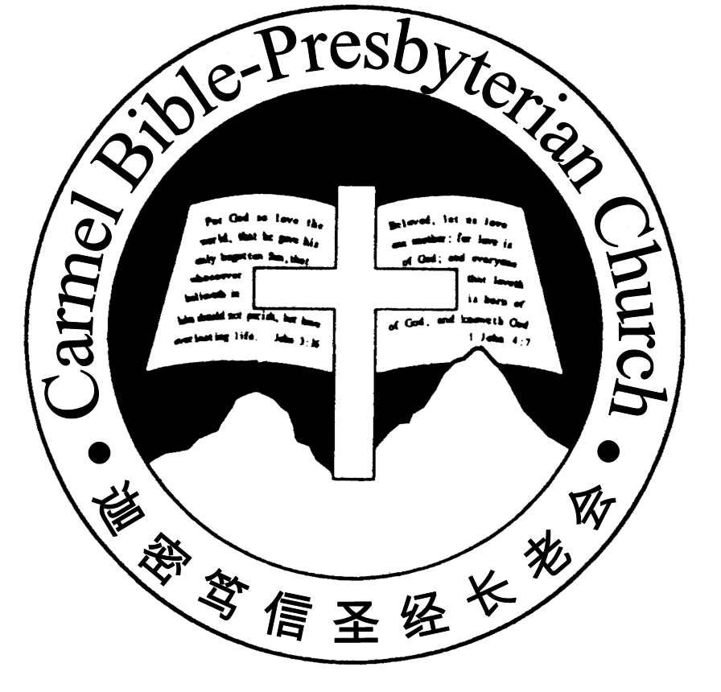
Carmel Bible-Presbyterian Church
Christ’s Love Brings Us Together

Theme for 2013/2014: Committed to Be Christlike

Vol. 16 No 12 | 23/3/14

Pastoral Chat He Leadeth Me.

Whenever I go to a foreign place, I would look for a local map. It will be my companion and guide to get me where I want to go. I may miss a place then I will ask the local for direction. This is because I know I need some guidance in a new place. It is pointless wandering around when there is help available to me.

We need guidance and direction to navigate through life. When we are the crossroads of our life, decisions have to be made. The inevitable leaps from one season of our life to next can be daunting – college to university, then to working life, singlehood to marriage then to parenthood, a strong and healthy body to a weakling and sickly body, career to retrenchment or retirement. They are streak with uncertainty and insecurity. We need guidance as such will have tremendous impact in our lives

When God called the Israelites out of slavery in Egypt, they were faced with the greatest challenge of their life. Though life was sickening in Egypt but going into the unknown was even more frightening. They had to trust their God-appointed leader, Moses to lead and guide them. With the hope of a better life in the Promised Land, they went forth.

‘And the Lord said: “I have surely seen the oppression of My people who are in Egypt, and have heard their cry because of their taskmasters, for I know their sorrows. So I have come down to deliver them out of the hand of the Egyptians, and to bring them up from that land to a good and large land, to a land flowing with milk and honey, to the place of the Canaanites… ’, (Exodus 3:7-8).

The basis of the Israelites was hope in God’s unfailing guidance. By His saving power, He promised to deliver them out the land of pains and sorrows. His presence would be with them throughout their journey out of Egypt to the wilderness into the Promised Land.

We do not know about tomorrow. We know that our life journey will not be always smooth going. Some days may be bright and sunny, other days may be cloudy and stormy. These are the test of our faith and challenge our resolve to remain steadfast in the Lord our Guide. Our path may be fraught with obstacles that can be overwhelming. There are times we may get overpower and become helpless. But knowing that we are finite and our strength is limited, we rest fully on God alone as our dependence and help. He is ever faithful and unfailing. He has given us the assurance of His daily guidance in every step of our life.

God sees our life and watches over us. He will continue to lead and guide us. The Lord assured the Israelites, “The Lord was going before them in a pillar of cloud by day to lead them on the way, and in a pillar of fire by night to give them light, that they might travel by day and by night. He did not take away the pillar of cloud by and day, nor the pillar of fire by night, from before the people” (Exodus 13:21-22).

We are safe in God who is our Shepherd. He will always be by our side, leading and guiding us through life until we reach the Promised Land. May we always lean and trust in Him, remembering that He will always be our constant Guide. Let Him be our comfort and encouragement – Preacher Lawrence

__________________________________________________________________________________________________________________________________

Prayer Items: The World and Our Nation
- God’s mercy and wisdom that the search teams involved to locate locating the aircraft MH370 since 8 march 14.
- God’s guidance and understanding for the Federal government to lead our nation wisely.

Duty Roster | Today 23/3/14 | Next Lord’s Day 30/3/14
Preacher | Pr Lawrence Chan | Pr Lawrence Chan
Worship Leader | Dn Thong Kok Fai | Steven Lee
Pianist | Andrew Chen | Grace Shao
Praise Chorus | Dn Timothy Cheong | Steven Lee
Offering Collection | Lo Chi Kou | Andrew Chen
AV | Gavin zou | Jonah Thong
Toddlers | Teacher: Mandy, Crystal | Teacher: Mandy, Crystal
Lower Junior | Teacher: Joyce Cheong  Assistant: ----------  Musician: Jessica Hong | Teacher: Joyce Cheong  Assistant: ----------  Musician: Timothy Cheong
Upper Junior | Teacher: Steven Lee | Teacher: ---------
Welcomers | Changing, Gavin | Huiqing, Jonah
Flower | Han Zhaohui | Lily Ying
Kitchen | Self-Control Team  (Yinglong, Guanglu, Tang Qiong, Mandy) | Love Team  (Dn Lin Feng, David, Haowen)

Offerings | 16/03/14
General Fund | $761.30
Thanksgiving | $0.00
Mission Fund | $0.00
Camp Fund | $40.00 |  |  | To-date: $8,134.80
Building Fund | $200.00 |  |  | To-date: $280,783.78
Property Maintenance | $0.00 |  |  | To-date: $1,500.00
BF Interest-free Loan | $0.00 |  |  | To-date: $260,000
A love-gift envelope for Dn Daniel Ong
Order of Worship
10.30am
Prelude |  | Pianist: Andrew Chen
Congregation |  | “The Lord is in His Holy Temple”
Call to Worship |  | Dn Thong Kok Fai
Welcome & Greetings
握手问安
Praise Chorus |  | Dn Timothy Cheong
Invocation & Doxology* |  |  | *Congregation Standing
Responsive Reading |  |  | Psalm 23 (p.376)
Hymn of Response* |  |  | HOP 22 Great is Thy Faithfulness
Offering |  | Lo Chi Kou
Offertory Prayer |  | Dn Thong Kok Fai
Junior will leave for their class
Announcement
Pastoral Prayer |  | Preacher Lawrence Chan
Message |  | In Remembrance of Me…  “Remembering God’s Guidance”  Exodus 13:17-22 (p.47)
Hymn of Reflection* |  |  | HOP 293 Guide Me, O Thou Great Jehovah
Benediction* |  | Sing Threefold Amen after Benediction
You’re invited to join us in our lunch fellowship欢迎您会后留下与我们共享午餐

Sermon Outline: Remembering God’s Guidance Ex. 13:17-22

By remembering God’s guidance will strengthen our faith in Him because:

1. Our God is Omniscient, vv17- 18
1a. He knows what is best for us
1b. He is protective of us

2. Our God is our Shepherd, vv 19-22
2a. He would not let us down
2b. He clearly shows us the way

We warmly welcome you to join us in worshipping the Lord. May God’s peace and joy be your portion.

