Ministries for this Week (30 Mar – 6 Apr 2014)
We welcome you to join us in our weekly ministries:
- Friday: 7.30pm: English Care-Group Meeting: Steven’s home, (32.
Godwin Ave., Manning).
- Saturday: 3:30pm: AF Meeting: Bible Study: “The Gospel of John,
Chapter 8”, (6 Commercial Rd, Forrestdale).
7.30pm: Elim Fellowship: Tang Qiong’s home, (54,
Hetherington Dr., Bull Creek)
YF Meeting, Dn Timothy’s home, (68, Rhonda Ave,
Willetton).
- Sunday: 9.30am: BS & Prayer Meeting: The Epistle of 1 John, Library
10.30am: Mandarin Service: Main hall
English Service: Library
Children Ministry: Classrooms

Sharing With You
- Next Lord’s Day is the Lord’s Supper Sunday. Let’s prepare our hearts as we come before His Table to partake the Lord’s Supper.
- Updating of membership record: Membership Form will be given out to you to update your personal particulars. Please see Mimi or Pr Lawrence for the form.
- BMC will continue to display our church development plan of the Forrestdale property after service during the month of March.
- Easter Baptism, Reaffirmation of Faith, Child Baptism and Transfer of membership class will continue today after service in library. Those who are prepared, please let Pastor Peter know immediately and attend the class.
- Easter Combined Church Camp with Covenant BPC from 21-24 April 2014, Bayview Geographe, Resort, Busselton. The theme is “Forgetting what lies behind and straining forward to what lies ahead” (Philippians 3:13-14). The camp speakers are Rev David Yan for the English session, Rev Yeo Say Hock for the Mandarin session and Daniel and Tabitha for the Children Ministry. The camp fee for the adult, 13 yrs and above: $230; 12yrs and below: $190. Today is the last day of registration for the camp. You are encouraged to come for the camp and please see Dn Lin Feng or Tony for the registration form.
- Library is closed for the summer till further notice.

Worshipping at: Oberthur Pri. Sch., Nicholls Crescent., Bull Creek, WA 6149
Church Office: 6, Commercial Road, Forrestdale, WA 6112
Telephone: 08-9393-3515
Email: carmelbpc@iinet.net.au
Church Website: www.carmelwa.org.au
Pastors | Rev Peter Chng | Mobile: 0411-230-240
 | Rev Henry Tay | Telephone: 9414-6212
 | Preacher Lawrence Chan | Mobile: 0431-699-316

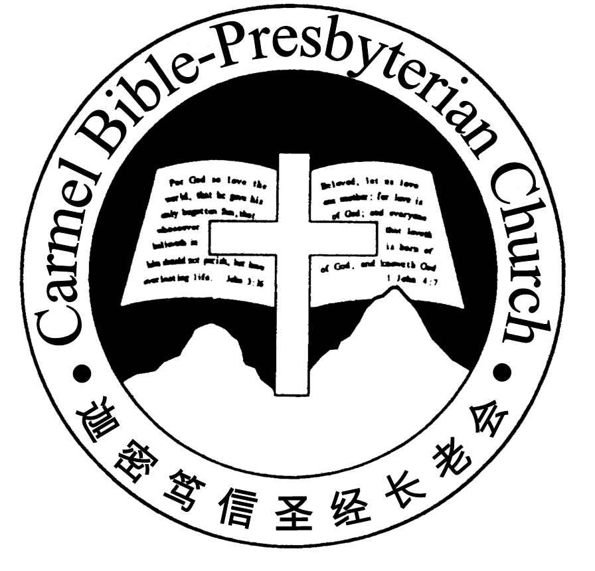
Carmel Bible-Presbyterian Church
Christ’s Love Brings Us Together

Theme for 2013/2014: Committed to Be Christlike

Vol. 16 No 13 | 30/3/14

Pastoral Chat In His mercy, God saved us

Yesterday can bring back to us fond memories of our past. They were sweet memories of comfort, wonder, and the joy of blessings that were showered upon our life. We recall God’s faithfulness and His gift of eternal life in His Son, Jesus Christ. We remember His mercy, the wonderful promise of peace and rest in Him as well as the assurance of His steadfast love and mercy. “The steadfast love of the Lord never ceases, His mercies never come to an end” (Lamentation 3:22).

Yesterday can also bring back haunting memories of our past. Some people find it difficult to move on because of their past. Sadly, they are gripped and nagged by the past as they cannot put it behind them. The sense of guilt lies deep in their heart that there is no peace and rest within. They are unable to let go or forgive themselves which impede them in life.

Memories are hard to delete, especially the unpleasant ones. The guilt of sins is like an invisible chain that imprisons us. This chain keeps us back that we cannot progress but makes us stagnant and ineffective. But God, in His mercy, has assured us of the forgiveness of our sin. Daniel says, “To the Lord our God belong compassion (mercy) and forgiveness, though we have rebelled against Him” (Daniel 9:9).

God, who created all things, desires that man who is His created being, to find peace and fellowship in Him. He gives man hope that he can rest in His mercy and forgiveness of sin. We have our shortfalls but not beyond the redemption of God. We are worthy of His loving-kindness. He seeks us that we may live a full life in the Lord Jesus Christ. By His mercy, He redeems and saves us from the eternal damnation.

Many are seeking for inner peace and rest. Many let past to be their stumbling blocks in life. Our past will either hold us back or be a stepping stone for us to move forward. We can let go and find mercy and rest in the true living God. Be encouraged that we can move forward without any baggage because there is a gracious and merciful God. He is a forgiving God who cleanses us of our past by shedding the precious blood of His Son Jesus Christ on the Cross. His blood covers all our sins and makes us whole again.

However, within our hearts, there is always yearning for mercy and forgiveness. There is a deep hunger for something to fill the void within us. Augustine of Hippo, who in his desperation to find fulfilment in life, indulged in excessive pleasures of the world, false religions, and etc, says “Our hearts are restless, until we find rest in you”. Our many attempts to find the rest is futile till our hearts find rest in God Himself.

Let’s come to Jesus and find in Him forgiveness and rest. May you come to Him and trust fully in His promise of salvation. Jesus, with these comforting words, is calling us, “I have blotted out, like a thick cloud, your transgression, and like a cloud, your sins. Return to Me, for I have redeemed you” (Isaiah 44:22). - Preacher Lawrence

____________________________________________________________________________________________________________________________________

Prayer Items:
- God’s grace and strength for the loved ones and friends of missing aircraft MH 370, that He will sustain them through this ordeal of waiting.
- God’s mercy and wisdom for our Christian politicians in the Federal Government to stand firm in their faith and for the truth of the Gospel.

Duty Roster | Today 30/3/14 | Next Lord’s Day 6/4/14
Preacher | Pr Lawrence Chan | Pastor Peter Chng
Worship Leader | Steven Lee | Pr Lawrence Chan
Pianist | Andrew Chen | Joy Han
Praise Chorus | Steven Lee | Dn Thong Kok Fai
Offering Collection | Gavin Zou | Andrew Chen
AV | Jonah Thong | Gavin Zou
Toddlers | Teacher: Mandy, Crystal | Teacher: Mandy, Crystal
Lower Junior | Teacher: Joyce Cheong  Assistant: ----------  Musician: Dn Timothy | Teacher: Joyce Cheong  Assistant: ---------  Musician: Dn Timothy
Upper Junior | Teacher: --------- | Teacher: Steven Lee
Welcomers | Huiqing, Jonah | David, Sandy
Flower | Lily Ying | Rose Cheong
Kitchen | Love Team  (Dn Lin Feng, David, Haowen) | Joy Team  (Sandy, Emma, Lumeng, Chanying, )

Offerings | 23/03/14
General Fund | $789.25
Thanksgiving | $40.00
Mission Fund | $0.00
Camp Fund | $20.00 |  |  | To-date: $8,154.80
Building Fund | $250.00 |  |  | To-date: $281,033.78
Property Maintenance | $0.00 |  |  | To-date: $1,500.00
BF Interest-free Loan | $0.00 |  |  | To-date: $260,000
Order of Worship
10.30am
Prelude |  | Pianist: Andrew Chen  Chen
Congregation |  | “The Lord Is in His Holy Temple”
Call to Worship |  | Steven Lee
Welcome & Greetings
握手问安
Praise Chorus |  | Steven Lee
Invocation & Doxology* |  |  | *Congregation Standing
Responsive Reading |  |  | Psalm 89:1-18 (p.404)
Hymn of Response* |  |  | HOP 28 I Sing the Mighty Power of God
Offering |  | Gavin Zou
Offertory Prayer |  | Steven Lee
Announcement
Pastoral Prayer |  | Preacher Lawrence Chan
Message |  | In Remembrance of Me…  “Remembering God’s Mercy”  Numbers 21:4-9; 9 (p.109)
Hymn of Reflection* |  |  | HOP 233 Like a River Glorious
Benediction* |  | Sing Threefold Amen after Benediction
You’re invited to join us in our lunch fellowship欢迎您会后留下与我们共享午餐

Sermon Outline:

Remembering God’s Mercy Numbers 21:4-9; John 3:14-15

To remember God’s mercy is to recognise our unfulfilling needs and only Jesus can satisfy our needs

- Our unfulfilling needs, Num 21:4-5
1a. There is always a desire for more
1b. Materials things are unable to satisfy us

- Only Jesus can satisfy our needs, Num 21:6-9; John 3:14-15
2a. God’s gracious provision
2b. Promise of spiritual life

We warmly welcome you to join us in worshipping the Lord. May God’s peace and joy be your portion.

