Ministries for this Week (6 Apr – 13 Apr 2014)
We welcome you to join us in our weekly ministries:
- Friday: 7.30pm: English Care-Group Meeting: Steven’s home, (32.
Godwin Ave., Manning).
- Saturday: 3:30pm: AF Meeting: WCF: “Of Creation”,
(6 Commercial Rd, Forrestdale).
- Sunday: 9.30am: BS & Prayer Meeting: The Epistle of 1 John, Library
10.30am: Mandarin Service: Main hall
English Service: Library
Children Ministry: Classrooms

Sharing With You
- Today is our Lord’s Supper Sunday. Let us prepare our hearts as we come before His Table to partake the Lord’s Supper.
- Updating of membership record: Membership Form will be given out to you to update your personal particulars. Please see Mimi or Pr Lawrence for the form.
- Good Friday Combined Service, 18 April, 10.30am. Note: There will be no fellowship lunch.
- Easter Baptismal Combined Service, 20 April, 10am. Note: There will no Bible Class.
- Easter Baptism, Reaffirmation of Faith, Child Baptism and Transfer of membership class will continue today after service in library. Those who are prepared, please let Pastor Peter know immediately and attend the class.
- Easter Combined Church Camp with Covenant BPC from 21-24 April 2014, Bayview Geographe, Resort, Busselton. The theme is “Forgetting what lies behind and straining forward to what lies ahead” (Philippians 3:13-14). The camp speakers are Rev David Yan for the English session, Rev Yeo Say Hock for the Mandarin session and Daniel and Tabitha for the Children Ministry. Camp registration is still open to those who are interested in going to the camp. Please Dn Lin Feng concerning the camp fee.
- Library is closed for the summer till further notice.

Worshipping at: Oberthur Pri. Sch., Nicholls Crescent., Bull Creek, WA 6149
Church Office: 6, Commercial Road, Forrestdale, WA 6112
Telephone: 08-9393-3515
Email: carmelbpc@iinet.net.au
Church Website: www.carmelwa.org.au
Pastors | Rev Peter Chng | Mobile: 0411-230-240
 | Rev Henry Tay | Telephone: 9414-6212
 | Preacher Lawrence Chan | Mobile: 0431-699-316

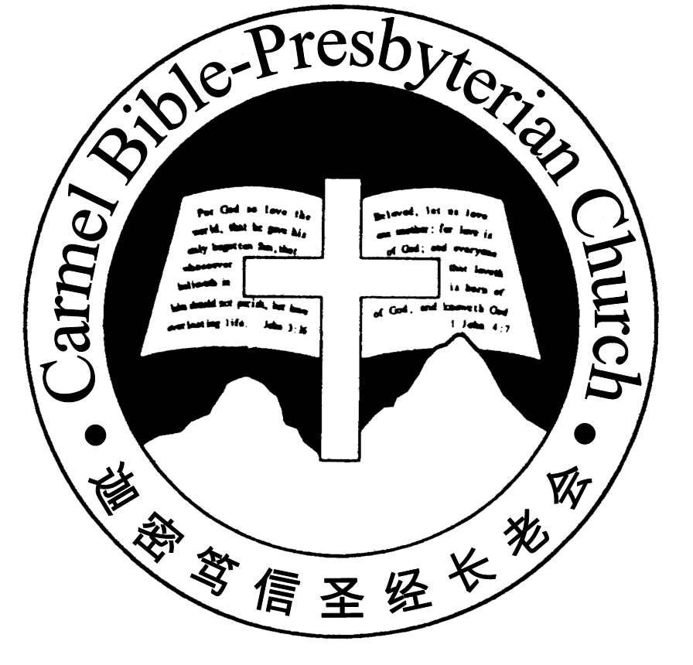
Carmel Bible-Presbyterian Church
Christ’s Love Brings Us Together

Theme for 2013/2014: Committed to Be Christlike

Vol. 16 No 14 | 6/4/14

Pastoral Chat OUR LORD’S AGONY AT GETHSEMANE

Reflecting on Jesus’ prayer at Gethsemane, the Gospel writer Luke recorded, “And being in agony, [Jesus] prayed more earnestly. And His sweat became like great drops of blood falling down to the ground” (Lk. 22:44).

According to Vine’s Complete Expository Dictionary of New Testament Words, the word translated “agony” in the Bible comes from the Greek word that had its origin as “a place of assembly” then for the contests and games which took place there. It was eventually used frequently to denote severe emotional strain and anguish. Our Lord was going through severe emotional strain and anguish at Gethsemane.

Being a physician, it would be natural for Luke to inquire and record a medical phe-nomenon known as hematidrosis: “And His sweat became like great drops of blood falling down to the ground.” Bible Commentator William Hendriksen expounds, “It must be borne in mind that the human nature of Jesus was sinless, and therefore very sensitive. When these factors—extreme anguish, earnest supplication, unpa-ralleled sensitivity—are combined, the resulting strain can easily cause subcuta-neous capillaries to dilate to such an extent that they will burst. And when this happens, as it is almost bound to do, in the vicinity of the sweat glands, blood and sweat will be exuded together. This can happen over a large part of the body. The thick drops or clots of blood, imparting a reddish colour to the beads of perspi-ration, will then trickle down to the ground.” That was the extent of the agony our Lord experienced when He had that deep conversation with the Father!

Although the word translated “agony,”—emotional strain and anguish—was used in association with anxiety and worry, it was obviously not our Lord had. He knew that He came to earth for the purpose of being “the (sacrificial) Lamb of God who takes away the sin of the world” (Jn. 1:29). “Throughout this fiery ordeal Jesus never, even for a moment, crossed the boundary line between fear and sin,” Hendriksen asserts. “Though [Jesus] was a Son, yet He learned obedience by the things which He suffered” (Heb. 5:8). It must be borne in mind that the agony that brought about this phenomenon was for all of us.

About 700 years before Jesus’ crucifixion, Isaiah prophesised, “He is despised and rejected by men, a Man of sorrow and acquainted with grief….Surely He has borne our griefs and carried our sorrows;…He was wounded for our transgression, He was bruised for our iniquities; the chastisement for our peace was upon Him. And by His stripes we are healed” (Isa. 53:3-5).

During the weeks leading to Good Friday, we will hear the classic oratorio Messiah composed in 1741 by George Frideric Handel. Musical Anecdotes carries a short story about Handel during the time he composed this oratorio. An intimate friend called on him just as he was in the middle of setting the words of “He was des-pised” to music, and found the great composer sobbing with tears. So great an impact was that passage had on the great composer. What about us?

Let’s take time to ponder our Lord’s agony leading to His death on the cross for us. His agony is for you and for me, lest we forget Gethsemane.—Pastor Peter

____________________________________________________________________________________________________________________________________

Prayer Items:
- God’s grace and protection for brethren who are studying in the Eastern States - Chi Keong (Melbourne), Jocelyn (Sydney) and Lily (Brisbane).
- God’s mercy and guidance for brethren who are now out of job because of our nation economy situation

Duty Roster | Today 6/4/14 | Next Lord’s Day 13/4/14
Preacher | Pastor Peter Chng | Pastor Peter Chng
Worship Leader | Pr Lawrence Chan | Dn Thong Kok Fai
Pianist | Joy Han | Andrew Chen
Praise Chorus | Dn Thong Kok Fai | Dn Timothy Cheong
Offering Collection | Andrew Chen | Jonah Thong
AV | Gavin Zou | Lo Chi Gou
Toddlers | Teacher: Mandy, Crystal | Teacher: Mandy, Crystal
Lower Junior | Teacher: Joyce Cheong  Assistant: ---------  Musician: Dn Timothy | Teacher: Joyce Cheong  Assistant: Clifford Lee  Musician: Clifford Lee
Upper Junior | Teacher: Steven Lee | Teacher: Steven Lee
Welcomers | David, Sandy | Yinglong, Shuzhi
Flower | Rose Cheong | Changying
Kitchen | Joy Team  (Sandy, Emma, Lumeng, Changying, ) | Peace Team  (Xiaohong, Yueying, Zhengxin )

Offerings | 30/03/14
General Fund | $1,063.60
Thanksgiving | $20.00
Mission Fund | $0.00
Camp Fund | $20.00 |  |  | To-date: $8,174.80
Building Fund | $50.00; $300.00 (#1103) |  |  | To-date: $281,383.78
Property Maintenance | $0.00 |  |  | To-date: $1,500.00
BF Interest-free Loan | $0.00 |  |  | To-date: $260,000
Order of Worship
10.30am
Prelude |  | Pianist: Joy Han  Chen
Congregation |  | “The Lord Is in His Holy Temple”
Call to Worship |  | Pr Lawrence Chan
Welcome & Greetings
握手问安
Praise Chorus |  | Dn Thong Kok Fai
Invocation & Doxology* |  |  | *Congregation Standing
Responsive Reading |  |  | Psalm 20 (p.375)
Hymn of Response* |  |  | HOP 219 ‘Tis so Sweet to Trust in Jesus
Offering |  | Andrew Chen
Offertory Prayer |  | Pr Lawrence Chan
Announcement
Pastoral Prayer |  | Pastor Peter Chng
Message |  | In Remembrance of Me…  “Remembering Jesus’ Agony”  Matthew 26:36-46 (p.670)
Hymn of Preparation* |  |  | HOP 96 Lead Me to Calvary
Lord’s Supper |  |  | Assisted by Pr Lawrence Chan
Benediction* |  | Sing Threefold Amen after Benediction
You’re invited to join us in our lunch fellowship欢迎您会后留下与我们共享午餐

Sermon Outline: Remembering God’s Mercy Mt 26:36-46

There are two points to ponder as we remember Jesus’ agony.

1 Jesus’ agonising was excruciating
1.1 Suffering the deep pain of total isolation
1.2 Bearing the sin of the whole world

2 Jesus’ handling of His agony
2.1 Submitting wholeheartedly to the Father
2.2 Loving us even to the very end

We warmly welcome you to join us in worshipping the Lord. May God’s peace and joy be your portion. We invite all baptized believers to partake the Lord’s Supper with us in remembrance of our Lord.

