Ministries for this Week (13 Apr – 20 Apr 2014)
We welcome you to join us in our weekly ministries:
- Friday: 10.30am: Good Friday Combined Service: Main Hall
No Care-Group Meeting
- Saturday: 3.30pm: AF Meeting: Difficult Biblical Questions & Passages,
(6 Commercial Rd, Forrestdale).
7.30pm: Elim Fellowship & YF: No meeting
- Sunday: 9:30am: No SBC/ Prayer Meeting
10am: Easter Combined Baptismal Service: Main Hall
Children Ministry: Classrooms

Sharing With You
- Congratulations to Mr & Mrs Yu Changjun for the gift of a baby boy, William Yu on the 6 April 14. We rejoice with the family. Thank God that both the mother and child are doing well.
- Good Friday Combined Service, 10.30am. Lord’s Supper will be observed. Let us come prepared with our heart and mind to partake of the Lord’s Supper. Note: There will be no fellowship lunch.
- Easter Baptismal Combined Service, 20 April, 10am. There will 3 adult baptisms, 1 infant baptism and 3 reaffirmation of faith. Note: There will no Bible Class.
- Updating of membership record: Membership Form will be given out to you to update your personal particulars. Please see Mimi or Pr Lawrence for the form.
- Easter Combined Church Camp with Covenant BPC from 21-24 April 2014, Bayview Geographe, Resort, Busselton. There will be a Camp briefing for all campers after the service today at the Main Hall.
All campers are to gather at Oberthur Primary School Car-park, 21/4, 9.30am.
- Library is closed till further notice.

Worshipping at: Oberthur Pri. Sch., Nicholls Crescent., Bull Creek, WA 6149
Church Office: 6, Commercial Road, Forrestdale, WA 6112
Telephone: 08-9393-3515
Email: carmelbpc@iinet.net.au
Church Website: www.carmelwa.org.au
Pastors | Rev Peter Chng | Mobile: 0411-230-240
 | Rev Henry Tay | Telephone: 9414-6212
 | Preacher Lawrence Chan | Mobile: 0431-699-316

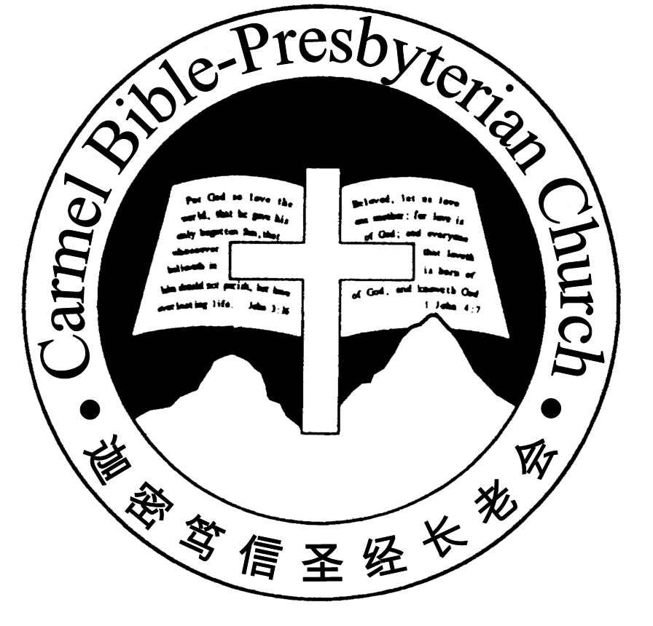
Carmel Bible-Presbyterian Church
Christ’s Love Brings Us Together

Theme for 2013/2014: Committed to Be Christlike

Vol. 16 No 15 | 13/4/14

Pastoral Chat NO GREATER LOVE

“Greater love has no one than this, than to lay down one’s life for his friends. You are my friends if you do whatever I command you” (John 15:13-14)

The above were part of the parting words by the Lord Jesus to His disciples. In it, He issued a new commandment for them to love one another. And these words have to be understood with the preceding verse when the Lord Jesus said, "This is my commandment, that you love one another as I have loved you" (v.12).

When Jesus commanded the disciples to love one another, He set them a bench-mark, and that benchmark was the extent of His love for them. How much did He loved the disciples and His children today? Jesus loved them to the extent that He laid down His own life for His friends--those who do whatever He commands. Hence, it's little wonder for Jesus to express "greater love has no one than this."

For my finite mind, I couldn't fathom the extent of the Lord's love. The Second Per-son of the Trinity, equal to God the Father in all His essence, could humble Himself to become like you and me. More than that, because of our sins, Jesus willingly obeyed the will of the Father, and suffered the excruciating death on the cross. No greater love am I able to find in this world.

Not only did Jesus express that matchless love for us, God the Father did that as well. "For God so loved the world that He gave His only begotten Son, that who-ever believes in Him should not perish but have everlasting life" (Jn. 3:16).

A story is told in Sunday School Times of a preaching on John 3:16. Peter Mac-kenzie, a Methodist preacher of a generation ago, living in England, preached an early sermon from John 3:16. Gypsy Smith tells us that the preacher, after announ-cing the text, said, "There are two striking things in my text: When God loves, He loves a world. When He gives, He gives His Son." Such is the boundless love of the eternal Father of mankind.

In another short story in Ministers' Research Service, a woman, attending one of Dr. Walter Wilson's meetings, waited after the service for spiritual help. When Dr. Wilson asked her if she could quote any Bible passage, she replied that she had once learned John 3:16 in Sunday School. She recited, "For God so loved the world that He gave His only forgotten Son, that whosoever believeth in Him should not perish but have everlasting life." Noticing that she had said "forgotten" for "be-gotten," Dr. Wilson said, "Do you know why God forgot His Son?" She answered, "No, I don't." And he said, "It was because he wanted to remember you." Then Dr. Wilson led her to a saving knowledge of Christ as Saviour.

"God forgot His Son because He wanted to remember us." What a sobering thought! We know that God would neither forget His Son nor forsake Him. But be-cause of His love for mankind, God was willing to part with the Son, in a way to forget Him, and sent Him to be with us and to be the Lamb of God to take away the sin of the world.

As we approach the Passion Week, let's take time to remember God, to remember His matchless love for each one of us.—Pastor Peter
____________________________________________________________________________________________________________________________________

Prayer Items: Our Ministry needs
- God’s protection and blessing for the Camp speakers and campers that we have a wonderful time of learning and fellowshipping with one another.
- God’s grace and mercy that the brethren will have a meaningful and joyous Good Friday and Easter Services.
Duty Roster | Today 13/4/14 | Good Friday 18/4/14
Preacher | Pastor Peter Chng | Pastor Henry Tay
Interpreter |  | Dn Daniel Ong
Worship Leader | Dn Thong Kok Fai | Dn Thong Kok Fai
Interpreter |  | Ricky Wong
Pianist | Andrew Chen | Joy Han
Praise Chorus | Dn Timothy Cheong | Tony Hung
Offering Collection | Jonah Thong
AV | Lo Chi Gou | Vera Wang
Lord’s Supper Assistants |  | Dn Shao Quanxi,  Dn Timothy Cheong
Toddlers | Teacher: Mandy, Crystal | Teacher: Mandy, Crystal
Lower Junior | Teacher: Joyce Cheong  Assistant: Clifford Lee  Musician: Clifford Lee | Teacher: Joyce Cheong  Assistant: Mandy  Musician: Joyce Cheong
Upper Junior | Teacher: Steven Lee
Welcomers | Yinglong, Shuzhi | Huiqing, Gore Chen
Flower | Changying | Mrs Gao
Kitchen | Peace Team  (Xiaohong, Yueying, Zhengxin )

Offerings | 6/04/14
General Fund | $2,620.65
Thanksgiving | $20.00
Mission Fund | $0.00
Camp Fund | $0.00 |  |  | To-date: $8,174.80
Building Fund | $750; $200.00 (#1045) |  |  | To-date: $282,333.78
Property Maintenance | $0.00 |  |  | To-date: $1,500.00
BF Interest-free Loan | $0.00 |  |  | To-date: $260,000
Two love-gift envelopes for Pastor Tay
Order of Worship
10.30am
Prelude |  | Pianist: Andrew Chen  Chen
Congregation |  | “The Lord Is in His Holy Temple”
Call to Worship |  | Dn Thong Kok Fai
Welcome & Greetings
握手问安
Praise Chorus |  | Dn Timothy Cheong
Invocation & Doxology* |  |  | *Congregation Standing
Responsive Reading |  |  | Psalm 21 (p.375)
Hymn of Response* |  |  | HOP 46 Our Great Saviour
Offering |  | Jonah Thong
Offertory Prayer |  | Dn Thong Kok Fai
Juniors leave for their Class
Announcement
Pastoral Prayer |  | Pastor Peter Chng
Message |  | In Remembrance of Me…  “Remembering Jesus’ Matchless Love”  Matthew 26:47-56 (p.670)
Hymn of Reflection* |  |  | HOP 389 My Jesus I Love Thee
Benediction* |  | Sing Threefold Amen after Benediction
You’re invited to join us in our lunch fellowship欢迎您会后留下与我们共享午餐

Sermon Outline:

Remembering Jesus’ Matchless Love Mt 26:47-56

Jesus’ matchless love is witnessed from the way He handled the dire situation of His arrest.

1 It was within Jesus’ power to save Himself
1.1 Escape was possible with His foreknowledge
1.2 Jesus could again summon for heavenly aid

2 Jesus gave sinners a chance to repent
2.1 To Judas—the betraying disciple
2.2 To the multitudes who bore hatred for Him

We warmly welcome you to join us in worshipping the Lord. May God’s peace and joy be your portion.

