Ministries for this Week (18 Apr – 20 Apr 2014)
We welcome you to join us in our weekly ministries:
- Friday: 10.30am: Good Friday Combined Service: Main Hall
7.30pm: No Care-Group Meeting
- Saturday: 3.30pm: AF Meeting: Difficult Biblical Questions & Passages,
(6 Commercial Rd, Forrestdale).
7.30pm: Elim Fellowship & YF: No meeting
- Sunday: 9:30am: No SBC/ Prayer Meeting
10am: Easter Combined Baptismal Service: Main Hall
Children Ministry: Classrooms

Sharing With You
- Lord’s Supper will be observed this morning. Let us prepare our heart and mind to partake the Lord’s Supper. Note: There will be no fellowship lunch today.
- Easter Baptismal Combined Service, 20/4. 10am. (Please note the change of time).
Baptismal Candidates:
Yang Fan, Fred Yang Feng, Yu Changjun & Crystal Xu Meng (adult baptism). Andrew Chen, Jonah Thong Jing & Gavin Zou (reaffirmation of faith).
Kristy LIzi Shang, daughter of Mr & Mrs Shang Weili (infant baptism).
- Updating of membership record: Membership Form will be given out to you to update your personal particulars. Please see Mimi or Pr Lawrence for the form.
- Easter Combined Church Camp with Covenant BPC from 21-24 April 2014, Bayview Geographe, Resort, Busselton. There will be a Camp briefing for all campers after the Easter Sunday Service at the Main Hall.
All campers are to gather at Oberthur Primary School Car-park, 21/4, 9.30am.
- Library is closed till further notice.

Worshipping at: Oberthur Pri. Sch., Nicholls Crescent., Bull Creek, WA 6149
Church Office: 6, Commercial Road, Forrestdale, WA 6112
Telephone: 08-9393-3515
Email: carmelbpc@iinet.net.au
Church Website: www.carmelwa.org.au
Pastors | Rev Peter Chng | Mobile: 0411-230-240
 | Rev Henry Tay | Telephone: 9414-6212
 | Preacher Lawrence Chan | Mobile: 0431-699-316

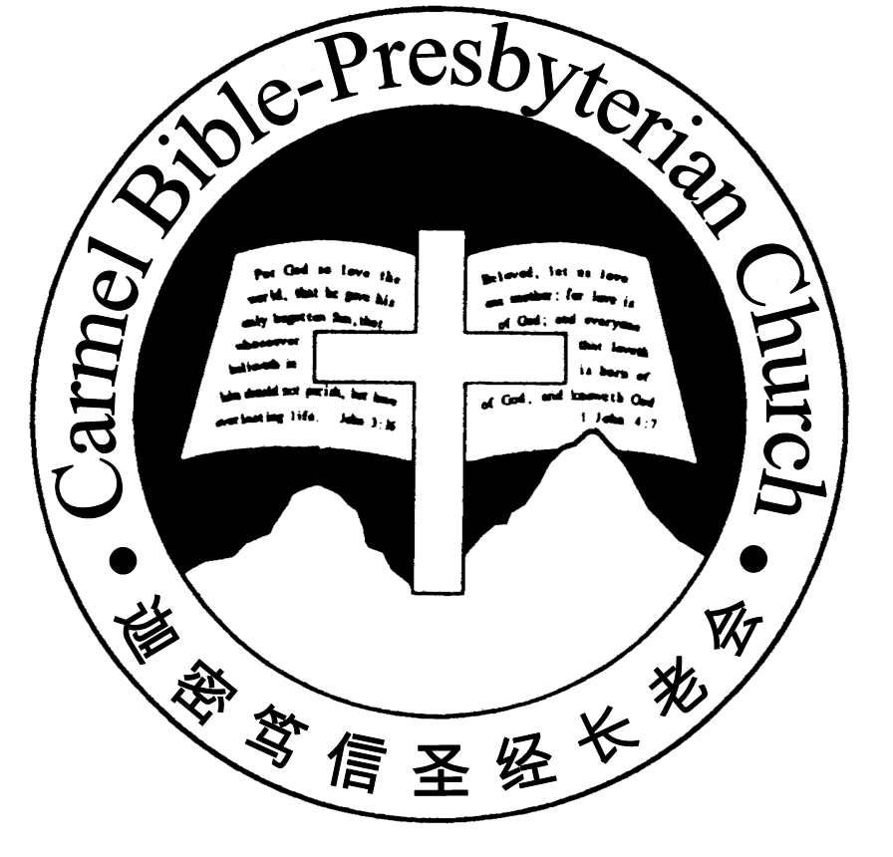
Carmel Bible-Presbyterian Church
Christ’s Love Brings Us Together

Theme for 2013/2014: Committed to Be Christlike

Good Friday Edition | 18/4/14

Pastoral Chat Remembering Jesus’ Death at Calvary

Now it was about the sixth hour, and there was darkness over all the earth until the ninth hour. Then the sun was darkened, and the veil of the temple was torn in two. So when the centurion saw what had happened, he glorified God, saying, “Certain-ly this was a righteous Man!” Luke (23:44-47).

The Gospel of Luke depicts a grim and ghastly scene at Golgotha. A sinless man was crucified. Jesus was made to suffer an excruciating and brutal death. The world was covered in total darkness for three hours in the middle of the day. How strange and unusual! There were earthquakes and the graves were opened, accompanied by the raising of the dead.

Jesus was put on trial before Pilate in the presence of the chief priests, the rulers and the people. And to this crowd, Pilate said to them, “You have brought this Man to me, as one who misleads the people. And indeed, having examined Him in your presence, I have found no fault in this Man concerning those things of which you accuse Him; no, neither did Herod, for I sent you back to him; and indeed nothing deserving of death has been done by Him” (Luke 23:14-15).

The Son of God and Messiah were condemned unjustly to be hanged on the tree. This method of execution was reserved only for the worst criminal and non-Roman citizens. It must have been a heart-breaking blow to His disciples. All was lost and hopeless and they deserted Him, even His heavenly Father. Jesus cried out with a loud voice, “My God, My God, why have You forsaken Me?” (Matthew 27:46). Our Lord and Saviour Jesus Christ had suffered a gruesome and lonely death.

Jesus’ disciples did not anticipate that their Master would come to such a dreadful end. Unprepared for life without their leader, they sank into sadness and despair. Days ahead were dreary and uncertain. Like lost sheep, they were now scattered and aimless, wondering where they would go from here. They failed to understand the meaning of Jesus’ death.

Today is Good Friday and is a very sombre day. It was the darkest day in the history of man. But God’s sacrificial love of His only begotten Son made it the greatest victory for man. Jesus was sacrificed on the Cross for the sake of man. Our sin killed an innocent Man, the Son of God. Jesus was wounded for our transgression. Sin has inflicted a grievous punishment on our Saviour. He bore the sin penalty for us. He died to satisfy the wrath of God, and to redeem us from the damnation of eternal punishment.

The Cross boldly declares both God’s love and God’s wrath. Like a double-edged sword, the Cross could either save us or reproach us. Will we examine what the Cross means to us this Good Friday? God reveals His amazing grace as well as our eternal hope in the saving death of Jesus on Calvary.

Hymn writer Isaac Watts says, “When I survey the wondrous Cross on which the prince of glory died, my richest gain I count but loss, and pour contempt on all my pride. Were the whole realm of nature mine, that were a present far too small. Love is so amazing, so divine, demands my soul, my life, my all”.

The Cross is a challenge to our walk in the Lord as His true disciples. It reminds us of our willingness to obey and submit to His will. If we claim Jesus to be the Son of God, our Lord and Saviour; if we truly believe He laid down His life to deliver us from condemnation, then He should be always the object of our commitment and love. May the remembrance of the Passion Week be meaningful and sweet to each one of us. – Pr Lawrence Chan
___________________________________________________________________________________________________________________________________

Prayer Items:

Duty Roster | Good Friday 18/4/14 | Easter 20/4/14
Preacher | Pastor Henry Tay | Pastor Peter Chng
Interpreter | Dn Daniel Ong | Nathan Teo
Worship Leader | Dn Thong Kok Fai | Dn Timothy Cheong
Interpreter | Ricky Wong | Tony Hung
Pianist | Joy Han | Grace Shao
Praise Chorus | Tony Hung | Steven Lee, Steven Tan
Offering Collection | --------- | ----------
AV | Vera Wang | Ricky Wong
Lord’s Supper Assistants | Dn Shao Quanxi,  Dn Timothy Cheong
Toddlers | Teacher: Mandy, Crystal | Teacher: Mandy, Crystal
Lower Junior | Teacher: Joyce Cheong  Assistant: Mandy  Musician: Joyce Cheong | Teacher: Joyce Cheong  Assistant: Shuie Chen  Musician: Joyce Cheong
Upper Junior | --------- | ----------
Welcomers | Huiqing, Gore Chen | Gore Chen, Changying
Flower | Mrs Gao | Michelle
Kitchen | ---------- | Patience Team  (Jsaon, Tony, Vera)

Offerings | 13/04/14
General Fund | $1,488.35
Thanksgiving | $20.00
Mission Fund | $0.00
Camp Fund | 40.00 |  |  | To-date: $8,214.80
Building Fund | $50.00; $600.00 (#1033); $2,300.00 (#1061); $700.00 (1072) |  |  | To-date: $285,983.78
Property Maintenance | $0.00 |  |  | To-date: $1,500.00
BF Interest-free Loan | $0.00 |  |  | To-date: $260,000.00
Order of Worship
10.30am

Prelude |  | Pianist: Joy Han  Chen
Congregation |  | “The Lord Is in His Holy Temple”
Call to Worship |  | Dn Thong Kok Fai; Interpreter: Ricky Wong
Welcome & Greetings
握手问安
Praise Chorus |  | Tony Hung
Invocation & Doxology* |  |  | *Congregation Standing
Responsive Reading |  |  | Isaiah 53 (p.496)
Hymn of Response* |  |  | HOP 100 The Old Rugged Cross
Announcement |  | Dn Thong Kok Fai; Interpreter: Ricky Wong
Pastoral Prayer |  | Pastor Henry Tay; Interpreter: Dn Daniel Ong
Message |  | In Remembrance of Me…  “Jesus on the Cross”  1 Corinthians 2:2 (p.768)
Hymn of Preparation* |  |  | HOP 99 When I Survey the Wondrous Cross
Lord’s Supper Assistants |  |  | Dn Shao Quanxi, Dn Timothy Cheong
Benediction欢迎您会 Sing Threefold Amen after Benediction

Sermon Outline:

Jesus on the Cross 1 Corinthians 2:2

- Response of the world to the Cross

- Paul’s perception of the Cross

3. Revelation of OT’s vision of the Cross

We warmly welcome you to join us in worshipping the Lord. May God’s peace and joy be your portion. We invite all baptized believers to partake the Lord’s Supper with us in remembrance of our Lord.

