Ministries for this Week (27Apr – 4 May 2014)
We welcome you to join us in our weekly ministries:
- Sunday: 2.30pm: Church Session Meeting - Postponed
- Wednesday: 10.30am: Tandara Aged Care
- Friday: 7.30pm: English Care-Group Meeting: Steven’s home, (32.
Godwin Ave., Manning).
- Saturday: 3.30pm: AF Meeting: Bible Study: “The Gospel of John”,
(6 Commercial Rd, Forrestdale).
7.30pm: Elim Fellowship, Tang Qiong’s home, (54 Hetherington
Dr., Bull Creek)
YF: Dn Timothy’s home, (68, Rhonda Ave, Willetton).
- Sunday: 9:30am: SBC/ Prayer Meeting: Library
10.30am: Mandarin Service: Main Hall
English Service: Library
Children Ministry: Classrooms

Sharing With You
- Praise God for the blessed time of learning and fellowshipping with brethren from Covenant BPC during the Easter Combined Church Camp at Busselton.
- Next Lord’s Day is the Lord’s Supper Sunday. Let’s prepare our hearts as we come before His Table to partake the Lord’s Supper.
- Updating of membership record: Membership Form has been given out to you to update your personal particulars. Please see Mimi or Pr Lawrence for the form.
- Library is closed till further notice.

Worshipping at: Oberthur Pri. Sch., Nicholls Crescent., Bull Creek, WA 6149
Church Office: 6, Commercial Road, Forrestdale, WA 6112
Telephone: 08-9393-3515
Email: carmelbpc@iinet.net.au
Church Website: www.carmelwa.org.au
Pastors | Rev Peter Chng | Mobile: 0411-230-240
 | Rev Henry Tay | Telephone: 9414-6212
 | Preacher Lawrence Chan | Mobile: 0431-699-316

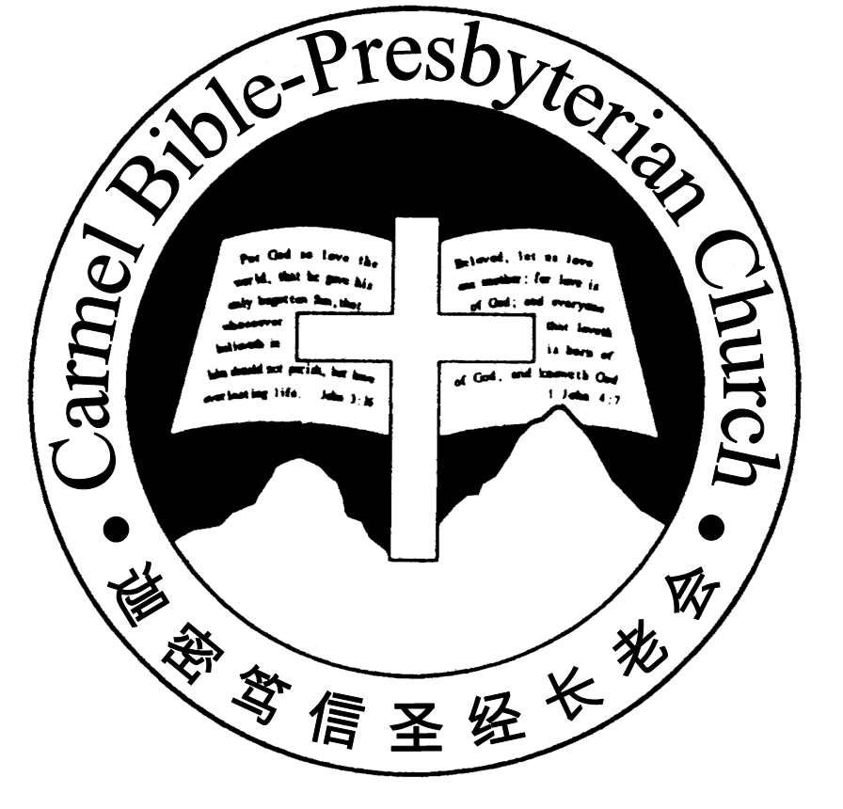
Carmel Bible-Presbyterian Church
Christ’s Love Brings Us Together

Theme for 2013/2014: Committed to Be Christlike

Vol. 16 No. 17 | 27/4/14

Pastoral Chat Graciousness of Jesus

I recall an occasion when I was stopped by a traffic police officer while I was on my way from my mission station to Nairobi, Kenya. The officer, after inspecting my car and check my road tax disc, asked for my driver’s license. “Do you know that you have committed an offence for driving without a valid document? Your road tax licensing has expired. I will book you for violating the traffic rules.” he asked me. Sheepishly, I replied, “Yes. I know. But I am on my way to Nairobi to get it done.”

In Kenya, as a foreigner, I had frequent encounters with these police officers. They were annoying as they would harass and find fault with foreigners. They considered them as ‘mzungu’ or ‘white man’ to be rich people and could be easily hustled. I knew that their only interest was to get something out of me. No one cared whether you had broken some traffic rules.

I apologised to him and said, “I am very sorry about the offence. I admit that it is my fault. I will pay the fine” Taken aback by my frankness, he hesitated and did not know how to react to my response. After much dilly-dallying as though he was serious and ready to issue me a summon, he put away his ticket booklet. He said, “I will let you go this time. Make sure you get your licence renewed.” What a relief! They would not let anyone go so easily. Many a time they would hassle and bargain with you until they received a bribe from you. Indeed it was a very pleasant surprise. Such incident was rather rare.

This may not be measured up to the standard of biblical grace, but this experience gave me some insight into the doctrine of the grace of God. I deserved to be punished as I had run afoul of the law. I had to bear the consequence of my mistake. The letter of the law states that I have broken the law. I must receive the appropriate penalty as prescribed by the law. However, the police officer showed his grace and mercy to let me go with a warning.

Such manifested the spirit behind and within that law, as Paul told the believers, “… for the letter kills, but the Spirit gives life” (2 Corinthians 3:6). When the letter of the law is coldly applied, it can at times break a person’s spirit. The law is never intended to do that. The law is put in place to protect the people and keep the country safe. It is doing its job.

Robert L. Deffinbaugh, a pastor, says, “The principle of grace is as fundamental to Christianity as that of justice is to Law, or love is to marriage. Christianity cannot be understood apart from an adequate grasp of grace. The doctrine of grace distinguishes the Christian faith from every other religion in the world, as well as from the cults. Rightly understood and applied, the doctrine of grace can revolu-tionize one’s Christian life.”

The Apostle Paul’s life was dramatically transformed that he denounced all his earthly wealth, “But what things were gain to me, these I have counted loss for Christ. Yet indeed I also count all things loss for the excellence of the knowledge of Christ Jesus my Lord, for whom I have suffered the loss of all things, and count them as rubbish, that I may gain Christ” (Philippians 3:7-8).

Let us not forget Jesus’ graciousness. May we worship Him, with sincere heart and adoration. His grace and forgiveness cause us to love Him all the more with our whole life. May we love and grow deeper in our relationship with Jesus as the days go by. – Pr Lawrence.
________________________________________________________________

Prayer Items: The World and Our Nation
- God’s grace and mercy for the leaders to resolve the conflicts in the Middle-East region and Ukraine.
- God’s grace and wisdom for our State and Federal leaders to wisely plan the nation budget.

Duty Roster | Today 27/4/14 | Next Lord’s Day 4/05/14
Preacher | P Lawrence Chan | Pastor Peter Chng
Worship Leader | Steven Lee | Dn Timothy Cheong
Pianist | Andrew Chen | Andrew Chen
Praise Chorus | Dn Timothy Cheong | Steven Lee
Offering Collection | Lo Chi Gou | Gavin Zou
AV | Gavin Zou | Jonah Thong
Toddlers | Teacher: Mandy, Crystal | Teacher: Mandy, Changying
Lower Junior | Teacher: Joyce Cheong  Assistant: ---------  Musician: Jessica Hong | Teacher: Adelisa Chng  Assistant: Changying  Musician: Joyce Cheong
Upper Junior | --------- | Steven Lee
Welcomers | Huiqing, Jonah | David & Sandy Hong
Flower | David Hong | Bonnie
Kitchen | Kindness Team  (Phung Lee, Jessica) | Goodness Team  (Alex, Huiqing, Mandy)

Offerings | 20/04/14
General Fund | $1,395.10
Thanksgiving | $20.00
Mission Fund | $0.00
Camp Fund | $20.00 |  |  | To-date: $8,254.80
Building Fund | $250.00; $300.00 (#1103) |  |  | To-date: $286,533.78
Property Maintenance | $0.00 |  |  | To-date: $1,500.00
BF Interest-free Loan | $0.00 |  |  | To-date: $260,000.00
Order of Worship
10.30am

Prelude |  | Pianist: Andrew Chen  Chen
Congregation |  | “The Lord Is in His Holy Temple”
Call to Worship |  | Steven Lee
Welcome & Greetings
握手问安
Praise Chorus |  | Dn Timothy Cheong
Invocation & Doxology* |  |  | *Congregation Standing
Responsive Reading |  |  | Psalm 110 (p.414)
Hymn of Response* |  |  | HOP 226 He Hideth My Soul
Juniors will leave for their class
Announcement |  | Steven Lee
Pastoral Prayer |  | Pr Lawrence Chan
Message |  | In Remembrance of Me…  “Remembering Jesus’ Graciousness”  John 21:15-19 (p.732)
Hymn of Reflection* |  |  | HOP 421 Saved by Grace
Benediction欢迎您会 Sing Threefold Amen after Benediction
You’re invited to join us in our lunch fellowship欢迎您会后留下

Sermon Outline:

Remembering Jesus’ Graciousness John 21:15-19

Two ways we can learn to remember our Jesus’ graciousness

- Knowing His tender-love
  - His patience with us
1.2 His assuring word to us

- Responding to His mercy
1.1 By letting go of the past
1.2 By our recommitment to Him

We warmly welcome you to join us in worshipping the Lord. May God’s peace and joy be your portion.

