Ministries for this Week (4 May – 11 May 2014)
We welcome you to join us in our weekly ministries:
- Friday: 7.30pm: English Care-Group Meeting: Steven’s home, (32.
Godwin Ave., Manning).
- Saturday: 3.30pm: AF Meeting: WCF: “Of Providence, Chapter 5”,
(6 Commercial Rd, Forrestdale).
- Sunday: 9:30am: SBC/ Prayer Meeting: Library
10.30am: Mandarin Service: Main Hall
English Service: Library
Children Ministry: Classrooms
2pm: Church Session Meeting: Library

Sharing With You
- Today is the Lord’s Supper Sunday. Let’s prepare our hearts as we come before His Table to partake the Lord’s Supper.
- Parents’ Day: Next Lord’s Day we will celebrate Parents Day in lieu of Mother’s Day. There will be no Combined Service for parents’ Day. Fellowship lunch will be as usual. Please continue to bring a dish and the young people will also contribute to the lunch.
- Updating of membership record: Membership Form has been given out to you to update your personal particulars. Please see Mimi or Pr Lawrence for the form.
- Library is closed till further notice.

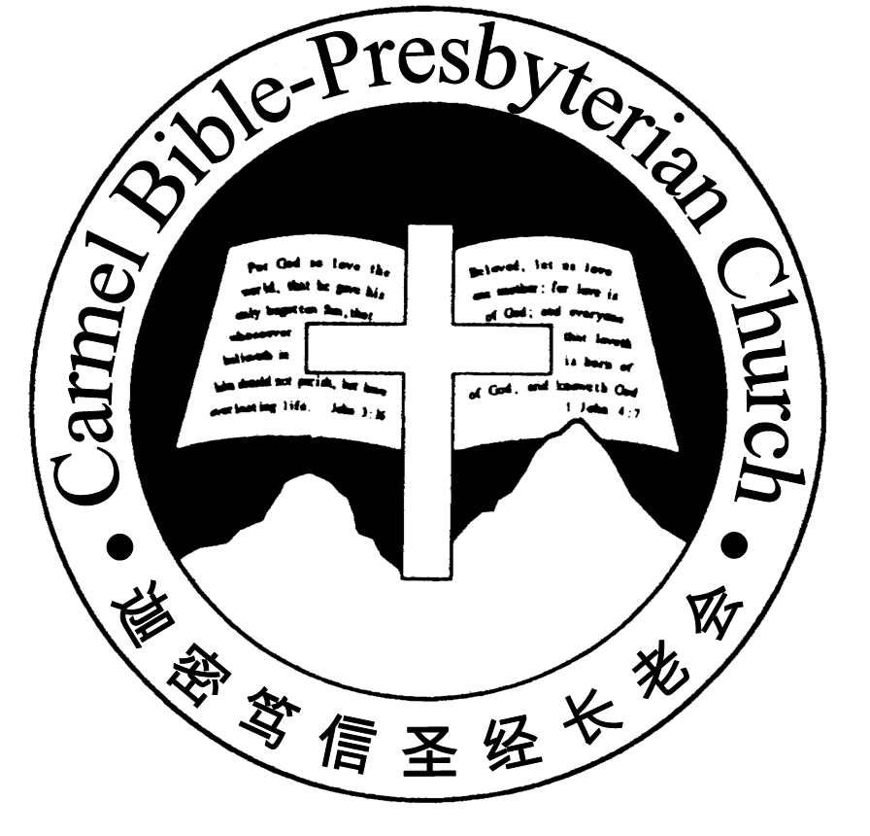
Carmel Bible-Presbyterian Church
Worshipping at: Oberthur Pri. Sch., Nicholls Crescent., Bull Creek, WA 6149
Church Office: 6, Commercial Road, Forrestdale, WA 6112
Telephone: 08-9393-3515
Email: carmelbpc@iinet.net.au
Church Website: www.carmelwa.org.au
Pastors | Rev Peter Chng | Mobile: 0411-230-240
 | Rev Henry Tay | Telephone: 9414-6212
 | Preacher Lawrence Chan | Mobile: 0431-699-316
Christ’s Love Brings Us Together

Theme for 2013/2014: Committed to Be Christlike

Vol. 16 No. 18 | 4/5/14

Pastoral Chat Losing Self; Gaining Christ

“Yet indeed I also count all things loss for the excellence of the knowledge of Christ Jesus my Lord, for whom I have suffered the loss of all things, and count them as rubbish, that I may gain Christ” (Philippians 3:8)

In life, winning and losing seem to many a big issue. Being a Singaporean, I was both amazed and troubled when “Kia-su” syndrome came up for discussion about its citizens some years ago. This syndrome was inferred from observations that Singaporeans were apprehensive of losing just about anything. Living in Singapore since birth till I moved to Australia in 1990, I realise that I was one of them, afraid of losing, especially my self-esteem, or, to put it more bluntly, my ego.

Even after graduated from Bible College and began ministering, that fear of losing my ego remained with me. Unknowingly, I hid that under a cloak known as “Ex-celling.” I thought it was the right attitude for a minister of the gospel, but little did I know that it was much more for my ego than for the Lord’s ministry. No doubt that any minister of the Lord must endeavour to excel for the Lord, as modelled by the apostle Paul. “I discipline my body and bring it into subjection, lest, when I have preached to others, I myself should become disqualified” (1 Cor. 9:27). The funda-mental dividing line, as we search ourselves, is self or Christ.

During a personal study of the epistle of Philippians years ago, it dawned on me on my conscious effort of hiding ego under the cloak of excelling. Paul, an apostle par-excellence, even recognised by the apostle Peter (2 Pet. 3:15-16), made an on-going and conscious effort to “count (or reckon) all things loss for the excellence of the knowledge of Christ Jesus my Lord,…that I may gain Christ” (Phil. 3:8). As a matter of fact, he deemed all those things which he termed as gains loss, and rubbish (vv.8-9). Hence, what ego do I have to defend?

The apostle Paul had so much to brag about, and rightly so: “circumcised the eighth day, of the stock of Israel, of the tribe of Benjamin, a Hebrew of the He-brews, concerning the law, a Pharisee; concerning zeal, persecuting the church; concerning the righteousness which is in the law, blameless” (vv.5-6). Recognising himself to be the least of the apostles and unworthy to be called an apostle for his past act of persecuting the church of God, Paul worked harder than any of the apostles (1Cor. 15:9-10). Yet in the same breath, Paul could say it was “not I, but the grace of God which was with me” (v.10). Many of us would have taken these as gains, but Paul reckoned them as loss in order to gain Christ.

What is the secret of such kind of living? Paul reveals, “For living to me means simply “Christ”, and if I die I should merely gain more of him” (Phil. 1:21; JB Philips) He made a determination—the essence of his existence and ministry is Christ. And to have died after living such a life is only gain to him. Living for Christ doesn’t come automatically upon accepting Jesus as personal Saviour, nor does it come through added knowledge of the Bible. Determination must be present.

After remembering and celebrating Jesus’ triumph over death, and after our camp at Busselton, it’s appropriate for us to contemplate living for Christ and losing self. May the Lord help us to resolve to live for Christ.—Pastor Peter
________________________________________________________________

Prayer Items: Our Congregational Needs
- God’s grace and mercy for those who are recovering from their illness and the elderly to weather through the winter.
- God’s strength and wisdom for parents with young children to nurture their children in the Word of God.

Duty Roster | Today 4/05/14 | Next Lord’s Day 11/05/14
Preacher | Pastor Peter Chng | Pastor Peter Chng
Worship Leader | Dn Timothy Cheong | Pr Lawrence Chan
Pianist | Andrew Chen | Grace Shao
Praise Chorus | Steven Lee | Dn Timothy Cheong
Offering Collection | Gavin Zou | Andrew Chen
AV | Jonah Thong | Gavin Zou
Toddlers | Teacher: Mandy, Changying | Teacher: Mandy
Lower Junior | Teacher: Adelisa Chng  Assistant: Changying  Musician: Joyce Cheong | Teacher: Adelisa Chng  Assistant: Shuie Chen  Musician: Jessica Hong
Upper Junior | Steven Lee | Steven Lee
Welcomers | David & Sandy Hong | Yinglong, Shuzhi
Flower | Bonnie | Han Zhaohui
Kitchen | Goodness Team  (Alex, Huiqing, Mandy) | Faithfulness Team  (Dn Shao, Shuzhi, Gore)

Offerings | 27/04/14
General Fund | $1554.05
Thanksgiving | $20.00
Mission Fund | $0.00
Camp Fund | $1,020.00 |  |  | To-date: $9,274.80
Building Fund | $50.00 |  |  | To-date: $286,583.78
Property Maintenance | $0.00 |  |  | To-date: $1,500.00
BF Interest-free Loan | $0.00 |  |  | To-date: $260,000.00
Order of Worship
10.30am

Prelude |  | Pianist: Andrew Chen  Chen
Congregation |  | “The Lord Is in His Holy Temple”
Call to Worship |  | Dn Timothy Cheong
Welcome & Greetings
握手问安
Praise Chorus |  | Steven Lee
Invocation & Doxology* |  |  | *Congregation Standing
Responsive Reading |  |  | Psalm 101 (p.408)
Hymn of Response* |  |  | HOP 398 All to Jesus I Surrender
Offering
Offertory Prayer |  |  | Dn Timothy Cheong
Juniors will leave for their class
Announcement
Pastoral Prayer |  | Pastor Peter Chng |  |  | 0
Message |  | Losing Self; Gaining Christ …  “Living For Jesus, Part 1”  Philippians 1:1-11 (p.790)
Hymn of Preparation* |  |  | Living For Jesus
Lord’s Supper |  |  | Assisted by Dn Timothy Cheong
Benediction欢迎您会 Sing Threefold Amen after Benediction
You’re invited to join us in our lunch fellowship欢迎您会后留下

Sermon Outline: Living for Jesus (I) Philippians 1:1-11

To aspire to live for Jesus, there are four attitudes we ought to cultivate.

- Having a precise perception
  - Of self
1.2 Of brothers and sisters in Christ

- Understanding Christian relationship
1.1 Fellowship in the gospel
1.2 Partakers of the grace of God

We warmly welcome you to join us in worshipping the Lord. May God’s peace and joy be your portion. We invite all baptized believers to partake the Lord’s Supper with us in remembrance of our Lord.

