Ministries for this Week (25 May – 1 Jun 2014)
We welcome you to join us in our weekly ministries:
- Wednesday: 10.30am: Tandara Aged Care
- Friday: 7.30pm: English Care-Group Meeting: Steven’s home, (32.
Godwin Ave., Manning).
- Saturday: 3.30pm: AF Meeting: Bible Study: “The Gospel of John,
Chapter 8:21-38”, (6 Commercial Rd., Forrestdale).
Elim Fellowship: TBC
YF Outing: Piney Lakes Reserves
- Sunday: 9:30am: SBC/ Prayer Meeting: Library
10.30am: Mandarin Service: Main Hall
English Service: Library
Children Ministry: Classrooms
2.30pm: Church Session Meeting: Library

Sharing With You.
- Next Lord’s Day is our Lord’s Supper Sunday. Let us prepare our heart and mind as we come before the Lord’s Table.
- Updating of membership record: Membership Form has been given out to you to update your personal particulars. Please see Mimi or Pr Lawrence for the form.
- Library is closed till further notice.

Worshipping at: Oberthur Pri. Sch., Nicholls Crescent., Bull Creek, WA 6149
Church Office: 6, Commercial Road, Forrestdale, WA 6112
Telephone: 08-9393-3515
Email: carmelbpc@iinet.net.au
Church Website: www.carmelwa.org.au
Pastors | Rev Peter Chng | Mobile: 0411-230-240
 | Rev Henry Tay | Telephone: 9414-6212
 | Preacher Lawrence Chan | Mobile: 0431-699-316

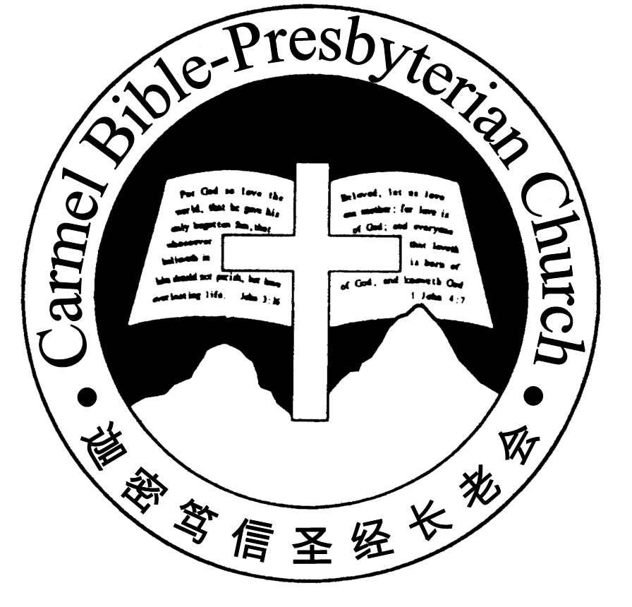
Carmel Bible-Presbyterian Church
Christ’s Love Brings Us Together

Theme for 2013/2014: Committed to Be Christlike

Vol. 16 No. 21 | 25/5/14

Pastoral Chat Giving your life to Christ

Leonard Griffith in his book, ‘This is Living’, shared this conversation between a young man and W. E. Gladstone, the Prime Minister of England.

The young man said, “Mr. Gladstone, I would appreciate your giving me a few minutes in which I might lay before you my plans for the future. I would like to study law.” “Yes,” said the great statesman, “and what then?” “Then, sir, I would like to gain entrance to the Bar of England.” “Yes, young man, and what then?” “Then, sir, I hope to have a place in Parliament, in the House of Lords.” “Yes, young man, what then?” pressed Gladstone. “Then I hope to do great things for Britain.” “Yes, young man, and what then?” “Then, sir, I hope to retire and take life easy.” “Yes, young man, and what then?” he tenaciously asked. “Well, then, Mr. Gladstone, I suppose I will die.” “Yes, young man, and what then?” The young man hesitated and then said, “I never thought any further than that, sir.” Looking at the young man sternly and steadily, Gladstone said, “Young man, you are a fool. Go home and think life through!”

What are we living for in life? Your response to this question will determine the direction and goal in life. Many young people may not give much thought as to what they are living for. Some may drift through life with a ‘happy go lucky’ attitude. Others may be ambitious with high aims. Most of them would live for themselves, a self-centred life.

Many dream to be successful in life. In whatever they seek to do, they are strongly motivated to make their mark in life and find a place in society. Like the young man in the story, most are concerned as how they should plan the future to fulfil their heart desire and establish his career. There is little consideration of what lies beyond after death or the uncertainty and vulnerability of life. Many are too engrossed in pursuing their dreams. They are focused to achieve their goal.

Is life all about how and what we can attain? Or is there life after our passing? Consider what the apostle Paul says, ‘To me to live is Christ and to die is gain’ (Philippians 1:21). That is the motto of his life. It is the knowledge of truth, which is the Gospel of Christ Jesus that ingrained deeply into his heart. He deems it a privilege to know personally the Person Jesus, the Son of God, who is his Lord and Saviour. He is the joy of his salvation and the satisfaction of life.

What he treasures most in life is not the fame, status or wealth he had gained but that he has the gift of eternal life. Worldly things are no longer attractions to him. He looks beyond his present life. The writer of James gives a clear warning, “whereas you do not know what will happen tomorrow. For what is your life? It is even a vapour that appears for a little time and then vanishes away” (James 4:14).

Beloved readers, what are you living for in life? Are you investing your life in worldly things that soon fade away or seeking after things that are valuable? Without a purpose, you will be swept along with the current of the world. And with wrong purpose, you will be heading the wrong way.

We pursue zealously after our dreams. Our focus perhaps is to be at the top of the corporate ladder. As the elderly statesman’s advice to the young man, ”Go home and think life through.” Life is more than the material gains of the world. What you decide now will be where you are going and how you live your life, whether it is for Christ or for self. – Pr Lawrence Chan
________________________________________________________________________________________

Prayer Items: The World and Our Nation
- God’s grace and mercy that the young girls who were kidnapped in Nigeria by the extremists would be rescued soon.
- God’s wisdom and guidance to our leaders from all the parties that they will come out with a workable solution concerning the Federal budget.

Duty Roster | Today 25/05/14 | Next Lord’s Day 1/06/14
Preacher | Pr Lawrence Chan | Pastor Peter Chng
Worship Leader | Steven Lee | Dn Thong Kok Fai
Pianist | Andrew Chen | Joy Han
Praise Chorus | Dn Timothy Cheong | Steven Lee
Offering Collection | .Gavin Zou | Jonah Thong.
AV | Jonah Thong | Andrew Chen
Toddlers | Teacher: Chang Hong | Teacher: Chang Hong
Lower Junior | Teacher: Adelisa Chng  Assistant: Tian Changying  Musician: Joyce Cheong | Teacher: Joyce Cheong  Assistant: Shuie Chen  Musician: Joyce Cheong
Upper Junior | Steven Lee | Steven Lee
Welcomers | Tian Changing, Gore Chen | David & Sandy Hong
Flower | Lyanne Teo | Lyanne Teo
Kitchen | Self-control Team  (Yinglong, Guanglu,  Tang Qiong, Mandy) | Love Team  (Dn Lin Feng, David Hong, Haowen)

Offerings | 18/05/14
General Fund | $1,686.75
Thanksgiving | $40.00
Mission Fund | $0.00
Camp Fund | $20.00 |  |  | To-date: $9,334.80
Building Fund | $50.00; $2000.00 (1007);  $150.00 (1061); $300.00 (1103) |  |  | To-date: $289,533.78
Property Maintenance | $0.00 |  |  | To-date: $1,800.00
BF Interest-free Loan | $0.00 |  |  | To-date: $260,000.00
Order of Worship
10.30am

Prelude |  | Pianist: Andrew Chen  Chen
Congregation |  | “The Lord Is in His Holy Temple”
Call to Worship |  | Steven Lee
Welcome & Greetings
握手问安
Praise Chorus |  | Dn Timothy Cheong
Invocation & Doxology* |  |  | *Congregation Standing
Responsive Reading |  |  | Ephesians 2:1-10 (p.787)
Hymn of Response* |  |  | HOP 40 And Can It Be that I Should Gain?
Offering |  |  | Gavin Zou
Offertory Prayer |  |  | Steven Lee
Announcement
Pastoral Prayer |  | Pr Lawrence Chan
Message |  | Losing Self; Gaining Christ …  “Giving Your Life to Christ”  Philippians 1:19-26 (p.791)
Hymn of Reflection* |  |  | HOP 378 My Saviour’s Love
Benediction欢迎您会 Sing Threefold Amen after Benediction
You’re invited to join us in our lunch fellowship欢迎您会后留下

Sermon Outline:

Giving Your Life to Christ Philippians 1:19-26

Two motivations why a person is persuaded by the Gospel to give his life to Christ:

1. He is convicted of the truth
1.1 A personal encounter with Christ
1.2 Experienced God’s transforming power

2. He is committed to the truth
2.1 Christ is reason for his living
2.2 Death is not an enemy

We warmly welcome you to join us in worshipping the Lord. May God’s peace and joy be your portion.

