Ministries for this Week ( 1 Jun – 8 Jun 2014)
We welcome you to join us in our weekly ministries:
- Sunday: 2.30pm: Church Session Meeting: Library
- Friday: 7.30pm: English Care-Group Meeting: Steven’s home, (32.
Godwin Ave., Manning).
- Saturday: 2pm: AF Outing: South Perth
7.30pm: Elim Fellowship: Tang Qiong’s home,
(54 Hetherington Dr., Bull Creek).
YF: Dn Timothy Cheong’s home,
(68 Rhonda Ave, Willetton).
- Sunday: 9:30am: SBC/ Prayer Meeting: Library
10.30am: Mandarin Service: Main Hall
English Service: Library
Children Ministry: Classrooms

Sharing With You.
- Today is the Lord’s Supper Sunday. Let’s prepare our heart and mind as we come before the Lord’s Table to partake the Lord’s Supper.
- Volunteers needed this Saturday, 7 June 14, 10am, to do gardening at the church property, Forrestdale.
- Updating of membership record: Membership Form has been given out to you to update your personal particulars. Please see Mimi or Pr Lawrence for the form.
- Library is closed till further notice.

Worshipping at: Oberthur Pri. Sch., Nicholls Crescent., Bull Creek, WA 6149
Church Office: 6, Commercial Road, Forrestdale, WA 6112
Telephone: 08-9393-3515
Email: carmelbpc@iinet.net.au
Church Website: www.carmelwa.org.au
Pastors | Rev Peter Chng | Mobile: 0411-230-240
 | Rev Henry Tay | Telephone: 9414-6212
 | Preacher Lawrence Chan | Mobile: 0431-699-316

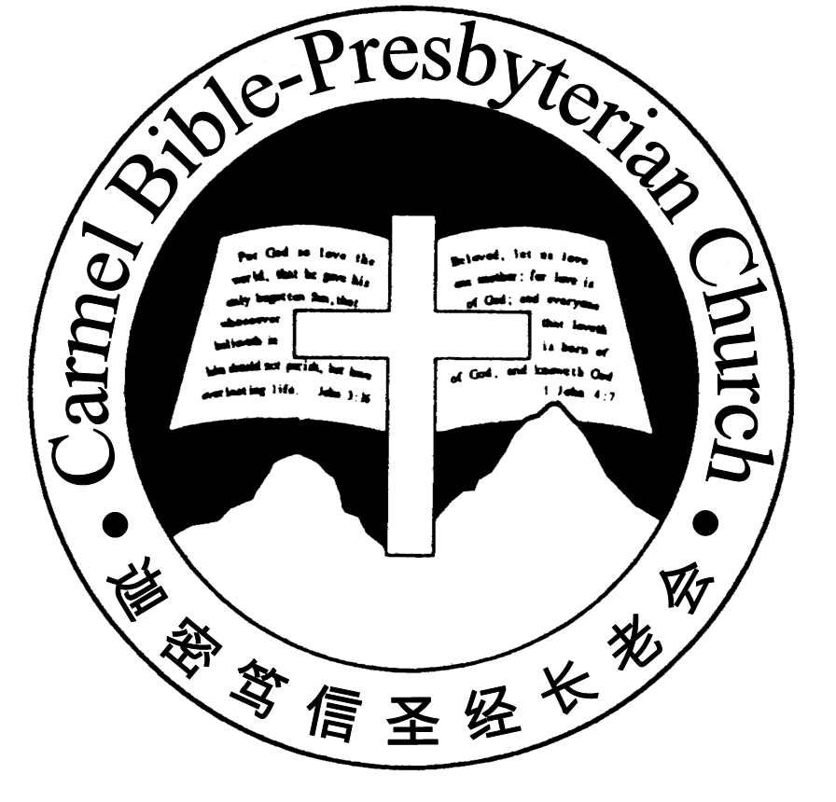
Carmel Bible-Presbyterian Church
Christ’s Love Brings Us Together

Theme for 2013/2014: Committed to Be Christlike

Vol. 16 No. 22 | 1/6/14

Pastoral Hold the Fort!

“Behold, I am coming quickly! Hold fast what you have, that no one may take your crown.” (Revelation 3:11)

As a conclusion to His message, the Lord issued the above call to the church in Philadelphia (Rev. 3:7-13).

The church in Philadelphia was one of only two churches that had commendations without any reprimand. The Lord said, “I know your works. See, I have set before you an open door, and no one can shut it; for you have a little strength, have kept My word, and have not denied My name” (v.8).

Apparently, although the church in Philadelphia was of little power or influence, it continued to hold fast to the Lord’s teachings and His name in times of crisis. Their crisis was probably forced by the Jews (v.9). However, these opposing Jews would be ultimately humiliated, and the Lord would make them come and worship before the feet of the church in Philadelphia, and to know that the Lord have loved them (v.9). And in times of crisis, instead of giving up in despair, the Philadelphians kept the Lord’s command to persevere, the Lord promised to keep them from the hour of the severe global tribulation (v.10).

Before the Lord’s promised final victory, the message to the church is to endure. “Hold fast what you have, that no one may take your crown” (v.11). Interestingly, there was a similar message to the church in Smyrna, the other church who re-ceived commendation without any reprimand. “Be faithful until death, and I will give you the crown of life” (2:10). How many churches today are prepared to endure? How many churches are willing to hold the fort? I wonder…

One day at a Sunday school meeting which Philip Bliss attended, an incident in the American Civil War was mentioned. General Corse was put in charge of the Altoma Pass, which was besieged by the enemy under General Hood. Gen Corse refused Gen Hood’s summon to surrender. Despite the hopeless situation and many casualties, the defenders remained faithful.

At that moment, an officer caught sight of a white signal flag far away across the valley, some twenty miles away. The message from Gen Sherman was “Hold the fort, for I am coming.” Immediately cheers went up, and the defenders held the fort for three hours until the relief arrived.

Upon hearing this incident, the hymn “Hold the Fort” was born in Philip’s mind:

Ho, my comrades, see the signal waving in the sky!
Reinforcements now appearing, victory is nigh.
“Hold the fort, for I am coming,” Jesus signals still,
Wave the answer back to heaven, “By thy grace we will.”

Dearly beloved, in our quest to learn to lose self and gain Christ, we must learn to cultivate the attitude of perseverance. By God’s grace we will persevere for gos-pel’s sake.—Pastor Peter

________________________________________________________________________________________

Prayer Items: Our Congregational Needs
- God’s wisdom and understanding for all the students who are preparing for their coming examinations.
- God’s mercy and strength for those who are recovering from their illness to weather through the winter period.

Duty Roster | Today 1/06/14 | Next Lord’s Day 8/06/14
Preacher | Pastor Peter Chng | Pr. Lawrence Chan
Worship Leader | Dn Thong Kok Fai | Dn Timothy Cheong
Pianist | Joy Han | Grace Shao
Praise Chorus | Steven Lee | Dn Thong Kok Fai
Offering Collection | Jonah Thong. | Gavin Zou.
AV | Andrew Chen | Jonah Thong
Toddlers | Teacher: Crystal Tan | Teacher: Crystal Tan
Lower Junior | Teacher: Joyce Cheong  Assistant: Shuie Chen  Musician: Joyce Cheong | Teacher: Joyce Cheong  Assistant: Candas Thong  Musician: Jessica Hong
Upper Junior | Steven Lee | Steven Lee
Welcomers | David & Sandy Hong | Yinglong, Shuzhi
Flower | Lyanne Teo | Liu Xuerong
Kitchen | Love Team  (Dn Lin Feng, David Hong, Haowen Shao) | Joy Team  (Sandy Hong, Emma, Lumeng, Changying)

Offerings | 25/05/14
General Fund | $2,423.00
Thanksgiving | $20.00
Mission Fund | $0.00
Camp Fund | $20.00 |  |  | To-date: $9,354.80
Building Fund | $550.00; $200.00 (1033) |  |  | To-date: $290,283.78
Property Maintenance | $0.00 |  |  | To-date: $1,800.00
BF Interest-free Loan | $0.00 |  |  | To-date: $260,000.00
Order of Worship
10.30am

Prelude |  | Pianist: Joy Han  Chen
Congregation |  | “The Lord Is in His Holy Temple”
Call to Worship |  | Dn Thong Kok Fai
Welcome & Greetings
握手问安
Praise Chorus |  | Steven Lee
Invocation & Doxology* |  |  | *Congregation Standing
Responsive Reading |  |  | Psalm 85 (p.402)
Hymn of Response* |  |  | HOP 41 Crown Him with Many Crowns
Offering |  |  | Jonah Thong
Offertory Prayer |  |  | Dn Thong Kok Fai
Announcement
Juniors will leave for their class
Pastoral Prayer |  | Pastor Peter Chng
Message |  | Losing Self; Gaining Christ …  “Enduring For Christ”  Philippians 1:27-30 (p.791)
Hymn of Preparation* |  |  | HOP 305 Hold The Fort
Lord’s Supper |  |  | Assisted by Dn Thong Kok Fai
Benediction欢迎您会 Sing Threefold Amen after Benediction
You’re invited to join us in our lunch fellowship欢迎您会后留下

Sermon Outline: Enduring for Christ Philippians 1:27-30

There are two concepts to grasp for the ability to endure for Christ

1. Suffering for Christ is God’s appointment (vv.29-30)
1.1 It’s a grace-gift from God
1.2 For Christ’s sake

2. Enduring for Christ is a way of life (vv.27-28)
2.1 Of a heavenly citizen
2.2 Of evidence of salvation

We warmly welcome you to join us in worshipping the Lord. May God’s peace and joy be your portion. We invite all baptized believers to partake the Lord’s Supper with us in remembrance of our Lord.

