Ministries for this Week ( 22 Jun – 29 Jun 2014)
We welcome you to join us in our weekly ministries:
- Wednesday: 10.30am: Tandara Aged Care
- Friday: 6.30pm: Combined Mandarin and English Gospel Night:
Dn Timothy Cheong’s home, (68 Rhonda Ave, Willetton).
- Saturday: 11.30am: AF Meeting: WCF: “Christ the Mediator, Chapter 8”,
(6 Commercial Rd., Forrestdale).
- Sunday: 9:30am: SBC/ Prayer Meeting: Library
10.30am: Mandarin Service: Main Hall
English Service: Library
Children Ministry: Classrooms

Sharing With You.
- We bid farewell to Chun Ee and his three children as they had left Perth to join San San in Dubai last Wednesday, 18/6. They will be away for three years.
- Combined Mandarin and English Friday Gospel Night, 6.30pm, 27/6, at Dn Timothy’s home. Members are encouraged to bring a dish to share for the dinner fellowship. You are also encouraged to bring your loved ones and friends for the Gospel Night.
- Next Lord’s Day is Gospel Sunday. You are encouraged to bring your loved ones and friends to the service.
- We will be celebrating our Church 15th Anniversary on 24 August with a thanksgiving dinner. You are encouraged to bring your loved ones and friends to our anniversary service and thanksgiving dinner.
- Updating of membership record: Membership Form has been given out to you to update your personal particulars. For those who have taken the form and yet to return to Mimi or Pr Lawrence, kindly do so asap so that we can have an up-to-date of our membership record.
- Library is closed till further notice.

Worshipping at: Oberthur Pri. Sch., Nicholls Crescent., Bull Creek, WA 6149
Church Office: 6, Commercial Road, Forrestdale, WA 6112
Telephone: 08-9393-3515
Email: carmelbpc@iinet.net.au
Church Website: www.carmelwa.org.au
Pastors | Rev Peter Chng | Mobile: 0411-230-240
 | Rev Henry Tay | Telephone: 9414-6212
 | Preacher Lawrence Chan | Mobile: 0431-699-316

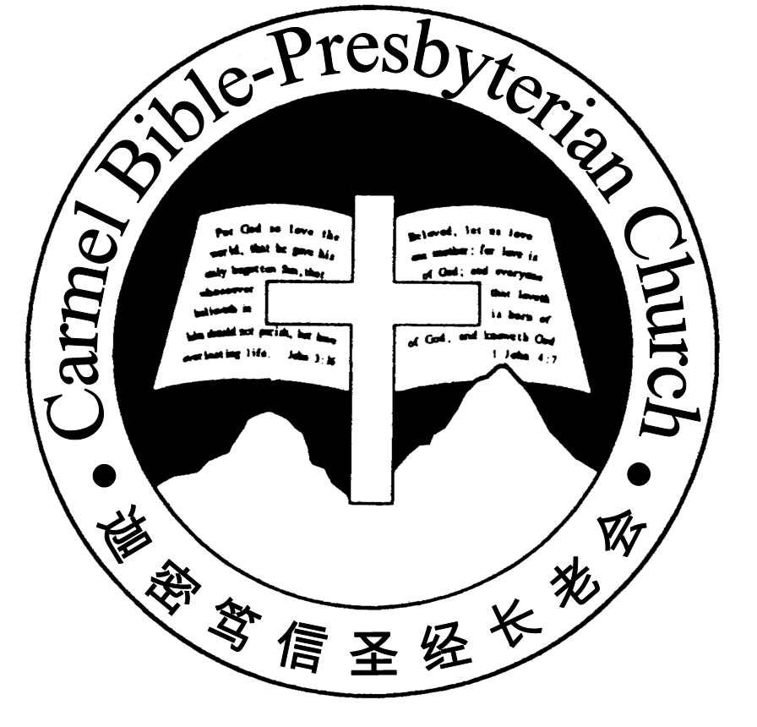
Carmel Bible-Presbyterian Church
Christ’s Love Brings Us Together

Theme for 2013/2014: Committed to Be Christlike

Vol. 16 No. 25 | 22/6/14

Pastoral The Word of Life

“For Ezra had set his heart to study the Law of the Lord, and to do it and to teach his statutes and rules in Israel” (Ezra 7:10).

Ezra was a godly young man who had just returned to Jerusalem from exile in Babylon. There was a dire need for spiritual reformation of the people and renewal of fellowship with the Lord. Knowing his priorities, he purposed in his heart to study and apply God’s Word in his life as well as to impart his knowledge to his people.

God has neither forgotten His people nor His promise to them as His chosen people. His Word has always been crucial to the nation of Israel. His people will only progress and prosper under the guidance of God. As His children, they ought to take His Word seriously and live their life according to His commandment.

The apostle Paul, in his exhortation to the believers in Philippi, reminded them of the importance of God’s Word in their life. His Word is like our life’s compass. We should embrace and use it to ensure that we are heading in the right direction. When we treasure God’s Word as the true living Word, we would hold fast to it as the Word of life. When we are living in Christ, we would live a life such that is under the influence of God’s Word.

What is something in life that we hold dearly to our heart? A recent survey about Smartphone – 8 out of 10 Singaporeans said that they cannot leave home without their Smartphone. Modern gadgets like smart phones and tablets have changed the life of the people, the way they work and communicate with others. These are very helpful gadgets but they interrupt our family life, increase our stress level, and get in the way of our relationships.

If we cherish the things of the earth, then our heart is not in heaven. If we have time to watch TV, read newspaper every day and for our family, but do not have time to read God’s Word, we love the world more that God’s Word.

A former Franciscan priest, Brennan Manning made this observation, “The greatest single cause of atheism in the world today is Christians: who acknowledge Jesus with their lips, walk out the door, and deny Him by their lifestyle. That is what an unbelieving world simply finds unbelievable.”
Many may have the knowledge of the truth. But often their lives show otherwise. They may have memorised the Scripture. Sadly, their lives remain unaffected by the Word of life. Are we giving lip service to God’s Word?

James warns us that if we are only hearers and not doers of God’s Word, then we are actually deceiving ourselves, (James 1:22). Let us take heed and hold fast to the Word of life. – Pr Lawrence Chan

________________________________________________________________________________________

Prayer Items: The World and Our Nation
- God’s wisdom and mercy for the leaders in Middle-East to resolve the escalating conflict in Iraq.
- God’s grace and guidance for the Federal Government to lead our nation wisely in the way of Christian values.

Duty Roster | Today 22/06/14 | Next Lord’s Day 29/06/14
Preacher | Pr Lawrence Chan | Pastor Peter Chng
Worship Leader | Dn Timothy Cheong | Steven Lee
Pianist | Andrew Chen | Joy Han
Praise Chorus | Dn Thong Kok Fai | Dn Timothy Cheong
Offering Collection | Gavin Zou | Jonah Thong
AV | Jonah Thong | Gavin Zou
Toddlers | Teacher: Mandy  Assistant: Shuie Chen | Teacher: Mandy  Assistant: Candas Thong
Lower Junior | Teacher: Joyce Cheong  Musician: Joyce Cheong | Teacher: Joyce Cheong  Musician: Joyce Cheong
Upper Junior | Steven Lee | ---------
Welcomers | Changying, Gore Chen | Huiqing, Changying
Flower | Mr & Mrs Ng Chun Ee | Tian Fujun
Kitchen | Patience Team  (Tony, Jason) | Kindness Team  (Jessica, Phung Lee)

Offerings | 15/06/14
General Fund | $1,130.80
Thanksgiving | $0.00
Mission Fund | $0.00
Camp Fund | $20.00 |  |  | To-date: $9,414.80
Building Fund | $50.00; $200.00 (1045);  $300.00 (1103) |  |  | To-date: $290,833.78
Property Maintenance | $0.00 |  |  | To-date: $1,800.00
BF Interest-free Loan | $0.00 |  |  | To-date: $260,000.00
Order of Worship
10.30am

Prelude |  | Pianist: Andrew Chen  Chen
Congregation |  | “The Lord Is in His Holy Temple”
Call to Worship |  | Dn Timothy Cheong
Welcome & Greetings
握手问安
Praise Chorus |  | Dn Thong Kok Fai
Invocation & Doxology* |  |  | *Congregation Standing
Responsive Reading |  |  | Psalm 1 (p.368)
Hymn of Response* |  |  | HOP 279 What A Friend We Have in Jesus
Offering |  |  | Jonah Thong
Offertory Prayer |  |  | Dn Timothy Cheong
Announcement
Juniors will leave for their class
Pastoral Prayer |  | Pr Lawrence Chan
Message |  | Losing Self; Gaining Christ …  “Holding Fast the Word of Life”  Philippians 2:12-18 (p.790)
Hymn of Reflection* |  |  | HOP 137 Holy Bible, Book Divine
Benediction欢迎您会 Sing Threefold Amen after Benediction
You’re invited to join us in our lunch fellowship欢迎您会后留下

Sermon Outline:

Holding Fast the Word of Life Philippians 2:12-18

We know that we are holding fast the Word of life when:

1. We are fervent in our faith
1.1 Live in complete reliance on God
1.2 Serve in submission to our Lord

2. We are witnesses for Christ
2.1 By being a light of Christ
2.2 By being conscientious of our service

We warmly welcome you to join us in worshipping the Lord. May God’s peace and joy be your portion.

