0
Ministries for this Week (6 July – 13 July 2014)
We welcome you to join us in our weekly ministries:
- Sunday: 2.00pm: Church Budget Meeting: Library
- Friday: 7.30pm: English Care-Group Meeting: Steven’s home, (32.
Godwin Ave., Manning).
- Saturday: 11.30am: AF Meeting: Bible Study: “The Gospel of John”,
(6 Commercial Rd., Forrestdale).
- Sunday: 9:30am: SBC/ Prayer Meeting: Library
10.30am: Mandarin Service: Main Hall
English Service: Library
Children Ministry: Classrooms

Sharing With You.
- Today is our Lord’s Supper Sunday. Let’s prepare our heart and mind to come to partake the Lord’s Supper in remembrance of our Lord Jesus.
- We will be celebrating our Church 15th Anniversary on 24 August with a thanksgiving dinner. You are encouraged to bring your loved ones and friends to our anniversary service and thanksgiving dinner.
- Updating of membership record: Membership Form has been given out to you to update your personal particulars. For those who have taken the form and yet to return to Mimi or Pr Lawrence, kindly do so asap so that we can have an up-to-date of our membership record.
- Library will be opened from Wednesday – Friday, 9am – 5pm; Saturday, 9am – 12pm, 6 Commercial Rd, Forrestdale. Please contact the office if you need library service.

Worshipping at: Oberthur Pri. Sch., Nicholls Crescent., Bull Creek, WA 6149
Church Office: 6, Commercial Road, Forrestdale, WA 6112
Telephone: 08-9393-3515
Email: carmelbpc@iinet.net.au
Church Website: www.carmelwa.org.au
Pastors | Rev Peter Chng | Mobile: 0411-230-240
 | Rev Henry Tay | Telephone: 9414-6212
 | Preacher Lawrence Chan | Mobile: 0431-699-316

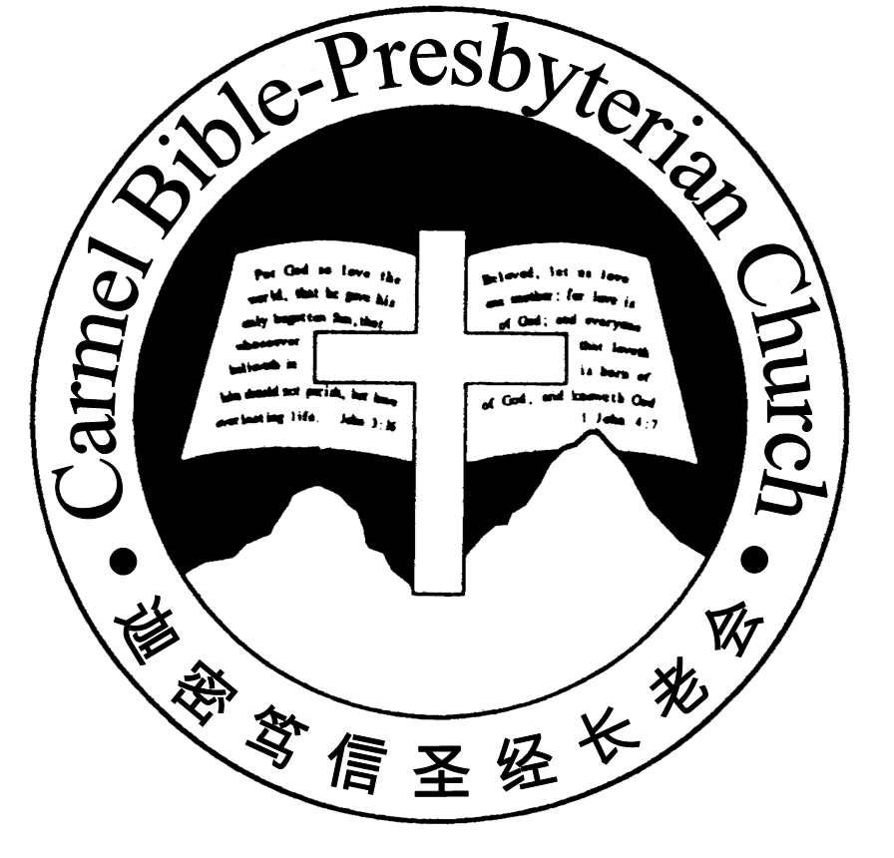
Carmel Bible-Presbyterian Church
Christ’s Love Brings Us Together

Theme for 2013/2014: Committed to Be Christlike

Vol. 16 No. 27 | 6/7/14

Pastoral Role Models

“And you became followers of us and of the Lord,...so that you became examples to all in Macedonia and Achaia who believe” (1 Thess. 1:6-7)

Someone once said, "We're all role models, either positively or negatively, no mat-ter what station in life we occupy. It's one of the things we attain simply by being human beings in a community of other human beings." What an apt saying!

All of us, children and adults alike, grow up having one or more role models. Some look up to sporting stars like Tiger Woods or Ronaldo; some pick Presidents or Prime Ministers, or famous surgeons and musicians, as their role models. Others set successful business leaders like Warren Buffett or Steve Jobs.

Unfortunately, instead of casting a positive shadow, some of these role models leave behind a negative legacy--infidelity, drug abuse, greed or wanton living.

As followers of Christ, do we have our role models? Thank God that we have. And they left behind positive legacy that we cherish and emulate! The apostle Paul is one of them.

Acts 17:1-10 records that Paul and his team preached Christ to the Jews in Thes-salonica. But some Jews became envious and gathered evil men to create an up-roar in the city, and attacked the house of Jason (v.5). In view of the danger, the believers sent Paul and Silas away by night to Berea (v.10). Though Paul was in that city for about a month, he left behind a positive legacy.

In his letter to the Thessalonians, Paul recalled his missions in their city: "For our gospel did not come to you in word only, but also in power, and the Holy Spirit and in much assurance , as you know what kind of men we were among you for your sake. And you became followers of us and of the Lord" (1 Thess. 1:5-6a). Paul was able to relate to the manner of life he and his team lived while bringing the gospel to them. Not only did Paul and his companions preach the gospel, but became role models for the Thessalonians to imitate. We could say that they not only talk the walk, but also walk the talk!

Amazingly, the positive legacy produced a tremendous impact and legacy. The apostle Paul had this to say about the believers in Thessalonica: "...having re-ceived the word in much affliction, with joy of the Holy Spirit, so that you became examples to all in Macedonia and Achaia who believe" (vv. 6b-7). The followers had become role models themselves!

What positive legacy did the Thessalonians leave behind? "For from [the Thessalo-nians] the word of the Lord has sounded forth, not only in Macedonia and Achaia, but also in every place. Your faith toward God has gone out, so that we do not need to say anything" (v.8). Their faith toward God even amid persecution and af-fliction had a positive impact to the believers in that region.

Dearly beloved, it's true that in whatever station in life we occupy, we're role mo-dels, either positively or negatively. We can neither hide nor run away from it. So, by the grace of God, let us follow godly role models and eventually become godly role models. – Pastor Peter
________________________________________________________________________________________

Prayer Items: Our Congregational Needs
- God’s wisdom and understanding for parents with young and teenage children to nurture and guide their children in the way of the Lord
- God’s grace and wisdom for us to grow closer and deeper in our spiritual walk with the Lord Jesus.

Duty Roster | Today 6/07/14 | Next Lord’s Day 13/07/14
Preacher | Pastor Peter Chng | Pastor Peter Chng
Worship Leader | Dn Thong Kok Fai | Pr Lawrence Chan
Pianist | Andrew Chen | Grace Shao
Praise Chorus | Steven Lee | Dn Timothy Cheong
Offering Collection | Gavin Zou | Jonah Thong
AV | Jonah Thong | Gavin Zou
Toddlers | Teacher: Tiffany Teo  Assistant: Changying | Teacher: Chang Hong  Assistant: Chen Shuie
Lower Junior | Teacher: Adelisa Chng  Musician: Timothy Cheong | Teacher: Adelisa Chng  Musician: Joyce Cheong
Upper Junior | Steven Lee | Steven Lee
Welcomers | David & Sandy Hong | Yonglong, Shuzhi
Flower | Xiaohong | Lyanne Teo
Kitchen | Goodness Team  (Alex, Huiqing, Yanhong) | Faithfulness Team  (Dn Shao, Shuzhi, Gore)

Offerings | 29/06/14
General Fund | $1,095.55
Thanksgiving | $0.00
Mission Fund | $0.00
Camp Fund | ($3,781.55) |  |  | To-date: $5,653.25
Building Fund | $50.00 (#1017); $400.00 (#1020); $200.00 (#1045) |  |  | To-date: $291,983.78
Property Maintenance | $0.00 |  |  | To-date: $1,800.00
BF Interest-free Loan | $0.00 |  |  | To-date: $260,000.00
A love-gift envelope for Pastor Peter Chng
A love-gift envelope for Pastor Henry Tay
Order of Worship
10.30am

Prelude |  | Pianist: Andrew Chen  Chen
Congregation |  | “The Lord Is in His Holy Temple”
Call to Worship |  | Dn Thong Kok Fai
Welcome & Greetings
握手问安
Praise Chorus |  | Steven Lee
Invocation & Doxology* |  |  | *Congregation Standing
Responsive Reading |  |  | Psalm 2 (p.368)
Hymn of Response* |  |  | HOP 14 Come, Thou Almighty King
Offering |  |  | Jonah Thong
Offertory Prayer |  |  | Dn Thong Kok Fai
Announcement
Juniors will leave for their class
Pastoral Prayer |  | Pastor Peter Chng
Message |  | Losing Self; Gaining Christ …  “Following Godly Examples”  Philippians 2:19-30 (p.791)
Hymn of Preparation* |  |  | HOP 246 Dare to Be a Daniel
Lord’s Supper |  |  | Assisted by Dn Thong Kok Fai
Benediction欢迎您会 Sing Threefold Amen after Benediction
You’re invited to join us in our lunch fellowship欢迎您会后留下

Sermon Outline: Following Godly Examples Philippians 2:19-30

In the lives of Timothy and Epaphroditus, we have two godly examples to follow

1. Timothy—godly example of living for Christ
1.1 A sincere caring spirit
1.2 A heart of serving

2. Epaphroditus—godly example of servant leadership
2.1 A spirit of humility
2.2 Preferring others’ interests to one’s own

We warmly welcome you to join us in worshipping the Lord. May God’s peace and joy be your portion. We invite all baptized believers to partake the Lord’s Supper with us in remembrance of our Lord.

